
K&M Tire

IT Support Services
10/29/2025

Table of Contents
1. K&M Tire 1
2. Office Manual Introduction 4
3. Conventions 5
Cautions & Warnings 5
4. Organizational Chart & Contacts 6
Organizational Chart 6
3CX – Phone System 6
Location Contact List 6
Organizational Information / Links 6
5. Security Guidelines for SOPs 7
6. SOP Management 8
6.1 SOP Source Documents 8
6.2 Creating SOPs 8
6.3 Updating SOPs 9
7. Communicating High Priority Issues 10
7.1 Identifying a High Priority Problem (Critical or Major) 10
7.2 Communicating Unplanned Issues to Relevant Stakeholders 10
7.3 Communication for Planned Outages 11
7.4 Frequency and Groups for Communications 11
7.5 Incident Reporting 13
7.6 Issue or Incident Tracking Log 13
8. Email Distribution List 15
8.1 Follow these guidelines when assigning Active Directory rights to employees. 15
8.2 All inactive users need to be removed from email distribution lists. 15
9. Call Escalation 16
9.1 Priority 1 Support 16
9.2 Priority 2 Support 16
9.3 Priority 3 Support 17
9.4 After hours calls 18
9.5 Follow up. 18
10. Purchasing PC’s and User Devices 19
10.1 How to Procure New PC’s and User Devices. In this document, the following will be designated as Devices: 19
10.2 Identifying a need for new PC’s and User Devices 19
10.3 Getting Pricing for a Device 20
10.4 Submitting Devices for Approval 20
10.5 Purchasing 21
10.6 Computer Setup 21
11. Setting up Desktop Phones and Extensions (3CX) 31
11.1 Identifying what phone is needed for position. 31
11.2 Adding New Extensions 31
11.3 Setting up User in 3CX Web Management Portal 32
11.4 Finalizing Account Activation 36
11.5 Testing Phone and Extension 39
11.6 Setting up Inside Sales Phone 40
11.7 Setting Up Dashboards 46
12. Adding Access for New Users 47
12.1 Identifying New Hires 47
12.2 Opening a Project in ManageEngine for New Hire 47
12.3 Purchasing the Devices if not in Storage. 48
12.4 Creating Active Directory (AD) and Mailbox 48
12.5 Creating user in MaddenCo sessions 50
12.6 WISE User Setup 55
12.7 Adding Other Access 58
12.8 Communicating New Users Access and Training 58
13. Job Transfer 59
13.1 Job Transfer Steps 59
14. Termination 61
14.1 Termination Steps 61
15. Packing of Items 63
15.1 Single Items in a box 63
15.2 Items in a tote 63
16. Creating an Invoice for shipping an Item 64
16.1 Madden Co Creating an Invoice 64
17. Documenting Tickets 65
17.1 Objective: Documenting Support Calls and Work in ManageEngine via the creation of tickets 65
17.2 All Support 65
18. Intranet Down 70
18.1 Objective: Documenting Support Calls and Work in ManageEngine via the creation of tickets – These steps are followed by the Development Team. 70
19. IT Internal Project Requests, Project changes, and Approval 71
19.1 Project Proposal/Change Process 71
19.2 Large Project Request (Entire Company/Multiple Departments) (120 hrs.+) 72
19.3 Small Project Request (Single Department) (<40) 73
19.4 Project Request from Detail 74
20. Purchasing New IT Infrastructure 79
20.1 Identifying a need for new IT Equipment 79
20.2 Getting a Quote for Equipment 79
20.3 Submitting Quotes for Approval 80
20.4 Purchasing 81
20.5 Installation of Equipment 81
20.6 Updating Documentation and Managing Maintenance Renewals 82
21. IT Invoice Approval Process 83
21.1 Invoice Review 83
21.2 Concur Expense Review 83
21.3 New Vendor Invoice Processing 83
21.4 Logging Invoices for IT Budget Tracking 84
22. Hardware Return Policy 85
22.1 Inspection 85
23. Acquiring New Location Internet/Phone 87
24. WISE Set Up 90
25. Pre-Go Live RDP Sessions for WISE 96
26. WISE Go Live 98
27. Password Management 108
28. Customer Number Change 109
29. Quoting Branch Services 118
30. Quoting Equipment 120
31. OE Connection Setup 121
32. Cell Phone 127
33. Cell Phone Maintenance 128
34. Year End Tasks 129
35. IT Acquisition 132
36. New Location Install 137
37. Sophos Notification 141
38. Cyber Security 142
39. Sophos User Quarantine 150
40. Using the Sophos Self Service Portal 153
41. Threats Detected on the Network 155
42. Milestone Server Set Up 159
43. Zebra Label Ordering 163
44. Existing User Requests 165
45. Daily System Check 166
46. Monthly System Clean UP 167
Appendix A: Revision History Tracking 168

K&M Tire
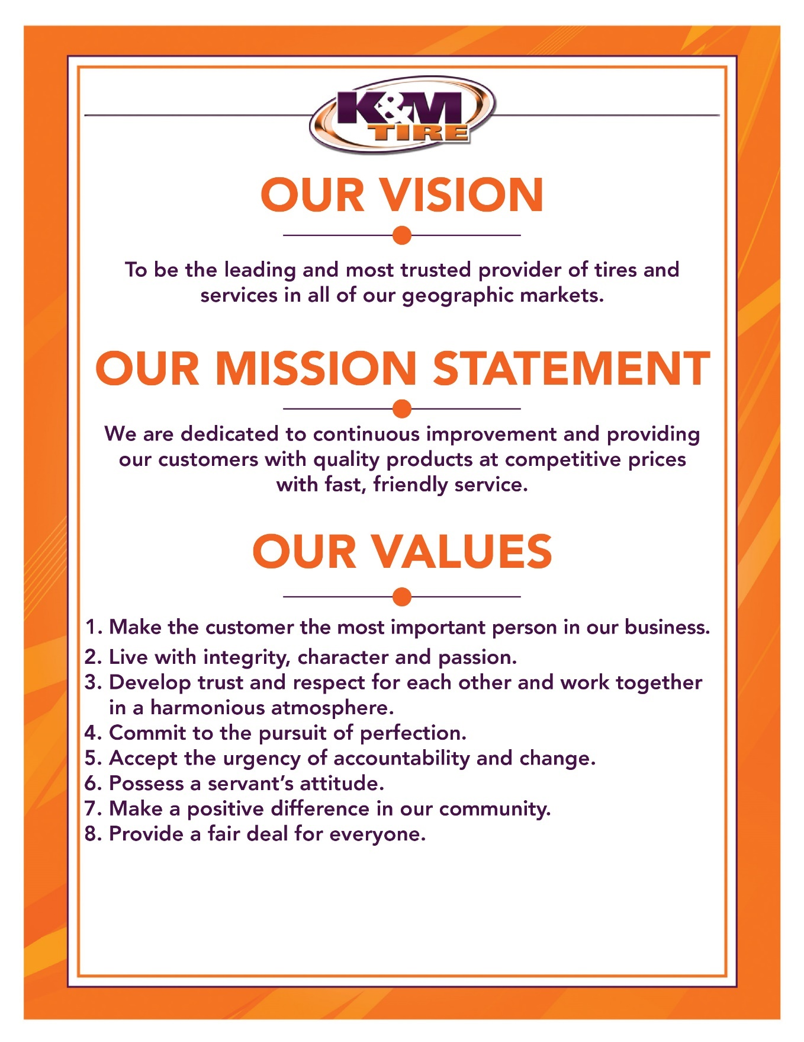



K&M Tire US Footprint
Click on the below link to see the footprint map
http://kmtire.com/km-cgi/distmap

Office Manual Introduction
This manual is intended to aid in the training of the K&M Tire (IT Department) team by providing step by step detail of the processes.

Provide link & path of where to find up to date version

ADD PRIVACY AND/OR SECURITY CONSIDERATIONS HERE.

Conventions
This document provides screen prints and corresponding narrative to describe how to use the MaddenCo, WISE and K&M Intranet, known as “company systems.”
When an action is required on the part of the reader, it is indicated by a line beginning with the word “Action:” For example:
Action: Click on OK.
Fields or buttons to be acted upon are indicated in bold italics in the Action statement; links to be acted upon are indicated as links in underlined blue text in the Action statement.
Note: The term ‘user’ is used throughout this document to refer to a person who requires and/or has acquired access to the company systems.

Cautions & Warnings
This manual does not supersede any safety or company policy.

Organizational Chart & Contacts

Organizational Chart
Organizational Chart

3CX – Phone System

Location Contact List
IT Contact List

Organizational Information / Links
ORG CHART / EXT

Security Guidelines for SOPs

When creating SOPs, keeping security in mind is a priority. SOPs contain a lot of critical business processes, procedures, and data, they are also available to anyone on the network. If a malicious actor were to get a hold of these, it could very easily lead to an attack or security breach. So, it is important to make sure that we are security conscious when creating them.
To help combat this, here are some general guidelines to follow to mitigate the risk:
- Generalize the information. The information should not be step-by-step, be as general as possible when it comes to defining the process. Replace sensitive information with random amounts of asterisks or reference the sensitive information to a secure document.
- Do not include credentials. By putting credentials inside of the SOP, anyone who can view that document can now access that system with the credentials provided. This causes a big concern for security because the malicious actor now has a way to escalate in the network. Either replace all usernames and passwords with a random number of asterisks or remove the information and reference it to a secured document.
- Do not include IP Addresses, Hostnames, or Ports. Exposing IP addresses, hostnames, and ports can help an attacker map out the network with ease. They can also figure out naming conventions and addressing schemes which will only aid them enumeration and possibly allow them to escalate privileges within the network. Either replace all networking information with a random number of asterisks or remove the information and reference it to a secure document.
- Do not include links to internal systems. By including links to internal systems, a malicious actor can use this information to find exploits and map out what we use internally. When including information about internal systems, do not put links to it and generalize information about the system as much as possible.
- Do not include paths to critical directories. If critical directory information is found by a malicious actor, they will most likely target it depending on what their goal is. This can lead to sensitive business data to be compromised with ease. Remove this information and reference to a secure document if necessary.
- Do not expose how sensitive data is obtained. By explaining where we obtain employee and customer information from, we are putting a target our back. If a malicious actor finds out the procedure, they will attack that system or users. We are putting our users and customers at risk by doing this. This should not be referenced or defined in the SOP.
- Be cautious with screenshots and charts. When inputting screenshots and charts, verify that there is no sensitive information in them. It is easy to miss, so just make sure to double check that the screenshot is in compliance with the other guidelines stated above.

SOP Management
To give direction on the creating, updating and management of IT Standard Operating Procedures.

6.1 SOP Source Documents
- For security and process management, IT maintains multiple sources of SOP documentation.
  - Microsoft Word F:\SOP\IT\Approved
    - Director of IT (DIT)
  - OneNote
    - Help Desk Manager
  - Zoho ManageEngine
      - Help Desk Manager
- All sources need to be maintained with updated SOP processes.
- The DIT will provide a final copy of the approved SOP to the Director of Support Services, Help Desk Manager the Development Manager within 5 days of receiving the approval from the IT Managing Director.
  - It is the responsibility of the appropriate IT employee listed above, to update the source document when the Information Technology SOP is final approved by the President.
  - These source documents should be updated within 15 days of receiving the approved copy from DIT.

6.2 Creating SOPs
- It is the responsibility of the Director of IT Development and Projects or Help Desk Manager to notify the Director of IT Business Analyst within 3 business days if new software or hardware is added that would create the need for a new SOP.
- The DIT will be responsible for working with IT Staff to determine the steps required to create the new SOP. The new SOP should be written within 30 days of notification.
- Upon completion of the draft being written, the DIT should present the draft to the VP of IT for review.
  - If modifications need to be made, the DIT is responsible for making these changes.
- After the VP of IT signs off on the draft, it will be presented to the President for final review and sign off.
  - If modifications need to be made, the VP of IT should communicate this to the DIT for updates. It is the DIT responsibility to make these changes.
Upon sign off from the President, the SOP will be moved to Approved SOP folder on the F: drive. F:\SOP\IT\Approved

6.3 Updating SOPs
- The Information Technology SOP should go through an annual review for accuracy and make appropriate updates.
- It is the responsibility of the DIT to ensure the review occurs on an annual basis. The review should start in January of each year and be completed by the end of February of the same year.
  - SOP sections will be presented to the appropriate IT employee for review.
  - If there are changes, the IT employee should notify the DIT of these changes so the updates can be documented.
  - If there are no changes, the IT employee should notify the DIT so the SOP section can be marked as reviewed for the annual process.
- Upon review of the entire SOP, the DIT should present it to the VP of IT for review.
  - If modifications need to be made, the DIT is responsible for making these changes.
- After the VP of IT signs off on the modifications, it will be presented to the President for final review and sign off.
  - If modifications need to be made, the VP of IT should communicate this to the DIT for updates. It is the DIT responsibility to make these changes.
- Upon sign off from the President, the SOP version will be updated and moved to Approved SOP folder on the F: drive and replace the existing version. F:\SOP\IT\Approved

Communicating High Priority Issues
This SOP outlines the process for the IT Department and Support Staff to effectively communicate high-priority or critical issues, including planned and unplanned outages, to ensure timely updates and clear communication as the issues are being addressed.

7.1 Identifying a High Priority Problem (Critical or Major)
- High-priority issues involve significant outages or a complete loss of functionality in critical systems. Examples of high-priority technologies include:
  - MaddenCo
  - Desktop Phones (3cx)
  - Weblink
  - Intranet
  - Email
  - Corporate Internet
  - WISE
  - eCommerce
  - Location-specific internet or power outage
- Identification Process:
  - IT staff must assess the scope and impact on users or customers.
  - Examples:
    - Critical: Weblink, WISE or Intranet completely down
    - Major: Widespread connectivity loss in a warehouse, affecting location
    - Minor: A single user’s scanning gun connectivity error, not impacting others.

7.2 Communicating Unplanned Issues to Relevant Stakeholders
Once identified, the issue should be promptly communicated to impacted groups and necessary personnel.
- Best Practices for Unplanned Outage Communication:
  - Send alerts quickly to affected staff to manage expectations and reduce Help Desk inquiries.
- Include the following details:
  - Affected services (state if the service is slow, intermittent, or completely down).
  - A brief, non-technical explanation of the issue.
  - Next steps and estimated resolution time (if known).
  - Contact information for further assistance.

- Follow Sample Notification Template (Unplanned Outage):

  - Issue with Delphos Internet
Delphos Internet connection has been experiencing intermittent connectivity issues since 8:00 am EST on 11/11/24. Users in Delphos Corporate and Warehouse report limited access on workstations and scan guns.
The IT Team is working to resolve this issue. An update will be provided at 8:20 am EST.
For more information, contact the IT Help Desk at help@kmtire.com or extension 2006.

7.3 Communication for Planned Outages
For scheduled maintenance, IT will notify stakeholders in advance, detailing the scope and benefits of the planned outage. Communication should be sent to the same groups impacted by the system or network that will be undergoing maintenance.
- Include the following information:
  - A non-technical description of the maintenance or upgrade and the affected services.
  - Purpose and benefit of maintenance.
  - Start and end times.
  - Next steps once maintenance is complete.
  - Contact details for further inquiries.

- Follow Sample Notification Temple (Planned Outage):

  - MaddenCo System Maintenance
Scheduled for 8:30 pm EST on 11/11/24 until 12:30 am EST on 11/12/24.
Services Impacted: WISE, MaddenCo, 3CX Phone Services.
Purpose: This maintenance will improve system performance across K&M locations.
For more information, contact the IT Help Desk at help@kmtire.com or extension 2006.

7.4 Frequency and Groups for Communications
- Frequency:
  - Provide updates no more than 30 minutes apart as a follow up to the unplanned or planned communication templates.
  - Each update should include:
    - A summary of troubleshooting steps taken.
    - An estimated time remaining until resolution, if available.
    - Avoid mentioning individual technical staff names in updates.
    - Example: “Spectrum, TSC, and K&M IT are actively addressing the issue and expect it to be resolved within the next hour.”
- Groups:
  - For the following email the entire company – company@kmtire.com
    - MaddenCo
    - Desktop Phones (3CX)
    - Weblink 2.1
    - Intranet
  - WISE – Email the following
    - Impacted warehouse management team
    - WSMs
    - WAMs
    - ROMs
    - VP of Operations
    - Director of IT
    - VP of IT
    - President
    - Manager of Inside Sales
    - VP of Sales
  - eCommerce Outages – EDI, API, Web Services - Email the following:
    - VP of Sales
    - Director of Marketing
    - Manager of eCommerce
    - eCommerce Group Email
    - Director of IT
    - Development Managers
  - Location specific internet outage – Email the following:
    - Location Manager
    - ROMs
    - WSMs
    - WAMs
    - President
    - VP of Operations
    - Director of Facilities
    - Director of IT
    - VP of IT
    - VP of Sales
  - Location specific power outage – Email the following:
    - Location Manager
    - ROMs
    - WSMs
    - WAMs
    - VP of Operations
    - Director of Facilities
    - Director of IT
    - VP of IT
    - ELT Distribution Group

7.5 Incident Reporting
An Incident Report Form is used to fully document and analyze critical incidents, ensuring accountability and identifying preventive measures.
- Incident Report Requirements: Complete the report within three business days, including:
  - Incident description
  - Times (Occurred, Reported, Resolved)
  - User impact and response actions
  - Root cause, resolution, and preventive measures
  - SOP changes if necessary
- Distribution: Send the report to the Director of IT, VP of IT, and the President.
- Incident Report Template Location:
F:\Information Technology\Shared\Incident Reporting\Incident Response Form.docx

7.6 Issue or Incident Tracking Log
To ensure long-term accountability, all incidents must be logged in the IT Issue Tracking Log, accessible in Microsoft Teams.
- Logging Process:
  - Access IT Department Team → IT Issue Tracking channel in Teams.
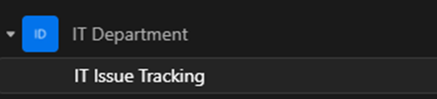
  - Open IT Issue Tracking Log.xlsx.
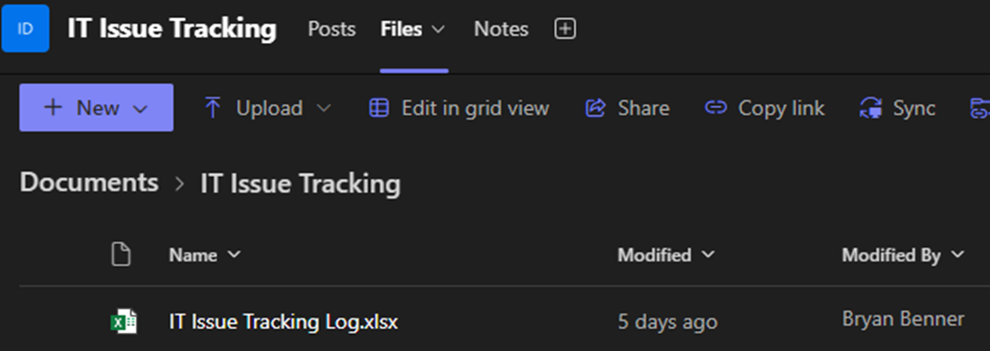

  - Complete required fields: date, issue description, severity, impact, root cause, and resolution.

- After opening the spreadsheet, you will need to place the following information into each column on a new row (after the last issue logged onto the spreadsheet).
- Field Descriptions:
  - Log Date: Date of logging.
  - Issue: Incident or Issue description
  - Severity: Critical, Major, Minor.
  - Impact: Who or what was affected.
  - Length of Issue: How long has occurred?
  - Source: Internal to K&M or External Supplier or Vendor
  - Root Cause: Determined root cause of the issue
  - Resolution: Describe the solution.
  - Resolved Date: Date resolved
  - Resolved By: Who fixed the issue.
  - Logged By: Who logged the issue.
  - SOP in Place/Needed? Indicate if there is an SOP related to the issue.
  - Ticket#: Include any ticket numbers from ManageEngine if applicable
  - Notes: Add any information relevant to the issue not included in prior fields.

Email Distribution List

8.1 Follow these guidelines when assigning Active Directory rights to employees.
- Corporate Emails:
  - Any Corporate Department
    - Ex. Information Technology, Accounts Payable, Accounts Receivable, Admins, Human Resources, etc.
- Inside Sales
  - Including work from home employees
- Warehouse Support Manager who is housed in the Corporate Office
  - This will not include any WSM at another location.
- Columbus, Ohio based employees in a Corporate Department
  - Ex: Information Technology, Accounts Payable, Inventory, etc.
- All Regional Operations Managers including Director of Operations
- NO Outside Sales unless they report out of Delphos, Ohio
- Delphos Warehouse Manager and Warranty Supervisor
  - All other Delphos Warehouse Employees should NOT be included.

8.2 All inactive users need to be removed from email distribution lists.

Call Escalation
The purpose of the IT call Escalation SOP is so all impacted parties can be communicated with in a timely and efficient manner. It also identifies who and when to escalate the issues to if the Level I Support cannot resolve these issues and they need to go to higher levels to get them resolved.

9.1 Priority 1 Support
- Call 2006 – Technical Support
- Should be the first point of contact for all IT Calls
- Should do their best to resolve the issue.
- Document in a ticket on ManageEngine as much information as possible
    - What’s the issue?
    - What Problem is it causing?
    - Is it Critical?
    - Who should we contact if there is a question?
      - Name
      - Number
- If the problem cannot be resolved within the Level 1 support, escalate by following Priority Classification sheet located under F:\Information Technology\Shared\After hours calls\Priority Classification.xlsx
- Contact IT Help Desk Manager to notify Upper Management if Level 1 or Level 2 Priority
- To escalate calls, see After Hours Calls sheet located on F:\Information Technology\Shared\After hours calls\after hours calls.xlsx

9.2 Priority 2 Support
- Wise Issues
- Pass on information to IT Help Desk Manager before notifying Upper Management if Level 1 or Level 2 Priority.
    - Priority Classification sheet located F:\Information Technology\Shared\After hours calls\Priority Classification.xlsx
    - If system is down or has critical issues
      - Notify the Director of IT if the issues are not resolved within 30 minutes.
      - Notify System Admin Supervisor (SAS) to see why the systems are down.
  - To escalate calls, see After Hour Calls sheet location on F:\Information Technology\Shared\After hours calls\after hours calls.xlsx
- Network, Phones, or Server
  - Pass information to System Admin Supervisor
    - If system is down or has critical issues
      - Pass on information to Director of IT and IT Help Desk Manager before notifying Upper Management if level 1 or level 2 priority.
          - Priority Classification sheet located under F:\Information Technology\Shared\After hours calls\Priority Classification.xlsx
        - Notify Director of IT if issue is not resolved within 30 minutes.
  - To escalate calls, see after hours calls sheet located on F:\Information Technology\Shared\After hours calls\after hours calls.xlsx
- Website, custom report, or intranet issues
  - Pass on information to IT Help Desk Manager
    - If system is down or has critical issues
        - Pass on information to IT Help Desk Manager before notifying Upper Management if Level 1 or Level 2 Priority
          - Priority Classification sheet located under F:\Information Technology\Shared\After hours calls\Priority Classification.xlsx
        - Notify Director of IT Services if the issue is not resolved within an hour.
  - To escalate calls, see After Hours Calls sheet located on F:\Information Technology\Shared\After hours calls\after hours calls.xlsx

- MaddenCo Issues
  - Pass on information to IT Help Desk Manager
    - If system is down or has critical issues
        - Pass on information to IT Help Desk Manager before notifying upper management if Level 1 or level 2 priority
        - Priority Classification sheet located under F:\Information Technology\Shared\After hours calls\Priority Classification.xlsx
        - Notify Director of IT right away
        - Contact Developer on call to see if they can find anything on their end that might be causing the issues
  - To escalate calls, see After Hours Calls sheet located on F:\Information Technology\Shared\After hours calls\after hours calls.xlsx

9.3 Priority 3 Support
- Critical issue that can’t be resolved quickly or is impacting a large group
  - Pass on information to IT Help Desk Manager before notifying upper management if level 1 or level 2 priority.
        - Priority Classification sheet located under F:\Information Technology\Shared\After hours calls\Priority Classification.xlsx
          - Pass on information to Director of IT if not resolved within the hour so we can determine the following:
        - Determine what is affected.
        - Determine estimated down time.
        - Determine Solution
        - Determine who needs notified.
          - Notify contact group and communicate all the above
          - Reference F:\Information Technology\Shared\After hours calls\after hours calls.xlsx
  - Execute plan of action to resolve issue and share with contact group.
  - Provide Status updates on progress hourly.

9.4 After hours calls
- Call 2006 – Technical Support
  - Calls after hours to this extension are forwarded to the On Call IT Team Member’s cell phone.
  - Should be the first point of contact for all IT Calls
  - Should do their best to resolve the issue.
  - Create a ticket in ManageEngine and document as much information as possible.
    - What’s the issue?
    - What Problem is it causing?
    - Is it Critical?
    - Who should we contact if there are any questions?
      - Name
      - Number
  - If necessary, escalate to level 2 support.
  - Document
    - Start issue.
    - Who all was involved?
    - What happened
    - What was done to correct the issue?
    - Completion time
  - To escalate calls, see after hours calls sheet located: F:\Information Technology\Shared\After hours calls\after hours calls.xlsx

9.5 Follow up.
- Follow up with everyone involved in the escalation trail.
- Contact the original person of contact.
  - Everything that has been fixed or addressed correctly.
- Document in a ticket in ManageEngine to fix issue for future reference.
- Document in the ticket in ManageEngine for tracking purposes
- Determine if action needs to be taken to prevent it from happening again.
  - Does something need to be replaced or repaired?
  - Are updates needed?
- Notify users of cause and plan of action to prevent it from happening again.
  - Create training plan or adjust SOP.
- Close ticket in ManageEngine once issue is fixed so we can track if this happens again.

Purchasing PC’s and User Devices

10.1 How to Procure New PC’s and User Devices. In this document, the following will be designated as Devices:
- Desktop PCs
  - 5 in stock
  - Re-order point when down to 2
- Laptop PCs
  - 5 kept in stock
  - Re-order point when down to 3
- Keyboards/Mouse
  - Order as needed, they come with each new PC/laptop
- Headsets
  - 5 in stock
  - Re-order point when down to 2
- Mobile Phones
  - Order only as needed due to price of the device and quick turnaround time
- Desk phones
  - 5 in stock
  - Re-order point when down to 2
- Computer Monitors
  - Order with points
  - Re-order point when down to 6
- Printers
  - Order only as needed due to price of the device and support contract limitations
- Scanners
- Zebra Handheld Scanners
  - 7 in stock
  - Re-order point when down to 5
- Docking Stations
  - 5 in stock
  - Re-order point when down to 3
Current Standards for each device are listed here F:\Information Technology\Shared\Product Info & Pricing\Computer, phone, headset, laptop.xlsx

10.2 Identifying a need for new PC’s and User Devices
- There are multiple reasons new PC’s need to be purchased. Below are examples:
  - A new position is created requiring a device.
  - A failure of a Device.
  - WISE installation.
    - A PC is procured to run WISE Shipping Monitor.
  - Additional Job Functions.
    - Ex. Inside sales team begins remote work program.
      - Headsets and laptops need to be ordered.
  - New Warehouse location replacing existing location (A Move).
    - Printers (1), Scanners (1), Desktop Phone (1), PC’s (1), Monitors (1).
      - The rest of the needed devices will move over from the preexisting warehouse.
  - Acquisition
    - Best practice is to set up all new devices prior to arriving onsite.
      - Existing equipment gets repurposed if possible.
  - New Routes for Warehouses.
    - New Mobile Phones are required for each new route.
- All purchases should be directly connected to an open ticket in ManageEngine (IT Service Desk).
  - All of the following steps need to be documented in ManageEngine at the time that they happen.

10.3 Getting Pricing for a Device
- After identifying the need for new devices in step 1 you now must acquire quotes from multiple vendors. The Help Desk Customer Support Representative will perform the following steps.
  - Look at the minimum of three (3) vendors to get quotes.
    - There are multiple vendors that we have worked with in the past and have established relationships with. A list of approved vendors for equipment is below. Do not limit the quote process to these vendors but any additional vendors will require approval from the Help Desk Supervisor to validate quotes.
      - CDW – Special Pricing Available
      - PC Connection
      - Amazon
      - Perry Pro Tech
      - New Egg
      - Com Resources
      - Verizon
      - Samsung
    - Initially look at pricing on vendor web pages.
      - Special pricing will be shown on web pages if available.
          - Help Desk Supervisor and IT Managing Director have quarterly meetings with vendor representative to review pricing on bulk orders if available.

10.4 Submitting Devices for Approval
- Once pricing has been obtained send a summary to Help Desk Manager for approval
  - Create an excel table to show differences in quotes:
    - Reason for Request
    - Quantity
      - Include bulk discount pricing if applicable.
    - Vendor
    - Manufacturer
    - Model
    - Cost
    - Lead time for arrival
    - Recommendation and justification on which device to move forward with.
  - Help Desk Manager to review pricing and device specifications as submitted by Technical Support Representative.
  - Help Desk Manager will submit request of recommended device including the following.
    - To include summary of organizational need.
    - Justification for purchasing.
      - Including what happens if we don’t purchase.
    - Cost at purchase.
  - Director of IT will communicate approval to Help Desk Manager.

10.5 Purchasing
- Once approval has been given, the Help Desk Manager will then give approval to the Technical Support Representative III to move forward with the purchase.
  - Credit Card information is saved on each vendor website.
    - The exceptions to this are CDW and other vendors who require a Purchase order (PO).
      - The start of the PO should be your initials.
        - Example: JAH83CRADLEPOINT
      - The PO # should have the location number and a brief description of what it’s for.
        - Example: JAH83CRADLEPOINT
      - Put a proper description in the order.
        - This will be useful for historical use and AP when paying.
        - PO’s can be sent with this format via email.
  - Whoever orders will then give confirmation back to Help Desk Manager the ship date and estimated time of arrival.
  - All orders go on IT Support Credit Card.
    - This is reviewed monthly in Concur by Help Desk Manager and IT Managing Director.
      - Once the card has been charged it will be viewable in Concur.
        - Please see Concur SOP for further instructions on submitting and approving.

10.6 Computer Setup
Before you begin reloading Windows you are going to need to pull the Windows 11 Pro license key. Here is how:
- To start the set up you will need to start by Powering on the computer. At the start screen you will set the language.
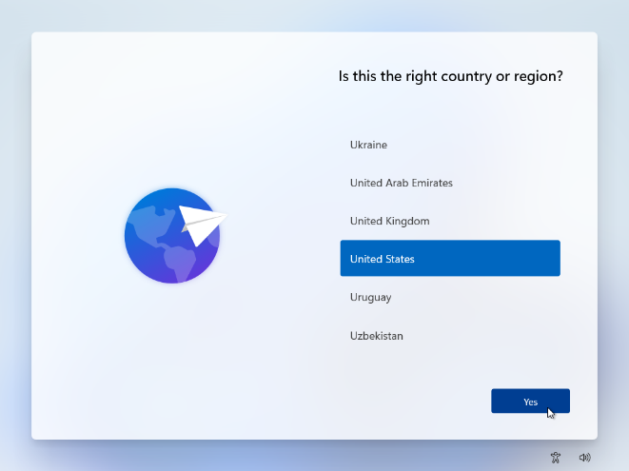

- When prompted to connect to the network you can connect to the KM_NET WIFI or have a network cable plugged in.
- You will click Skip for now for Naming the PC
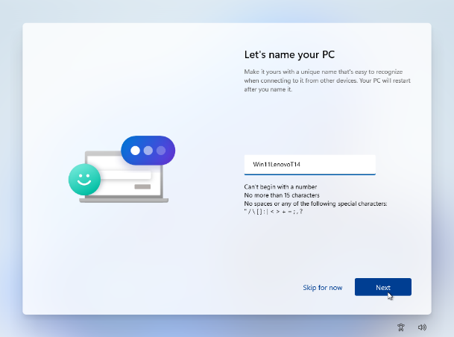

- The next prompt will want you to sign in with a Microsoft account. Here you will click Sign-in Options.

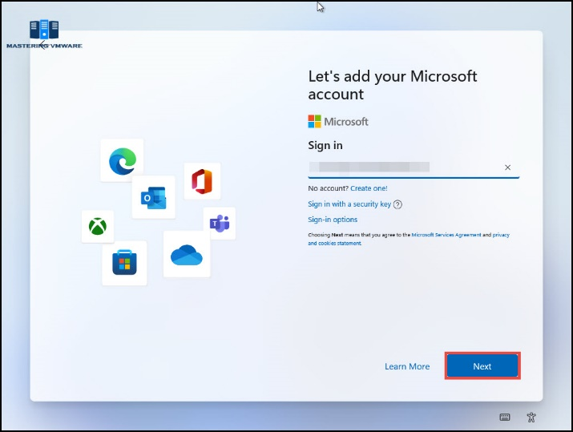

  - You can then select Domain join instead.

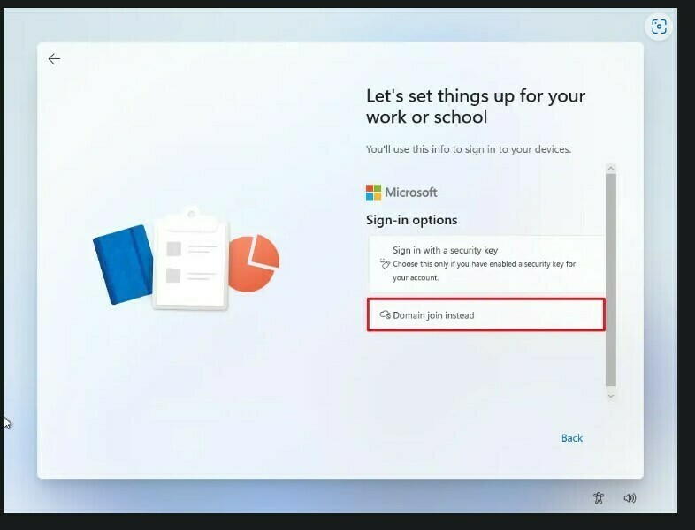

- Next screen will ask you to set the name. You can set this as IT for now.

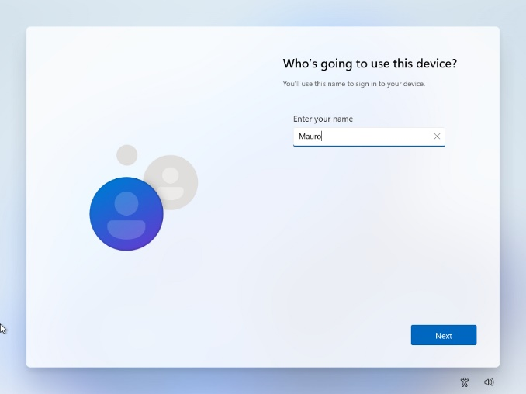

- After this it will proceed to finish setting up the account and take a couple minutes to complete.
- Once this loads you to the desktop you will now run “Show Key Plus” loader on install drive. This will pull the license key.
- Once you have acquired this you can now proceed with reloading Windows 11 Pro.
- Repeat steps 1-6. Once loaded into home screen you will begin running updates.

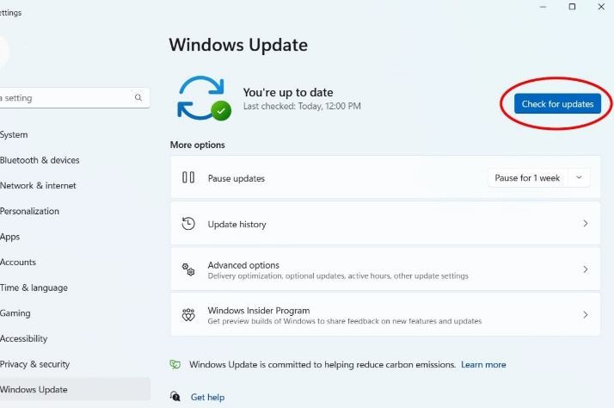

- Once all updates have been completed, launch CMD as administrator and run 2 commands here to get Serial number and set Local Admin account.
  - First command you will run is “wmic bios get serialnumber.” This will give you the laptop serial number.

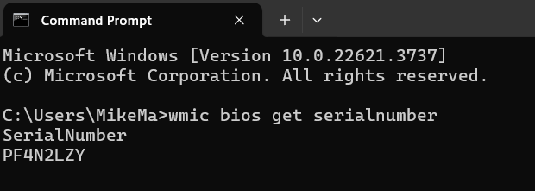

  - The second command is “net user Administrator #kmpc (serialnumber) /active:yes”.
    - This will create the new Local Administrator account.
- Once you have the new Local Admin account created you can now set the new device name which will be the Serial Number.
  - Right click on the Start button and select System

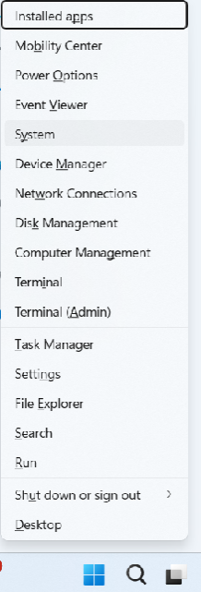

- From here you will select Advanced System Settings

- In this window you will go to Computer Name and select Change.

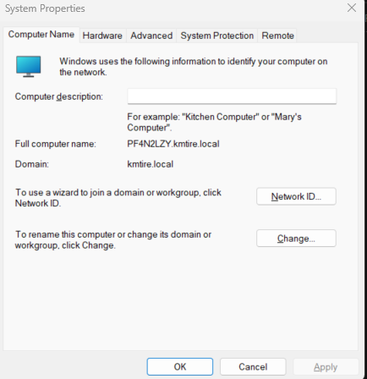

- This will open another window. You will set the Computer Name as the Serial Number.
  - Then go to Member of and select Domain and set that to kmtire.local. This will prompt a reboot once you select OK.

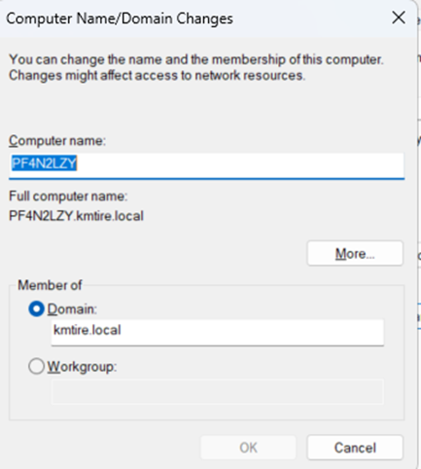

- Once the computer has restarted with domain setup, begin running Asset Manager scan to find device for tagging.
- Once the computer starts back up you will now sign back in with the new local Administrator account you created.
- Once the account is set up you will now remove the temp local account IT, which we created during the set-up.
  - Open CMD as Admin and run command “net user IT/ delete”
- You will now need to make Windows 11 allow you to launch programs with PowerShell.
  - Search for Windows PowerShell and launch.
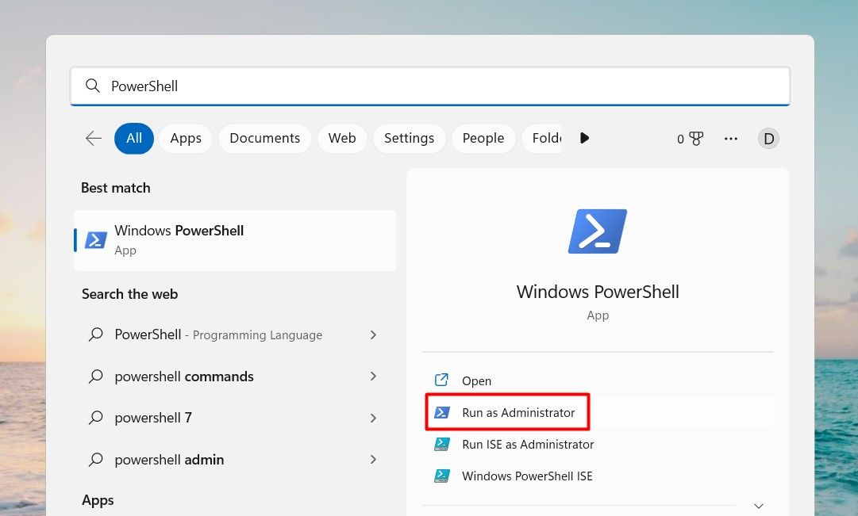

- In PowerShell you will type “Set-ExecutionPolicy Bypass -Scope CurrentUser-Force”
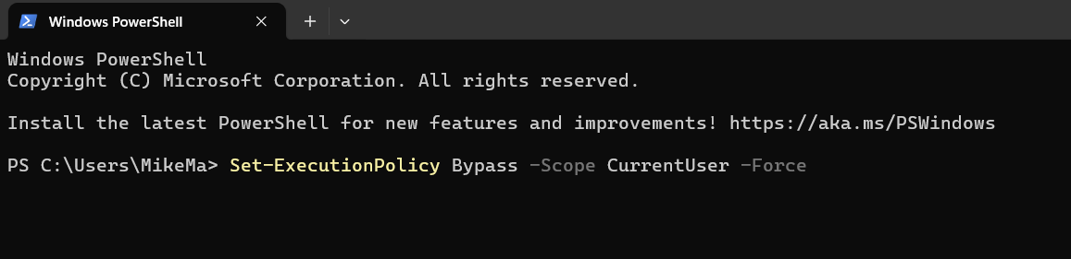

- You can now begin installing the necessary programs for RTD setup.
- Plug in your installer thumb drive.
  - Begin with running Windows removal Script.
  - Once the removal script has been completed you will then run the R7Agent- install.
    - There will be a PowerShell script for this installer that automatically populates the token for you.
  - You can now install Barracuda Webfilter.
    - This will prompt through the installer for a key. You click the browse folder button and then select the BCS key that shows up.
  - Next installer will be the Madden Co installer labeled IBMIAccess_V1r1
    - You first need to install Java
    - Next go to Windows_Application and then run install_acs_64_allusers
    - This will bring up about 10 boxes with Yes or No buttons. Hit Yes for every window prompt. This completes the installation.
  - Once that is completed, we can move on to Action1 Agent - Installer
    - This is broken down by 3 folders. We only need to worry about 2 of them.
      - Branch Location Installers - This is broken down by location. So, if you are sending the computer out to another location you will go to this folder and look for the installer for the needed location.
  - Corporate Installers - This is broken down by department. So, you will proceed to select the installer per the department your set up is for.
    - Next installer will be for VPN. Run the Setup batch file on drive.
    - Next installer will be Sophos.
      - The last 3 programs to run is going to be Chrome Installer, Foxit Installer, and FixMeIT Unattended Access.
  - This finishes the installation portion of the RTD process. Next step will be to make sure the device is in AD, Asset Manager, Sophos, and FixMeIT.
    - Active Directory -
    - Open AD and right click kmtire.local and select Find
    - Click the drop-down box for Find and select Computer and then insert the computer’s Serial Number and click Find Now.

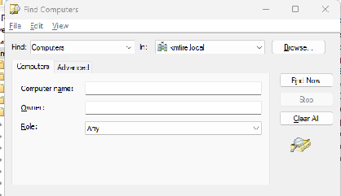

- This will populate your device and then you can right click on it and select Move. Move the device to the proper Branch Location or Corporate Location needed.
  - Desktops will go to under XX Workstations"
  - Laptops will go under "Laptops & Surfaces"
- Asset Manager –
  - In a tab open Manage Engine and go to Assets on the left.
    - You will select Computers and then Workstations
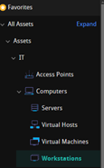
  - In another tab open Manage Engine and go to the gear icon at the top right corner
    - Go to Probe & Discovery
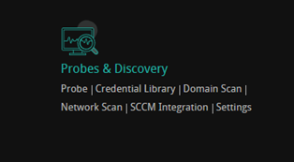
    - Now on the left click on Network Scan

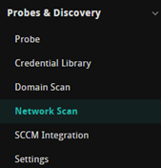

    - Click the gear next to IP range 172.26.0.127-172.26.6.255 and then click Scan Now
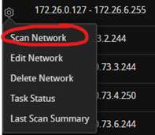
    - This can take a couple attempts and a couple hours to complete/populate the device.

- This can take a couple attempts and a couple hours to complete/populate the device.

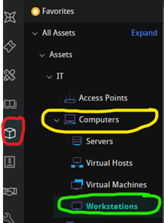
  - This can take a couple attempts and a couple hours to complete/populate the device.
  - We will scroll to the bottom, and we need to insert the AssetTag and Barcode / QR Code (Asset tags are on the small cabinet, top shelf, in a folder for that device model. Place this on the bottom side of the laptop or the top bevel next to manufacture labels for desktops).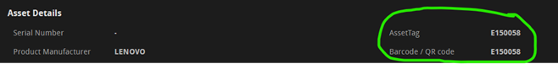

  - You will also need to update the Location and the State (For the Location make sure to set it Loc# - LocationName. For the State we need to make sure we set it to In Use

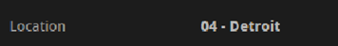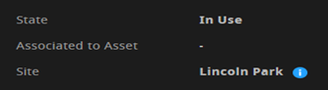

- FixMeIT -
  - FixMeIT is a program allowing us to remotely work on a person’s computer with them there or if they are away for lunch (only access with their permission).
    - In your FixMeIT app you can search the device by its PC name/serial number.
    - Once it populates the device you can click the pencil and then set the name as " Loc # - User’s Name - SerialNumber"
    - Under that there is drop down box to set the location. For RTD devices you will select the bottom option for RTD.
- The last thing to check will be Sophos. You will just need to log into the Sophos portal and go to Devices>Computers> Search serial number> confirm it sees the device and you are good then.
  - If it does not see it then try reinstalling Sophos.

Setting up Desktop Phones and Extensions (3CX)

11.1 Identifying what phone is needed for position.
- Yealink T22, T27, T28 and T43U phones are the current standards.
  - The following areas get T27, T28 or T43 Phones for desktop application.
    - All Corporate Office employees
    - All Inside Sales Employees
    - Warehouse management, including leads.
  - The following areas get T22 phones:
    - Phones in the warehouse are typically mounted on the warehouse wall.

11.2 Adding New Extensions
- For Warehouse employees
  - Go to the 3cx Web Management Portal https://3cx.kmtire.com/#/app/extensions Credentials to access can be found in OneNote security files.
    - Use the following steps to set up a new extension for a warehouse employee.
      - Select add new extension.
        - New Extension number – Ex. 1040
          - The first number is predefined in system as the next available number.
            - EX. “1” because it’s the first number being setup.
          - Second 2 numbers are location ID.
            - EX. “04” which is Detroit.
          - Third Number is the next number available if multiple extensions at warehouse.
            - EX. “0”
              - The Warehouse Manager Phone is always “0”. All other extensions follow the chronological order of deployment.
              - Numbers are shown on the setup screen.
- For Corporate Office Employees
  - Go to the 3cx Web Management Portal https://3cx.kmtire.com/#/app/extensions Credentials to access can be found in OneNote security files.
    - Use the following steps to setup and extension for a user at the corporate office.
      - Select add new users.
        - Search for next available open extension number in 3cx management console-In the 3000’s
        - Click Users
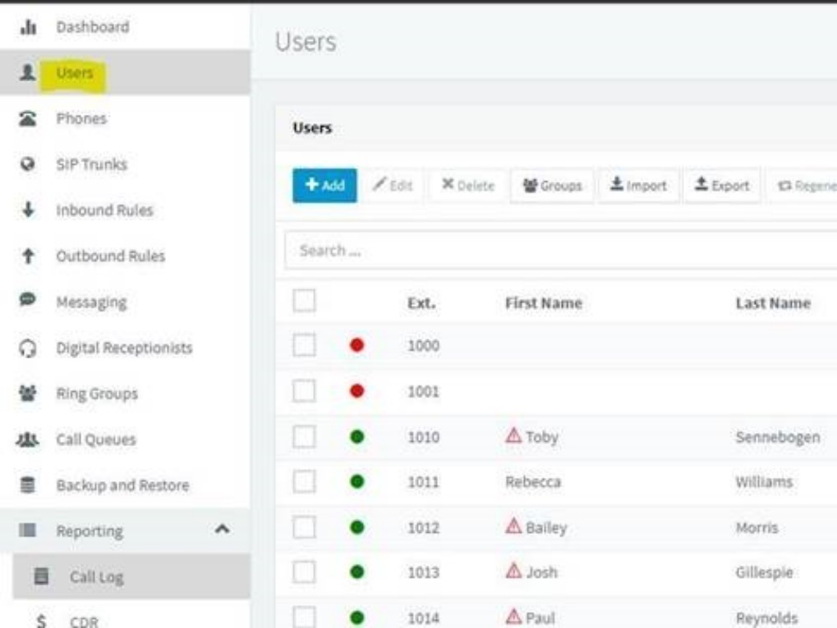

11.3 Setting up User in 3CX Web Management Portal
- Use the following steps to setup the user in the 3cx portal after completing Step 2: Adding New Extensions
  - General Tab
    - Extension – Should already be populated from previous step.
    - First Name – User’s first name
    - Last Name – User’s Last name
    - Email Address – Warehouse and Breakrooms excluded.
    - Mobile Number – Only if requested for forwarding.
      - Will be visible on 3cx application.
    - Outbound Caller ID
      - Corporate and Delphos Warehouse – 4196951061
      - All other locations – Sales 1-800 number associated with their region.
        - If questions, look at kmtire.com location map.
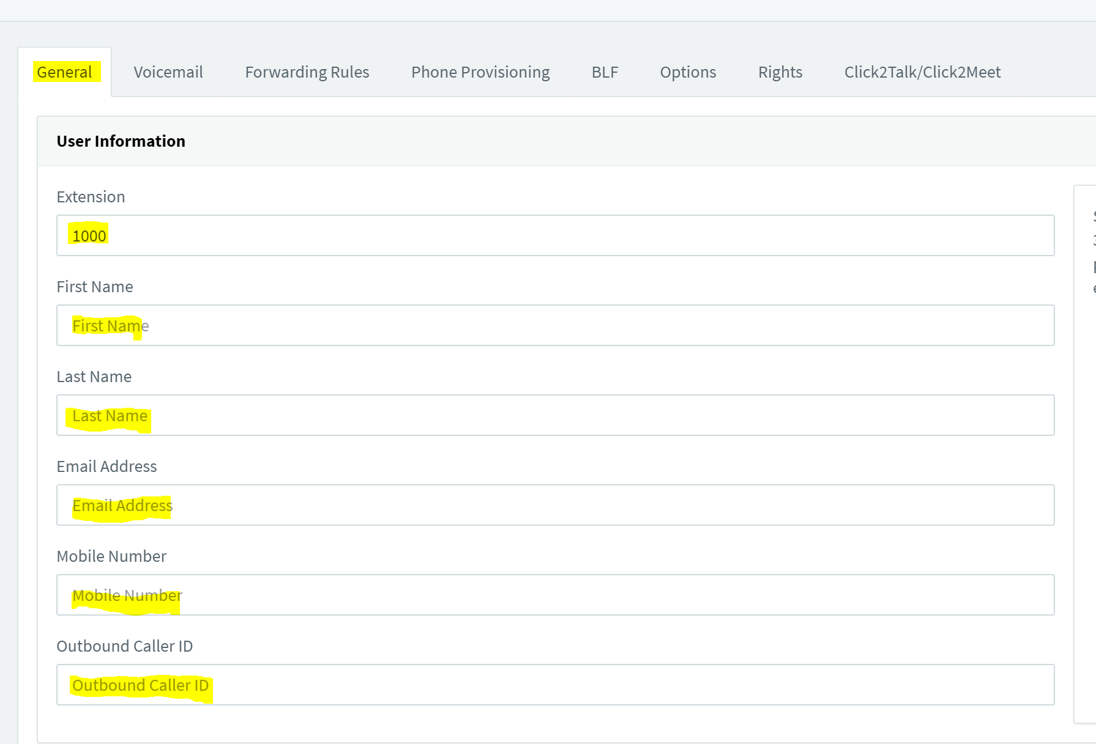
- Use the following steps to set up Voicemail in the 3cx Web Management Portal.
  - Go to Voicemail Tab
    - Check Enable Voicemail
      - Exception is if the phone is dock or break room phone described in step 1-A-2
    - PIN Number – 5555
    - Read Date/Time – Read in AM/PM Format
    - Email Notification – No Email Notification
      - If user requests email notifications – Send Email Notification only.
    - Disable Voicemail PIN Authentication – Remove check from box.

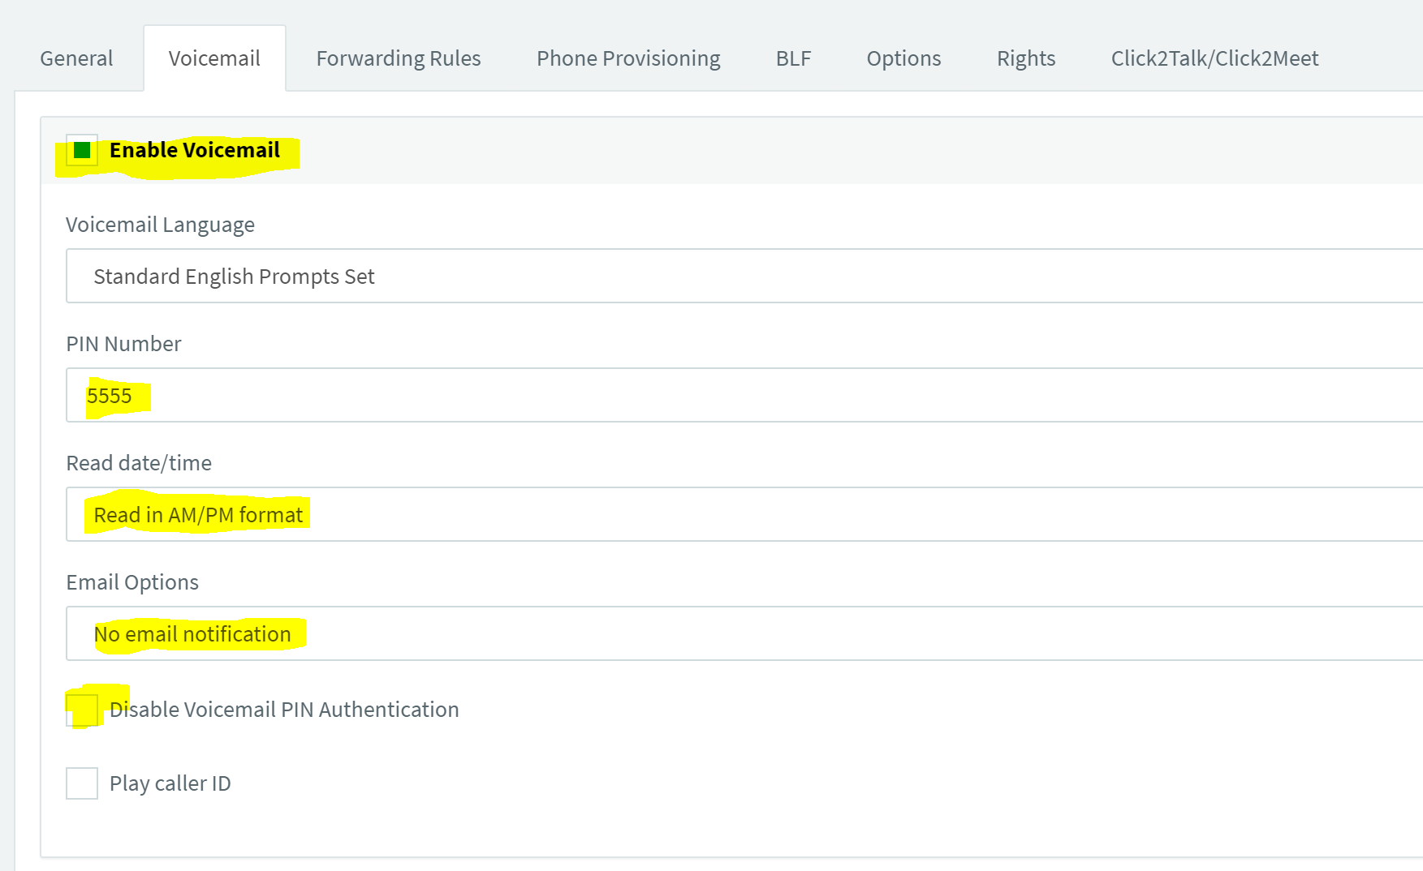

- Forwarding Rules Tab Setup
a. Leave as is unless request is put in to forward to cell phone or another 3cx extension

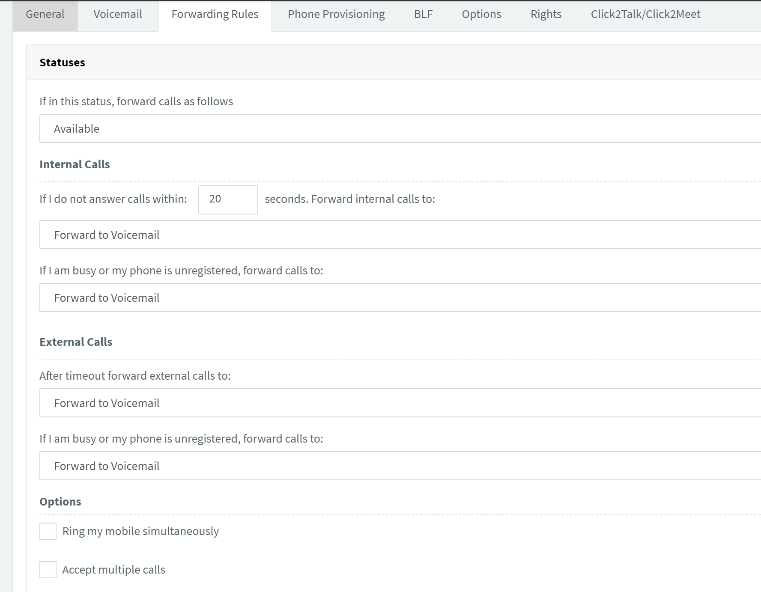
- Provisioning the phone – Adding Network Information
  - Adding phone template
    - Select physical phone type from drop down.
      - Select Add
      - Use Custom Templates
  - ID – Must match phone extension setup in Step 2
  - MAC Address – Can be found on the back of the physical phone.
  - If device is in storage continue to next step
  - All other fields will be populated and do not need changed.
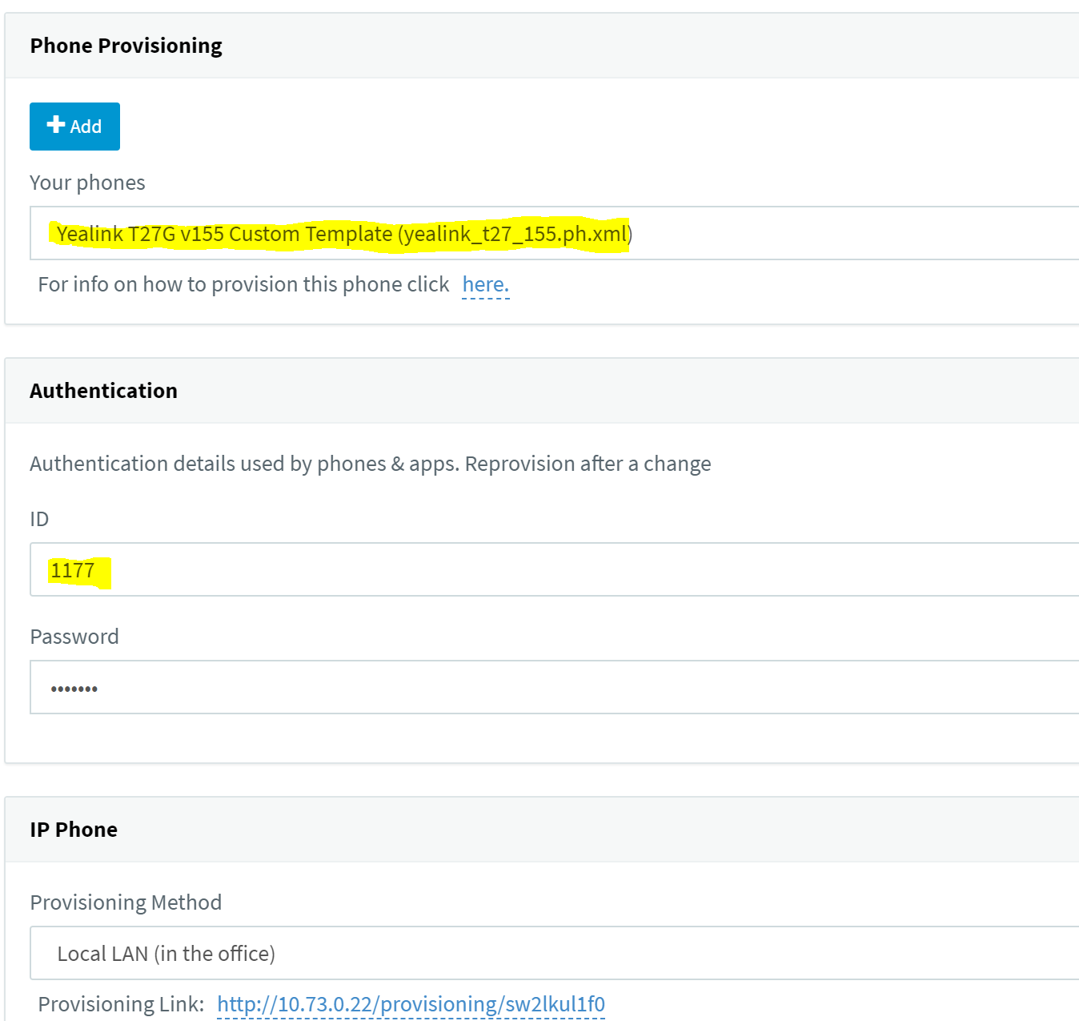
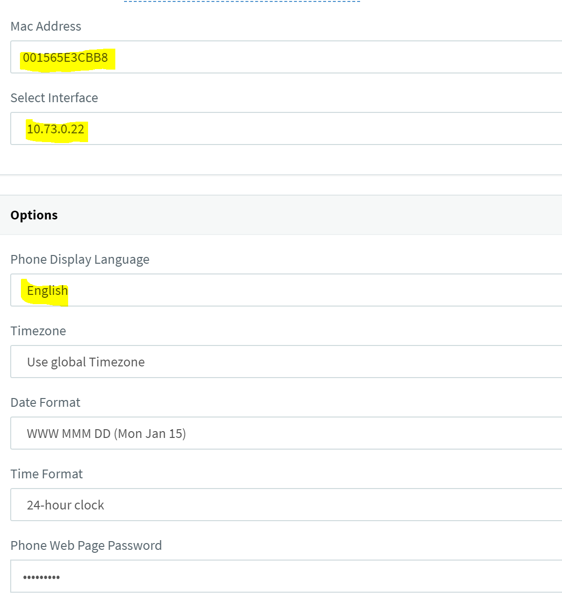
- BLF Tab – Adding Customized Speed Dials
  - 2010 (Human Resources) is in slot 9
  - 2006 (IT Help Desk) is in slot 10

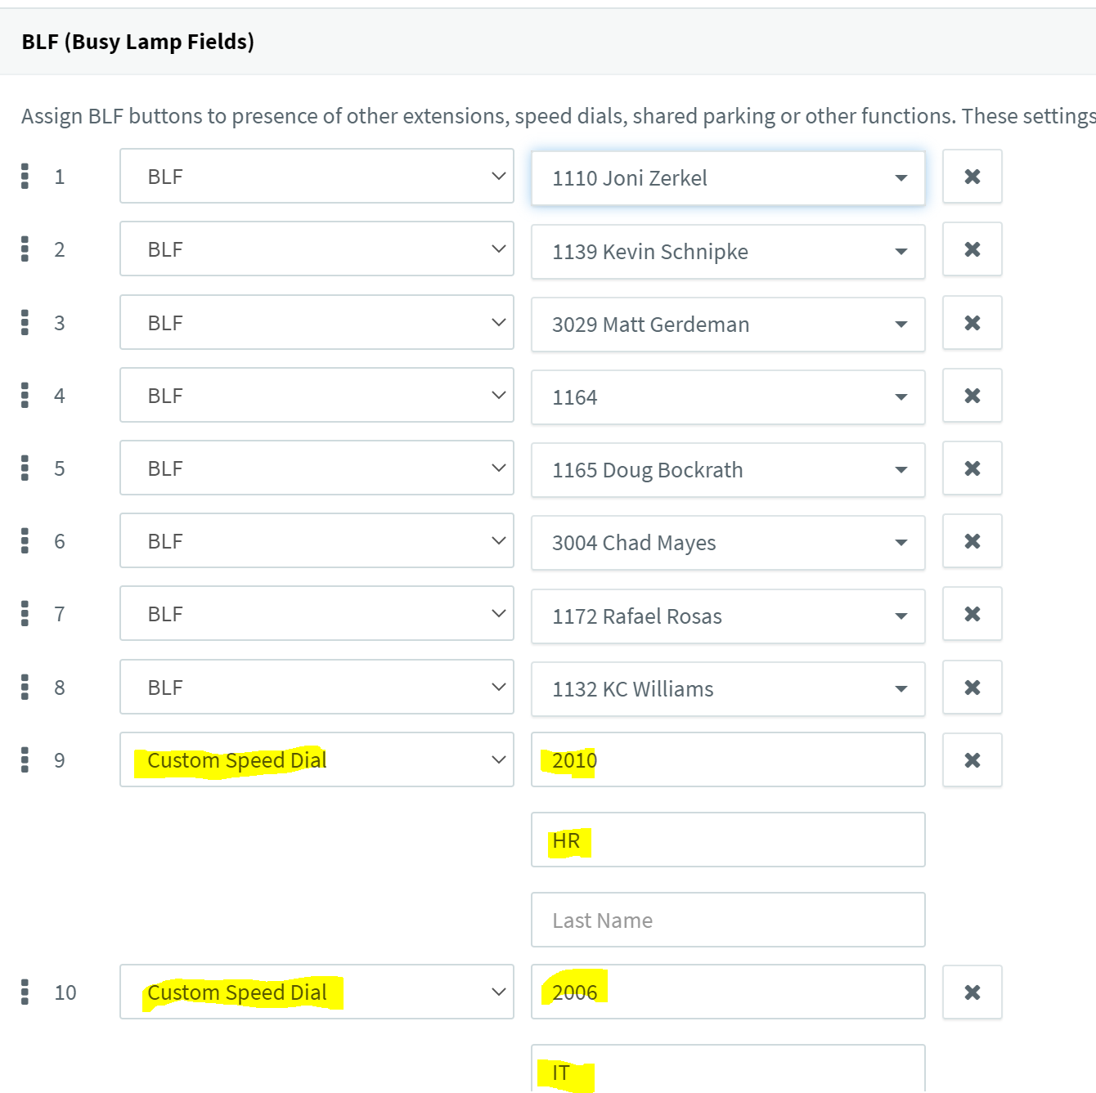
- Rights Tab – Group Membership
  - Go to Groups on the left side of the setup screen.
    - Double click on default
      - Add Members
      - Add the extension number that was created in step 2.
    - Go back to Groups on the left-hand side.
      - Add to department or location they will be working at
        - Example an employee works in HR department.
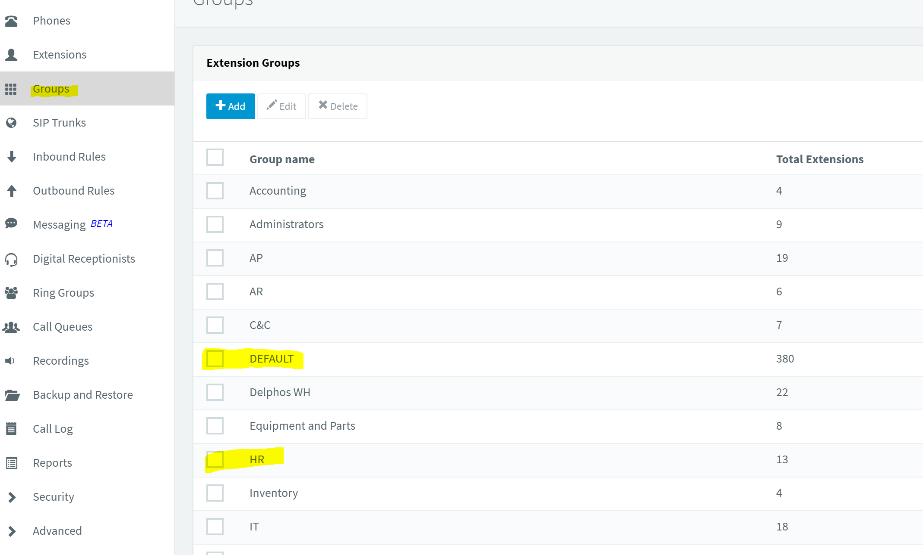

11.4 Finalizing Account Activation
- If at Corporate Office or Delphos Warehouse
  - Plug physical phone into network.
    - This will load all previous configurations that have been setup in steps 1-3
      - The MAC Address entered previously is the identifier.
    - Place phone on user’s desk
- For all K&M Tire locations other than Delphos
  - Login to Phone interface page by going to the IP of the phone.
    - Note for an offsite location at first it will be the DHCP assigned at Corporate when you first plug it in.
      - Login Credentials are in OneNote secure file.
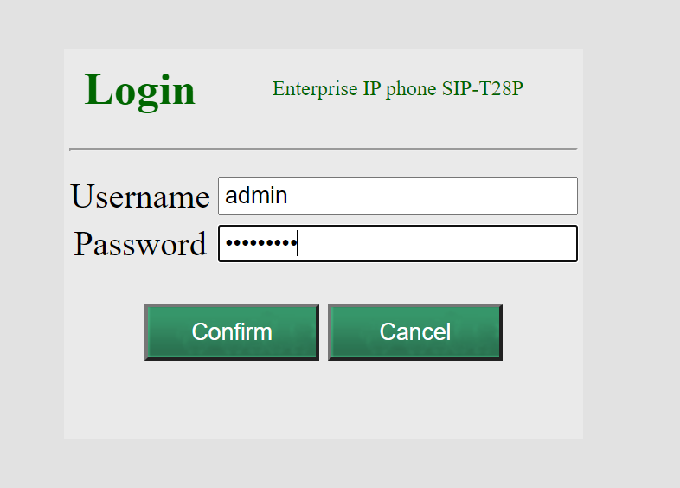
    - Update the SIP Servers LINK
      - Account
        - Label
          - Extension – Name of Employee
        - Display Name
          - Name of Employee
        - Registered Name
          - Extension Number
        - Username
          - Extension Number
        - Password
          - Can be found in OneNote Secure file.
        - Sip Server 1
          - Host: 10.73.0.22
          - Port: 5060
          - Server Expires: 120
        - Sip Server 2
          - Host: 10.73. Loc#.3
          - Port: 5060
          - Port: 5060
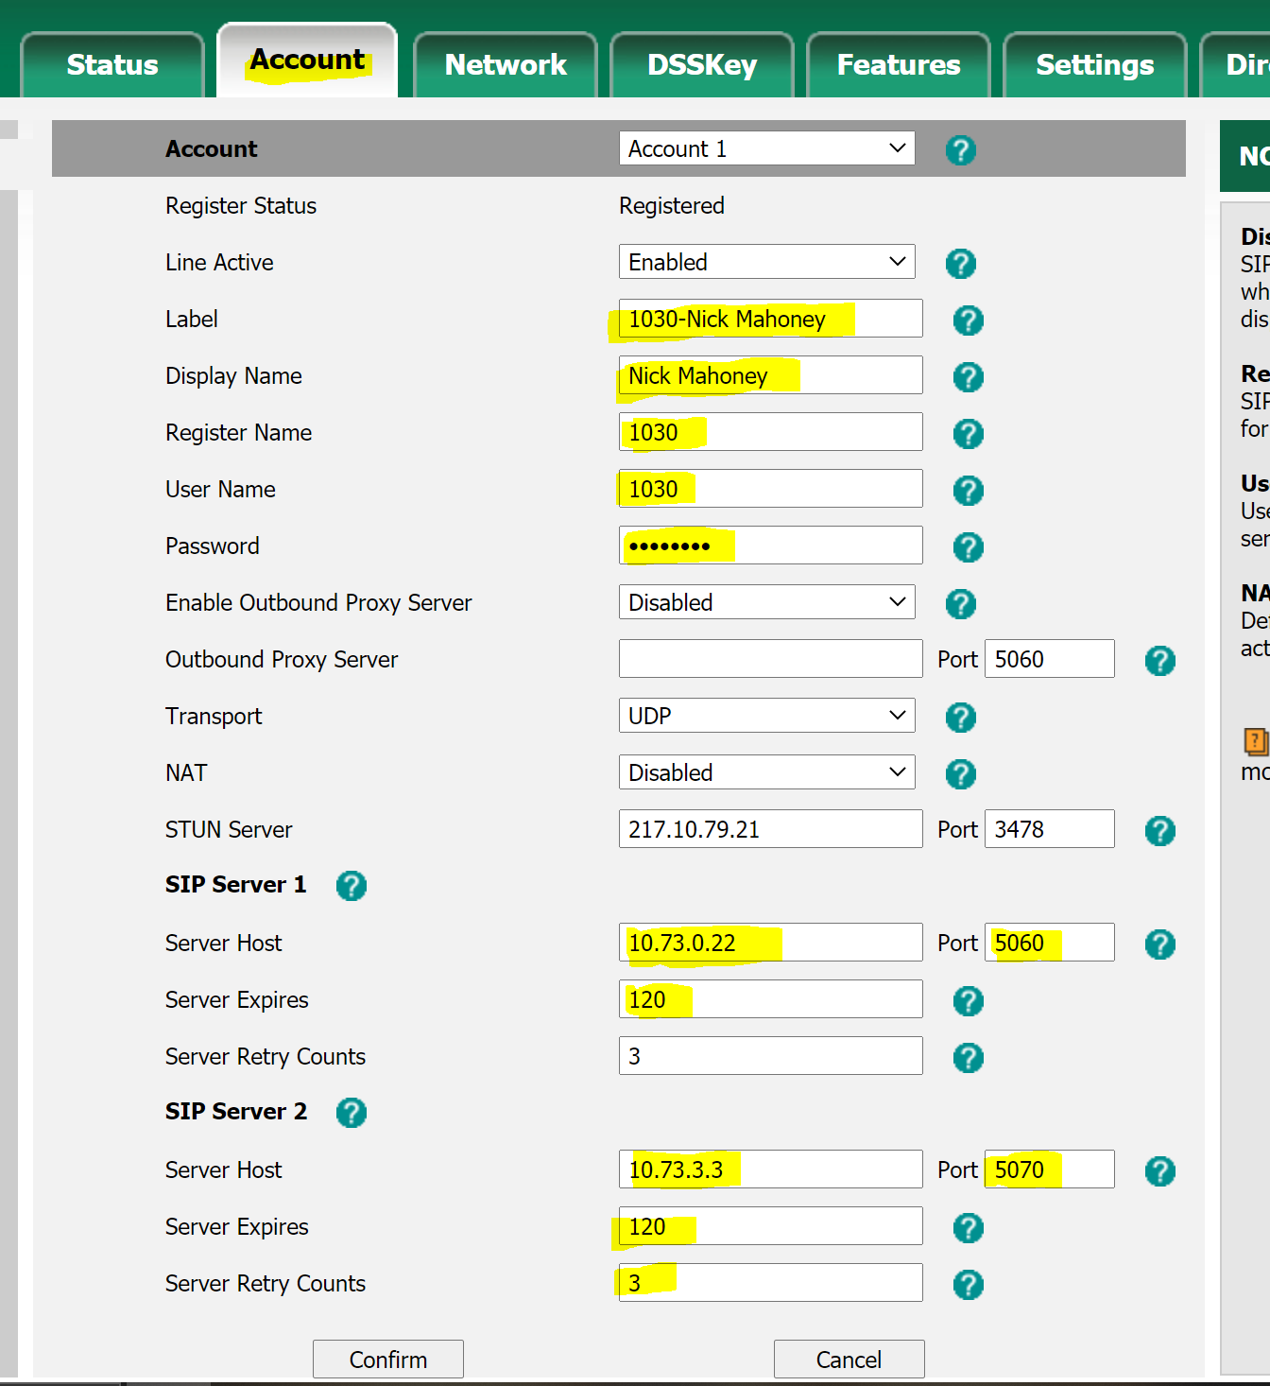

      - Setting up the phone’s static IP
        - Network Tab
          - IPv4 Tab
            - IP Address: 10.73. Loc#.180-205
            - Subnet Mask: 255.255.255.0
            - Gateway: 10.73. Loc#.1
            - DNS1: 10.73.0.14
            - DNS2: 10.73.0.15
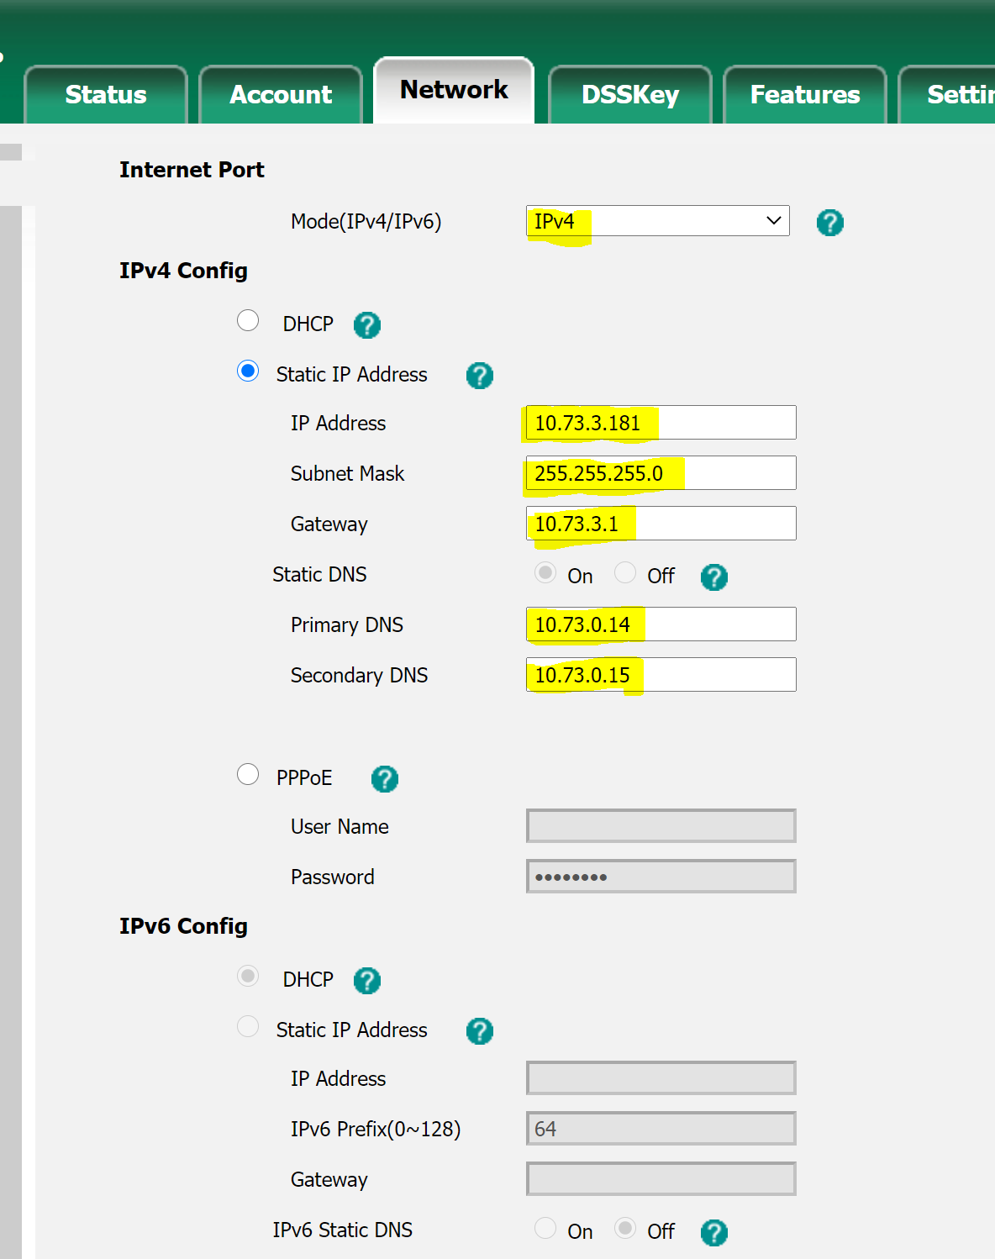

11.5 Testing Phone and Extension
- Once everything is setup, test phone functionality (speaker phone, BLF buttons, Handset (moving phone cord) to test for static/quality issues.
- If testing is successful, send a welcome email right before setting up phone on users’ desk (unless they already have the softphone installed).
- Welcome email is sent from 3cx console where a preexisting template will automatically populate. Screenshot below
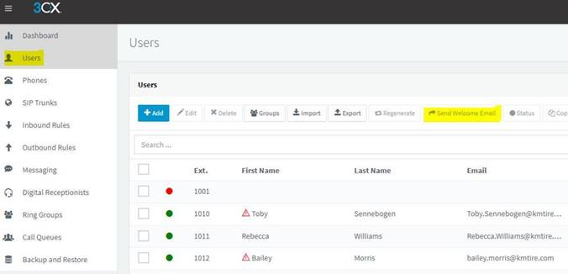
- On the user computer, go Softphone. Check voicemail tab and chat tab and delete any information from the previous user.

11.6 Setting up Inside Sales Phone
- Create IVR (Digital Receptionist) for Away/Out of Office/2
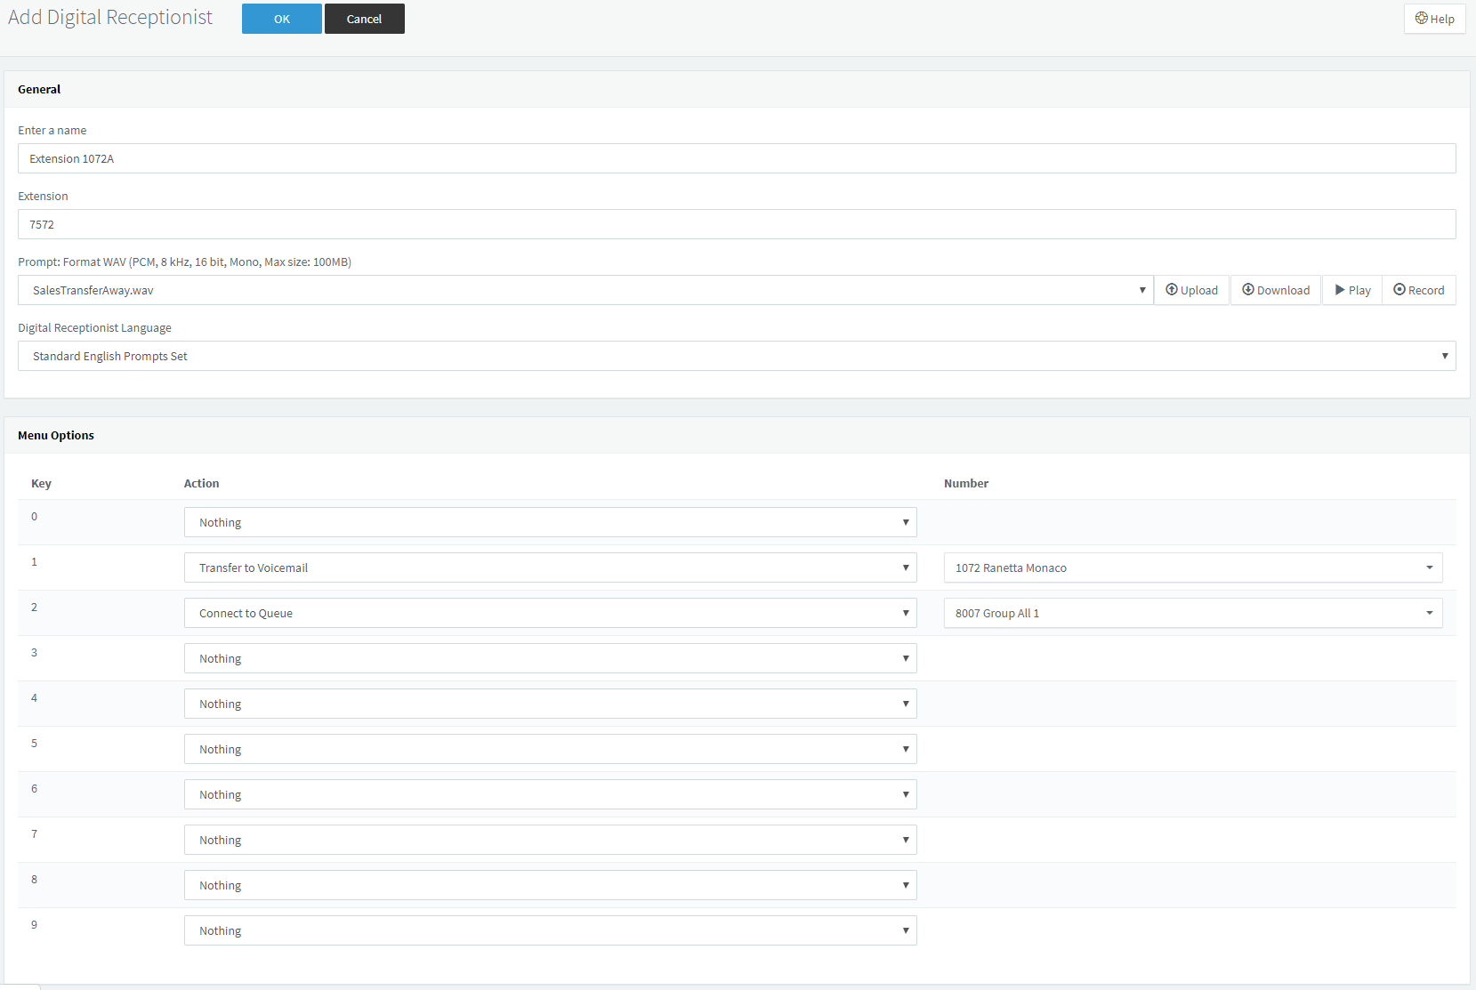
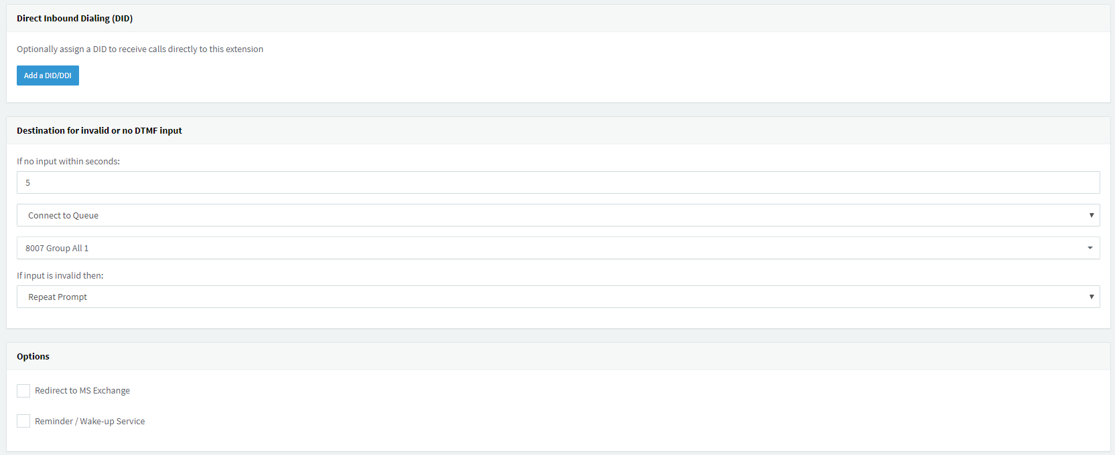

- Create IVR (Digital Receptionist) for Available/2
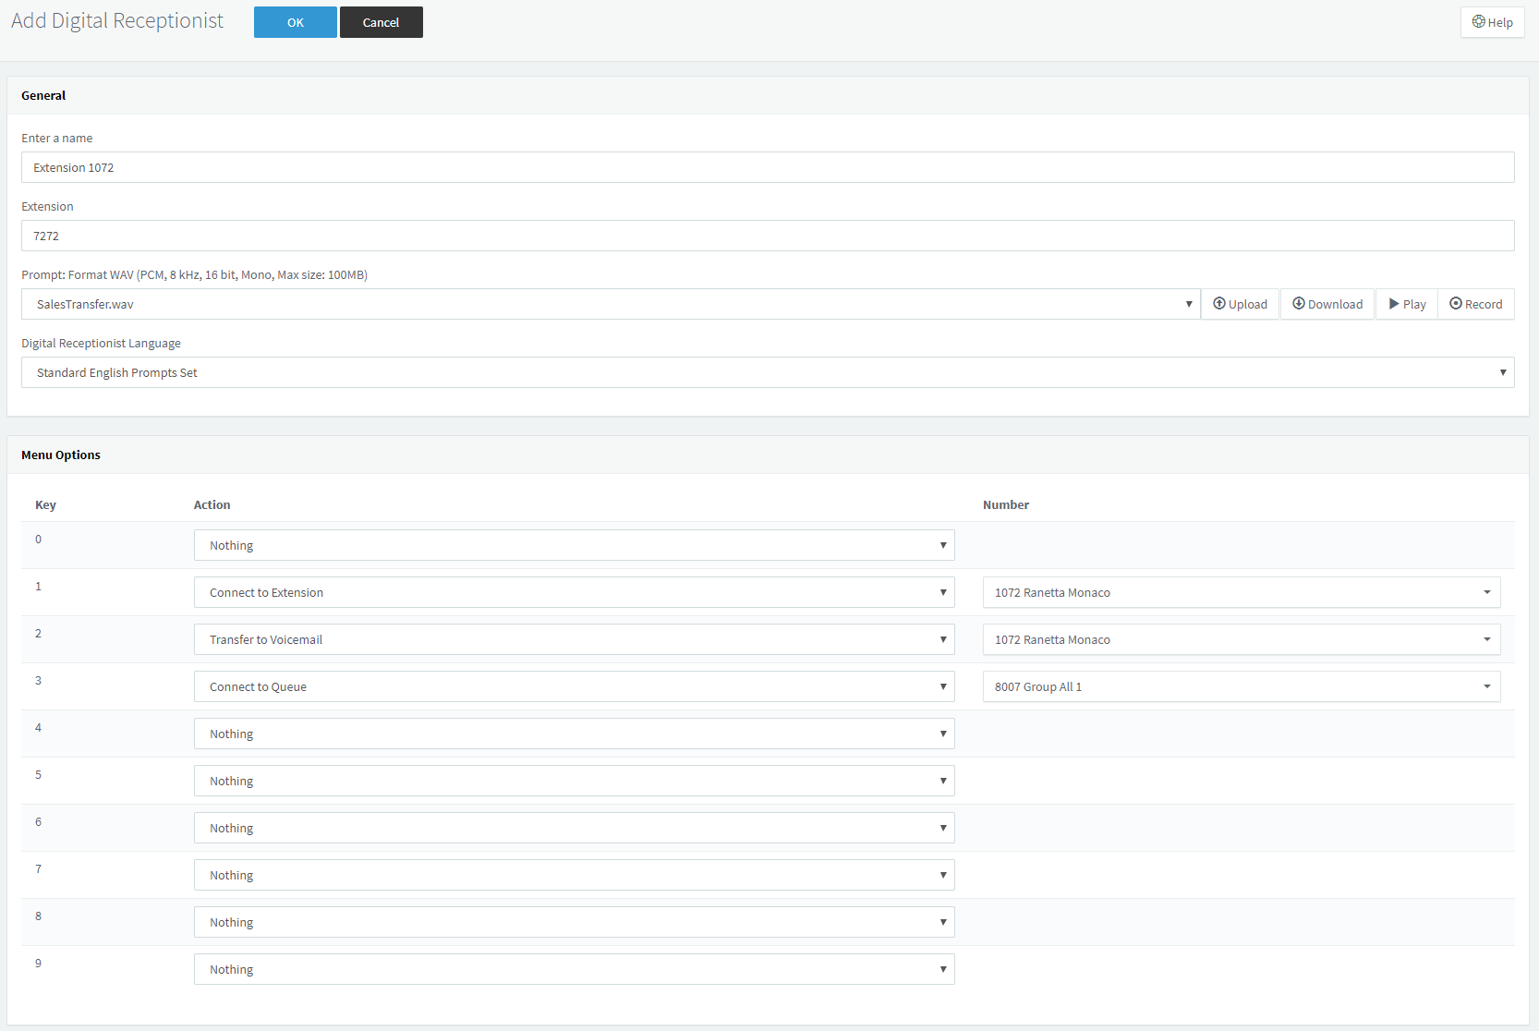

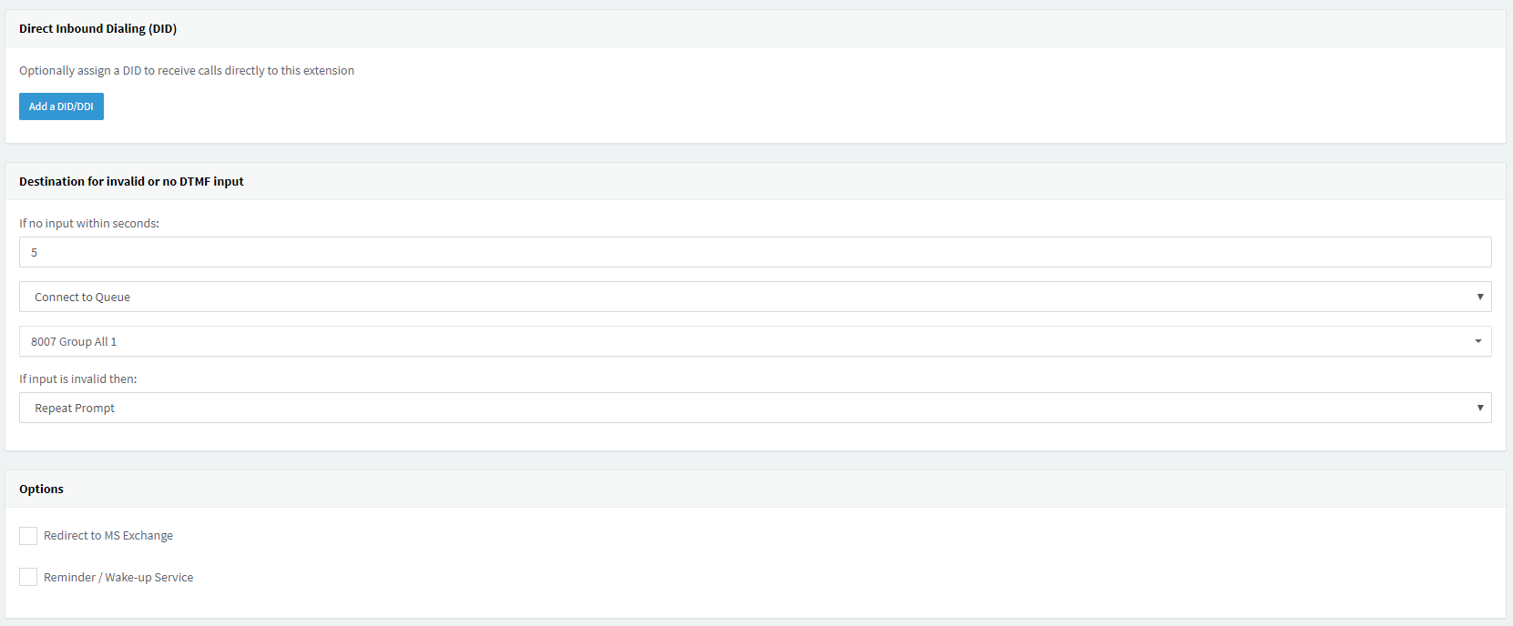
- Setup Extension
  - Setup BLF 1 to log OUT of queue.
  - Setup Call Forwarding Rules
  - Under 3CXPhone tab
    - Check Hide Forwarding Rules
  - Group – Sales

- Away/Out of Office/2
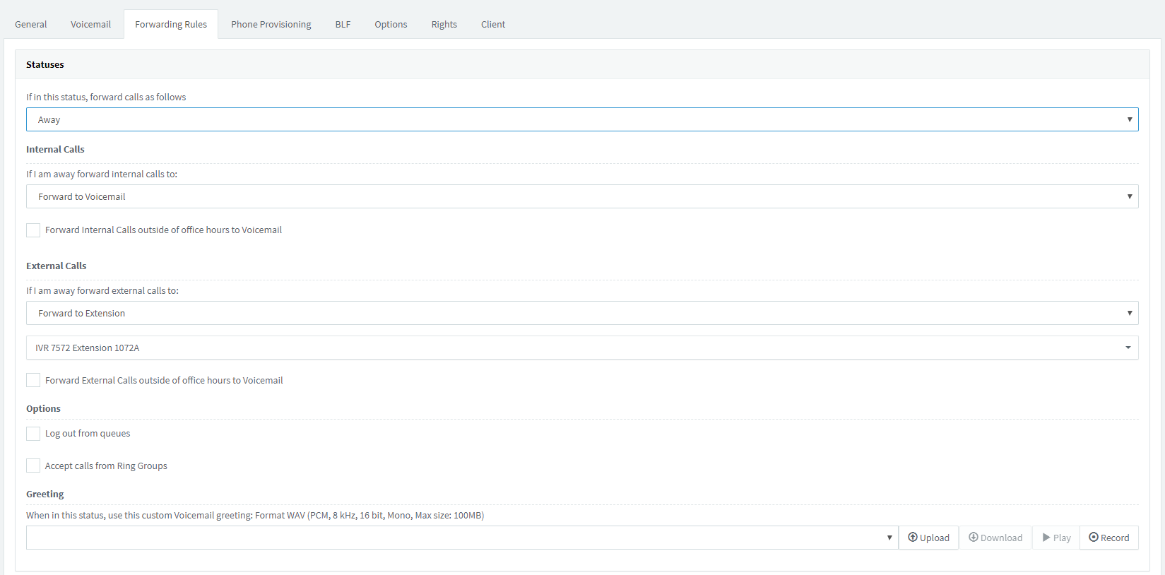

- Available

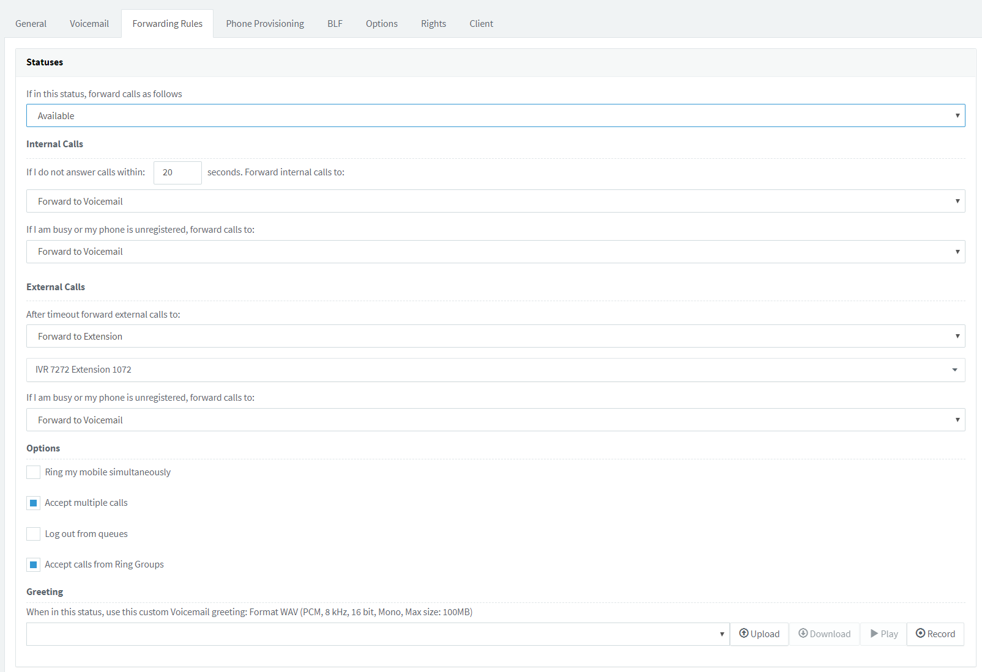
- Create Queue for Extension (add their extension only)
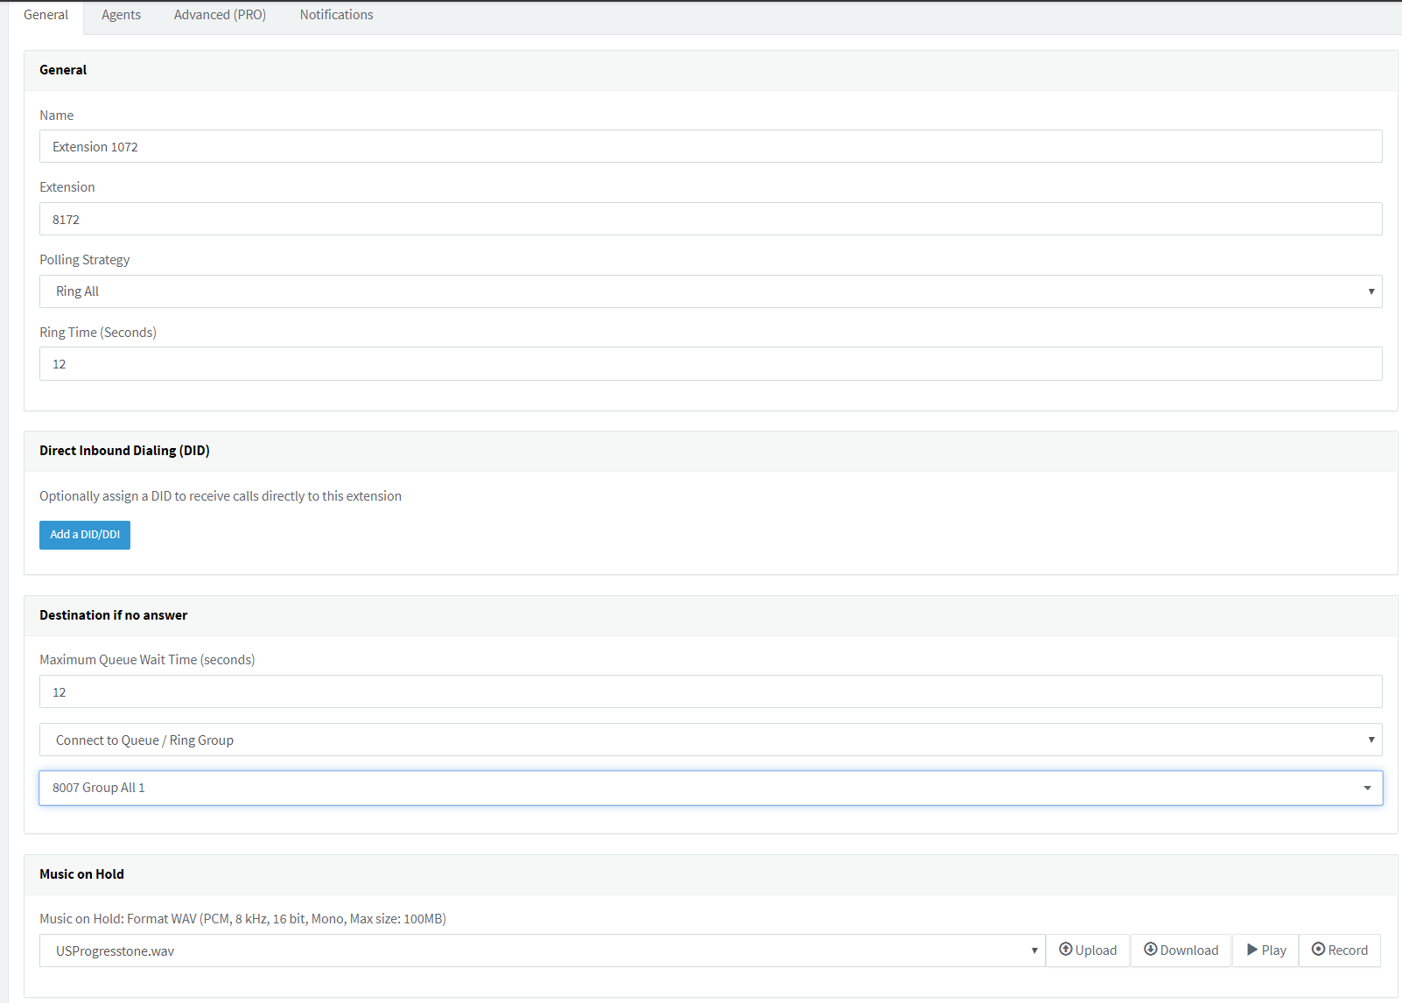
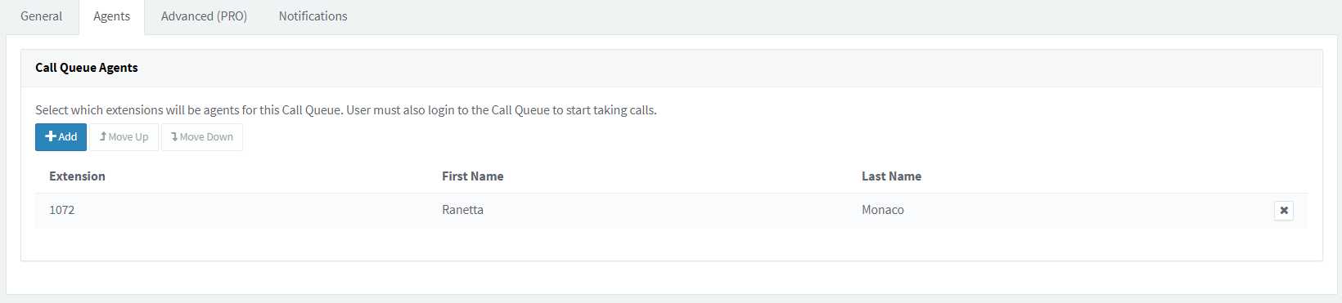
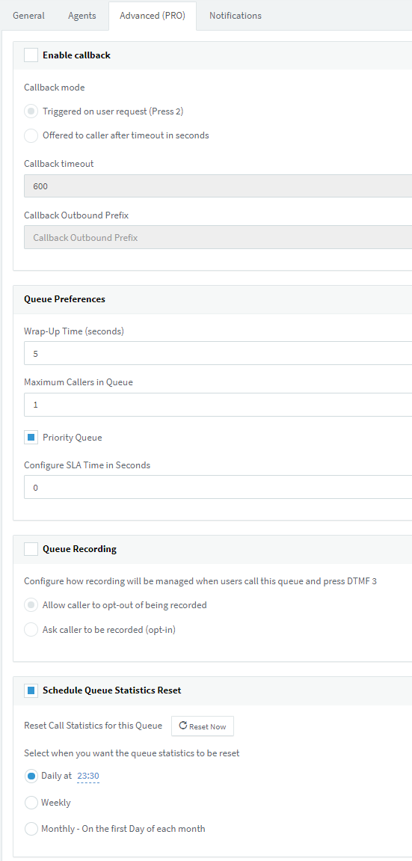
- Confirm with the Inside Sales Manager that employee needs to be in Group All 1 (Queue 8007), if so add them.

11.7 Setting Up Dashboards
- There are currently three dashboards.
  - Sales Dashboard
  - General Dashboard
  - Credits Dashboard
- Under the 3cx Softphone go to: Settings -> Advanced Settings -> Behavior -> External Application
  - Select Launch application on incoming call.
  - Set Path to Executable to the Google Chrome Executable
  - Set Parameters to Send to:
    - Sales Dashboard
      - http://intranet.kmtire.local/dashboard/sales/insideSales.php?phonenumber=%CallerNumber%&incoming=1
    - General Dashboard
      - http://intranet.kmtire.local/dashboard/general/general.php?phonenumber=%CallerNumber%
    - Credits Dashboard
      - http://intranet.kmtire.local/dashboard/credits/credits.php

Adding Access for New Users
Describe the process for identifying, categorizing, and deploying access and devices to new hires.

12.1 Identifying New Hires
- The Help Desk(help@kmtire.com) receives a ticket from HR regarding New Hire.
  - This will appear in ManageEngine as a ticket titled New Hire.
- The ticket will consist of a spreadsheet with employee info included such as first and last name, employee number, last 4 of SSN, branch location, and job title.
  - Depending on the job title will depend on what all is needed to be set up/created.
- From this point you will want to verify with the manager what equipment is going to be needed for the new employee.

12.2 Opening a Project in ManageEngine for New Hire
- The Help Desk will create a Project in ManageEngine with template User Setup
  - You will need to set the Title as “Loc**-New Hire (person’s name)”
  - Project type will be set to new hire.
  - Set the owner to yourself.
  - Scroll to the bottom and add your notes for description. Include location, person’s name, and what all is being set up or gathered.

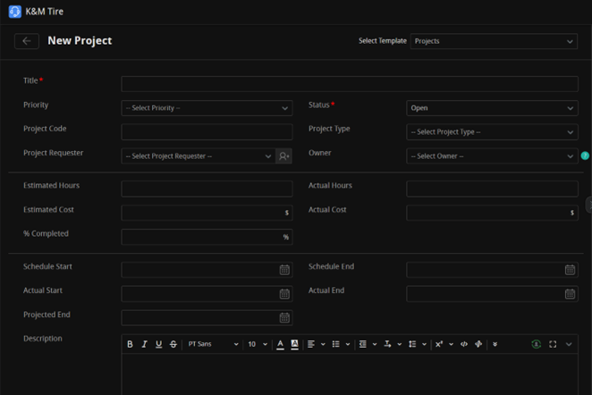

- From this point you will follow through the milestone’s
  - The ones with tasks you will need to click on and then close those tasks before closing the milestone.

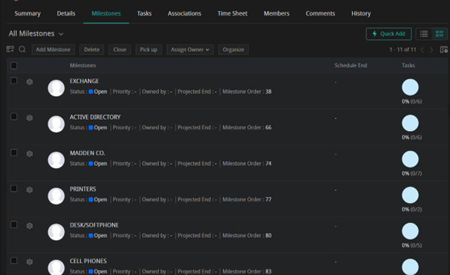

12.3 Purchasing the Devices if not in Storage.
- Verify inventory by counting devices available in storage.
F:\Information Technology\Shared\Inventory\IT Inventory.xlsx

- If something needs to be purchased/out of stock, please follow the Purchasing PC’s and User Devices SOP.

12.4 Creating Active Directory (AD) and Mailbox
Active Directory is a Microsoft Utility that allows enterprise IT environments the ability to manage all Microsoft related user access through a single interface. The following access is granted through AD:
- Exchange – Email Account
- Network Access – Ability to join network and VPN.
- Network Storage – The F: Drive
- Domain Access – The ability to access systems used by K&M including.
  - This is also used to be able to login to PC.
- WISE Access
  - Unless access to additional locations is requested, access will be for location that user is being hired into
- You are going to go exchange2.kmtire.com and sign in with ADM access.
- You will then go to Recipients and then Mailboxes.

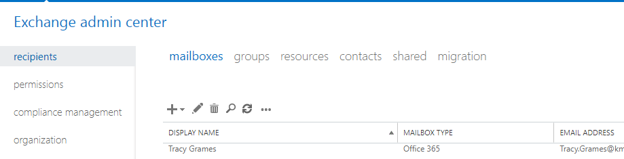

- From here you will click on the + and then select Office 365 Mailbox.

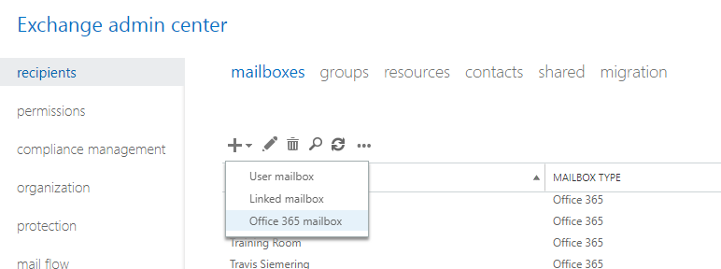

- This will open a window, and you will fill out the new employee’s information. Organization Unit will be the OU they fall under. User logon will be the firstname,lastname and you will switch from @kmtire.com.

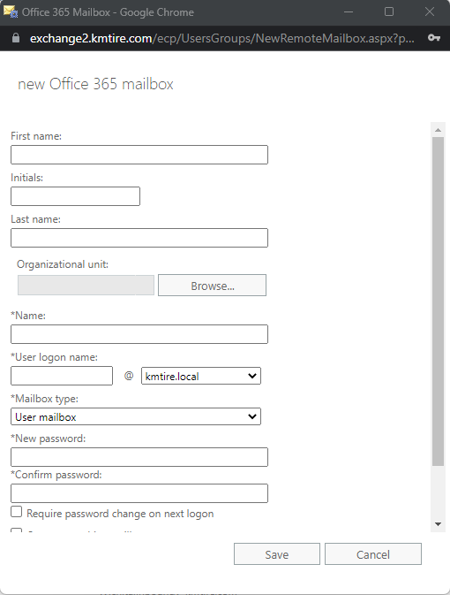
Note: This will create the user in the Active Directory for you. You can make sure they are in the proper OU at this point. This will take about 15-30 minutes to show up for licensing.

- From here you can look up the new hire in Microsoft 365 Admin Center by going to admin.microsoft.com

- You will then select Users on the left and then Active Users
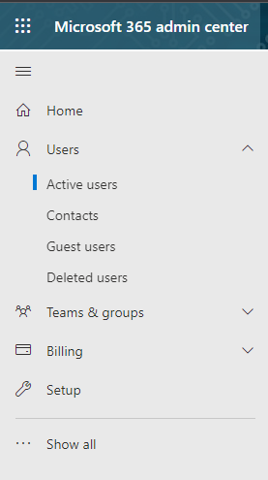

- Then you will search for the new account and click on it. From this point you can click on Licenses and Apps to license the account pending on their department/position.
  - To determine what type of license someone should get, check either the person you are copying, or check with someone with a similar job title.

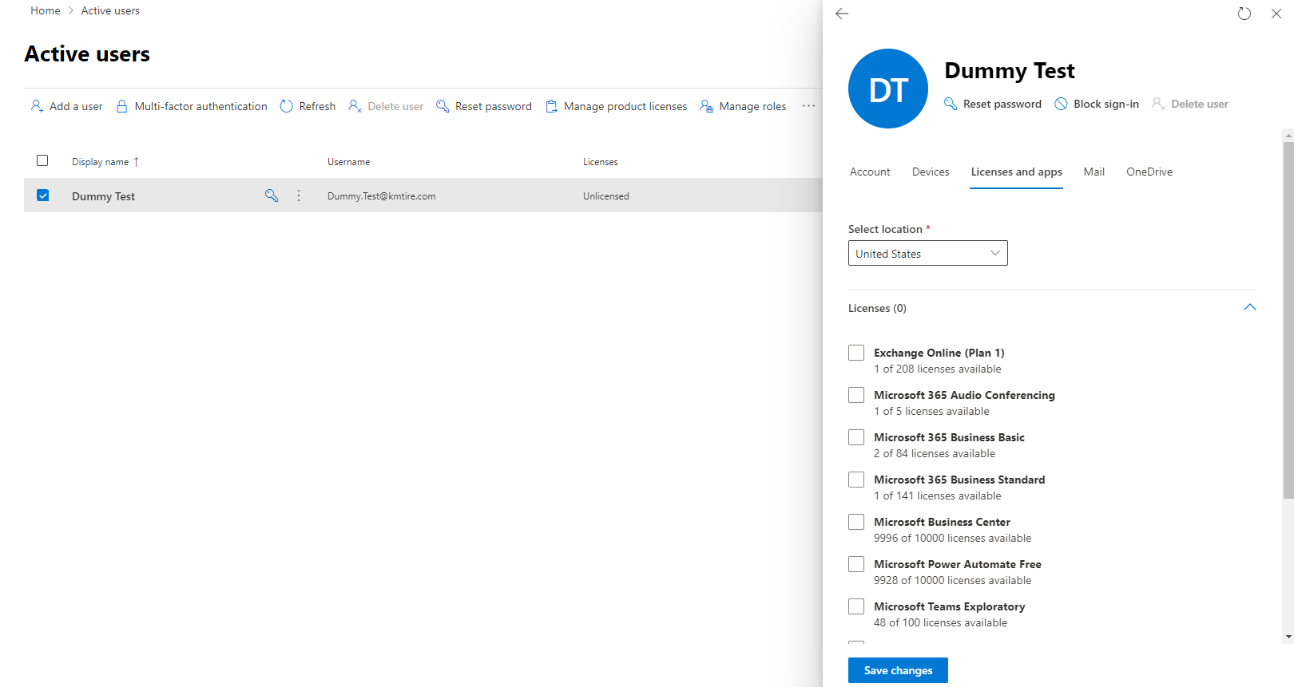

12.5 Creating user in MaddenCo sessions
- Create MaddenCo User
  - Login with System I User
  - Type WRKUSRPRF *ALL
  - Use hiring manager suggested profile to copy.
    - A copy of the profile should be emailed to the hiring manager for review and approval, prior to set up.
    - If no suggested profile, escalate to Help Desk Supervisor.
  - Put a 3(Copy) on selected profile.
  - Press Enter
  - Enter the Username (AD username- ALL CAPS) of new account.
    - Use the AD Username that was set up in Step 4 but in all Caps.
  - Update the Description (Location – Full Name)
  - Press Enter
  - Press F5 to refresh the list of users.
  - Make sure the new account is there.
    - If not there, repeat all steps in Step 5
- Add a Workstation
Create MaddenCo Workstation
    - Sign Into System I User
    - Type WRKDEVD
    - Press Enter
    - Put a 3 on the workstation to copy from hiring manager suggested profile.
    - Press Enter
    - Enter the new Workstation in the Device Description field.
    - Format:
      - WLZZSXXXX - Outside Sales - ZZ=Location # / XXXX=Salesman Number
      - WLZZEXXXX - Everyone Else - ZZ=Location # / XXXX=Extension Number
    - Enter the user's name, it is for in the Text 'Description.’
    - Press Enter

- Control Keys
Create MaddenCo User Control Keys
- Sign into MaddenCo User
        - Option 1
        - Option 6
        - Option 1
- Shift-F10
- Enter the username suggested by hiring manager to copy from in the Show Only User/Workstation field.
- Put a 3 on the line next to all needed keys based on a recommendation from hiring manager.
- Press Enter
- Change the username field to the username that was created Step 5-A
- Double check the control keys for the new user to ensure they have the access intended.
- Add MaddenCo Access (Copy to and from)
- If copying from a current user open the Intranet program called “IT - MaddenCo Access” under the IT section on Intranet.
- Put in the Username that access will be copied from in the “From User” field and the username of the person with new access to setup under the “To User”
        - In this case copying from Bryan Benner to Nick Schroeder.
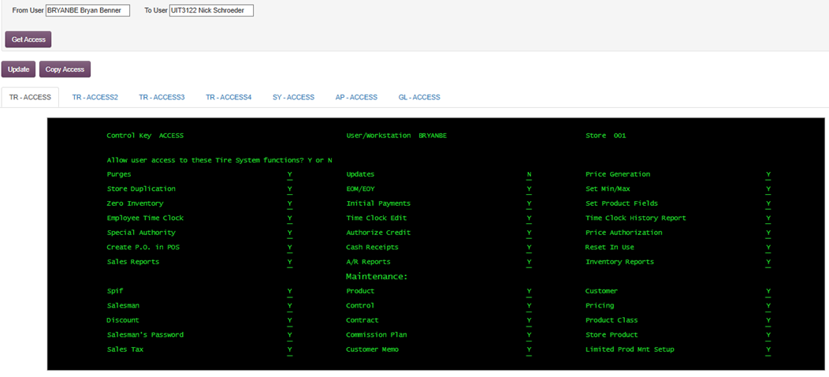
- After you click “Get Access” it will populate with all MaddenCo access fields.
- To complete the process, click the “Copy Access” button.
- You will then see a message that user access has been copied as shown below.
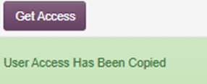

- Setting up Access in MaddenCo Directly
  - If you are not copying access, you can set up permissions directly in MaddenCo.
  - To do this you will login to MaddenCo.
    - Option 20 - System Menu
    - Open 1 – System Control File Maint
    - Start at “Access”
    - Find the username to Edit
    - Type 2 to edit and enter
    - Add Y or N to permissions to provide or deny access
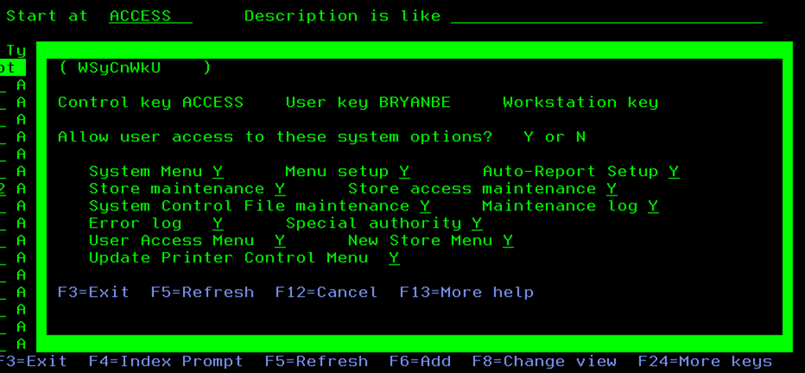
- Store Access
  - Add MaddenCo Store Access
    - Sign into Madden Co User
      - Option 20
      - Option 3
      - Option 2
    - Use hiring manager suggested profile to copy.
      - If no suggested profile; escalate to Help Desk Supervisor
    - Make a list of stores for AP, GL, PY, TR as needed.
      - AP – New hires working in Accounting Department
      - GL – New hires working in Accounting Department
      - PY – Very Limited. Requires special request from VP of Finance for access.
        - Controller, Accountants
      - TR – Everyone receives this.
    - F6 (Add Store Access)
    - Type username getting added in Workstation/User field.
    - Type the needed store number, region, and data type.
    - Press Enter
      - Repeat for each store entry needed.
  - To install this on a computer you will need to install this from P:/Approved Applications/AS400
    - Open IMBI Access V1r1

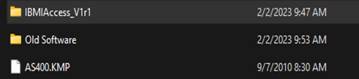

    - Choose Java Installer and this will be updated as new versions are released and approved by Information Security. Be sure to keep your install driver updated as well.

    - Then go back and go to Windows¬_ Applications.

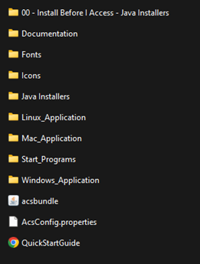

    - From here you will click on install¬_ acs _ 64_ all users.

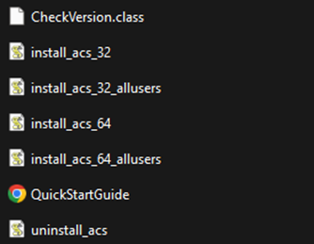

      - You will then hit YES on every prompt.

    - Once this is installed you will click on New Session

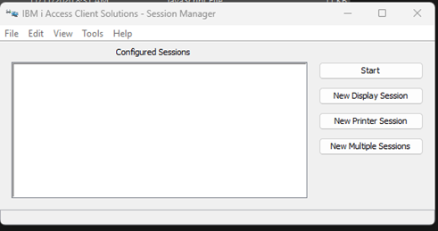

    - You will then get a window with several options. You will fill the Session Name with their session name given to them. (Example: WL**E****or WL**S***). Then the destination IP is 10.73.0.10 and Workstation ID is the Session Name.

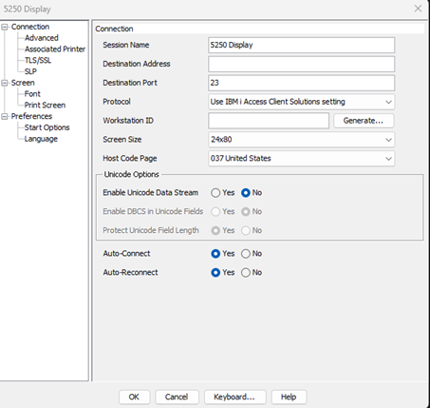

    - At the top left click Advanced and then change Password Prompting to the third option of Use default username to prompt once for each system.

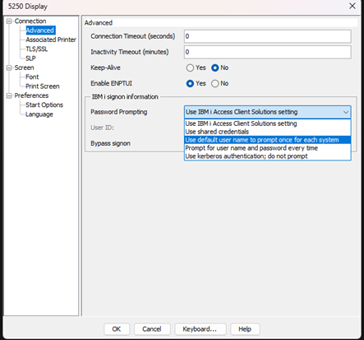

    - Then you will put in their User ID you set up when setting up users (All caps, first name and last initial) and then select Bypass Sign on to YES.

12.6 WISE User Setup
- WISE Access
  - At all WISE locations-All Warehouse users expect Route Driver to get access to the WISE servers.
- Warehouse New Hire Completes paperwork on the first day.
- HR sends paperwork, including social security number and employee number to IT.
- IT uses the social security number and employee number to create password and username.
- Manage trains new hire on logging into the WISE system.

- Adding users to WISE
- Remote Desktop into WISE Location Server
    - Example: WMS43:55200
- Follow the below path.
    - Tools
    - System Administration
    - User Maintenance

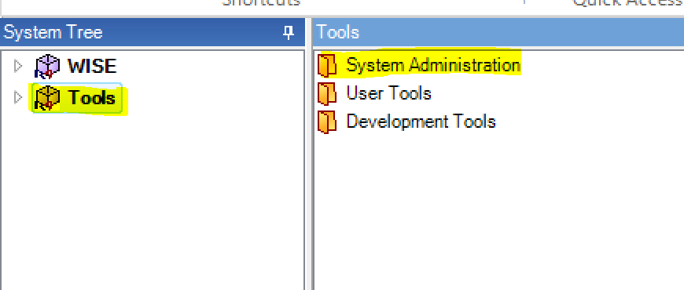

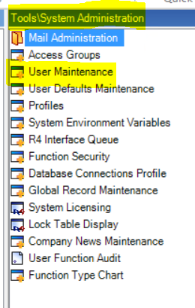

- Select Add
- User ID- Use Employee Number
- Comes with New Hire Paperwork emailed from HR.
- Password- Last 4 of social security number
- Comes with New Hire Paperwork emailed from HR.
- Name- User’s Name
- Start Module-WMS5
- Developer -Uncheck the box.
- Select Save
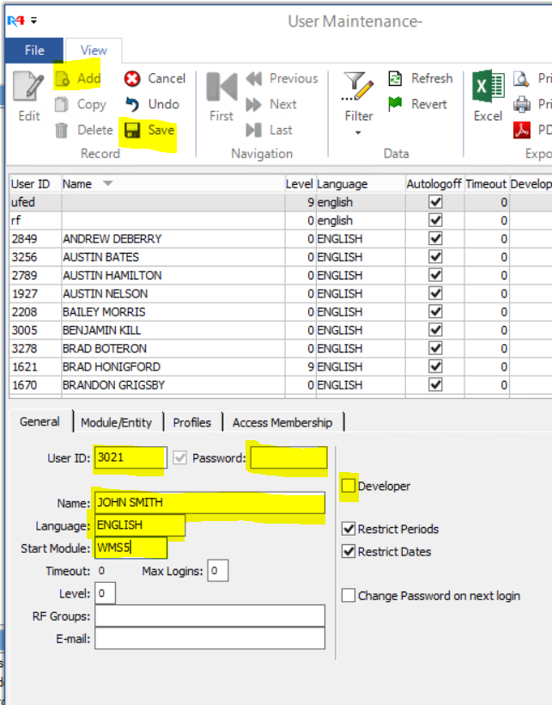

- Giving Permission in WISE
  - Follow the path below to provide user permissions.
    - WISE
    - Maintenance
    - Warehouse Map
    - Areas
      - Add all outbound areas.

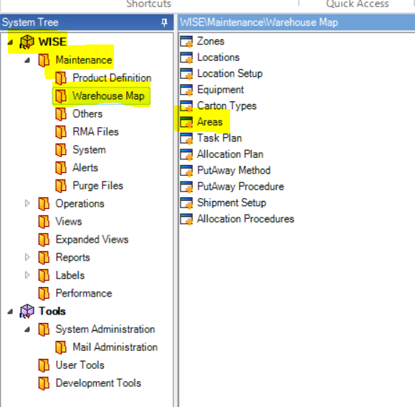

12.7 Adding Other Access
- 3CX Setup for New Users –
  - Office New Hires
  - Warehouse Leadership New Hires
  - Inside Sales New Hires
- Cell Phone Setup for New Users
  - Outside Sales
  - Warehouse Managers
  - New Routes
- Install Microsoft Office
  - Office 2016 and 2019 along with Exchange Online will be given to all Warehouse Employees
  - Office 2016 and 2019, along with Microsoft 365 Business Basics will be given to Outside sales representatives, Inside Sales and NAB
  - Microsoft 365 Business Standard will be given to all other Corporate Users, Regional Sales Managers and Management.
- Set up Email.
- Set up Printers.
- Change Google to default search engine.
- Create user folders on the F: Drive
  - Users to get folders.
    - All Corporate Users
    - Warehouse Managers
    - RSM
    - ROM
  - Access to all folders
    - System
    - The person’s whose folder that it belongs to
    - CEO
    - Domain Admins
    - ADM Accounts
    - Supervisor or Manager of the Person
- Create MaddenCo workstation on desktop, if applicable
- ManageEngine
  - A Project is created from ticket in Step 2. Tickets will be closed when the Project is complete.
- Set up Multifactor Authentication the day after the person starts so they can set up the method to receive the code or approval.

12.8 Communicating New Users Access and Training
- An email is sent to the Hiring Manager and New Hire for the following with all the logon information needed. You can find a document created for this at
F:\Information Technology\Shared\Josh's IT Notes\Documentation

- The document is titled Employee Login Info.

Job Transfer
This will be a run down of how to handle Job Transfers.

Job Transfer Steps
- Create a new project for a job transfer and name it “Job Transfer – Location # - Name” with the actual location number and name of person in the transfer.
- In the Project click on the “Associations” tab and then click “Attach” to find the ticket request that was put in for the job transfer.
  - Once you find the open ticket request check the box and click Associate.
  - This will connect the ticket request with the project to complete the job transfer.
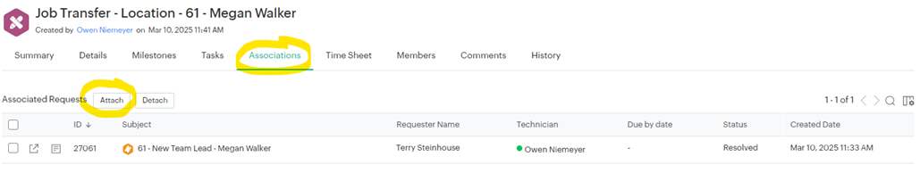
- Route Driver to Warehouse Employee:
- For this change you typically will only be adding them to WISE.
- Route Driver/Warehouse Employee to Team Lead, Assistant Manager, Warehouse Manager, etc.:
- This person is not going to have an account set up and will be set up as a new hire. Create a new hire project and follow these steps.
- Employee transferring from one department to another when they already have email and MaddenCo access:
- Document the current permissions and accesses. Take screenshots of all accesses and permissions for Madden Co, Intranet, and AD. Use the Word doc in F:\Information Technology\Shared\Procedures\Help Desk\Setup and add it to the Attachments at the bottom of the Job Transfers Project.
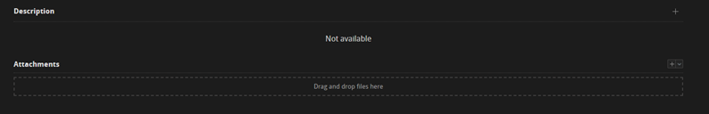
- Find out who a current employee is that the manager would like to have the permissions copied from.
- Set the user up with all permissions and access they need changed. This would include Madden Co, Intranet, Email (groups and shared mailboxes).
- Find out and set the user up with the devices needed. Things to ask about are desktops or a laptop, cell phone, desk phone, etc.
- Keep the ticket with the old and new permissions/access On Hold for 30 days. Also create a reminder to your personal calendar to remove the old access.
- Corporate employees transferring to Team Lead or Manager within a Department and have email and MaddenCo access:
- Document the current permissions and accesses. Take screenshots of all accesses and permissions for Madden Co, Intranet, and AD. Use the Word doc in F:\Information Technology\Shared\Procedures\Help Desk\Setup and add it to the Attachments at the bottom of the Job Transfers Project.
- If applicable, find the replaced employee in the team lead or manager role that has or has access set up that may be needed for the new transfer employee.
    - If no replaced employee to copy from send list of access to transfer employee new manager or supervisor for review and approval of accesses.
    - If there is no reference, go off current role-based access grids for base access.
- Role Access Grid can be found below and if needs edited the password to modify is ITADMIN.
- Once permissions are approved by the transfer manager, set the user up with all permissions and access they need changed. This would include Madden Co, Intranet, Email (groups and shared mailboxes).
- Find out if any device changes are needed for the new position. Things to ask about are desktops or a laptop, cell phone, desk phone, etc.
- Keep the ticket with the old and new permissions/access On Hold for 30 days.
- Communicate to the transfer manager and transfer employee of the change completion as well as the time that old permission/access document will be stored.
- Also create a reminder to your personal calendar to remove the old access.

Termination
When IT receives termination paperwork, create a project within ManageEngine to document the progress of the termination. Be sure to check with the reporting Manager/Supervisor to be sure they do not need email or cell phone number forwarded for 30 days.

14.1 Termination Steps
- Exchange
    - Forward email/cellphone to appropriate person
    - Hide email address from address book
    - Remove any special access
    - Disable active sync
    - Copy/move any local archiving
    - Remove mailbox
    - Remove email addresses from any group emails or distribution lists
- Active Directory
    - Change user password to randomly generated and document it
    - Remove all Members of Access
    - Remove user from Security group
    - Move user to disabled users OU
    - Delete AD user if no email forwarding is needed
- Active Directory
    - Remove control keys from user – Including AP & GL if an office employee
    - Remove from group access
    - Remove store access
    - Remove user (Make sure to talk to the Manager before to be sure there are no reports being ran under the user)
    - Remove salesman number
    - Move commission code to replacement salesperson (Be sure to check with the manager and/or Jon Schadl before moving)
        - If there is no replacement, leave alone until a new person is hired or VP of Sales requests a change.
    - For Sales staff, check if they have a void code and remove the void code if present
    - Remove Madden Co sessions
    - Remove User
- Printers
    - Corporate Konica – Remove user from user box and address book
    - Warehouse Printer/Scanner – Remove from address book
- Desk phone/Soft phone
    - Move extension to usable extension group
    - Remove extension from queue’s
    - Remove from ring groups
    - Remove name to Available and rename email for extension
    - Remove from scheduled reports
- Cell Phones
    - Update documentation 3cx/phonebook
    - Update signature capture device maintenance for Warehouse Managers ONLY
    - Forward number to requested number
- Intranet
    - Intranet 1: disable user/delete user – Must talk to Jon Schadl before deleting Outside Sales Reps
    - Intranet 2: disable user/delete user – Must talk to Jon Schadl before deleting Outside Sales Reps
    - Update IT – Location Data
- Device Returned
    - Computer/Laptop returned
    - Cellphone returned

- Make sure device and user are removed from Sophos
- Remove device from FixMeIT

- Remove or move user folder on F: drive – If moving the folder, you will move it to the Managers user folder and email the manager as well as department head once the move is complete
- Make sure to have another technician look through your Termination and Termination checklist
  - Please see the Termination Checklist below:

Packing of Items

15.1 Single Items in a box
- Make sure the item or items are securely packaged in the original packaging.
    - If the original packaging is not available, find a box that is close to the same size but will allow for packing materials in the box so we can secure the items in the box.
- Make an invoice for the box per the instructions in Section 15. Creating an Invoice for Shipping and Item.

15.2 Items in a tote
- A packing list will be added to each tote for all items in that tote.
    - One copy of the packing list will be the tote.
    - One copy of the packing list will be saved on the file server under the following folders: F:\Information Technology\Shared\Locations.
    - Packing list can be found here:
F:\Information Technology\Shared\Locations\Location Packing list\Packing list.xlsx

Creating an Invoice for shipping an Item

16.1 Madden Co Creating an Invoice
- Log into Madden Co and follow the steps below to make an invoice.
  - 1. Tire Dealer System
  - 7. Warehouse Order Entry Menu
  - 1. Order Entry
  - Enter Store Number 001
  - Enter Customer Number.
  - You will use the stock number for each location.
    - These can be found in Madden Co if you are not sure what they are.
  - F6
  - F6 then enter (this will get you an invoice number)
  - Put in your Salesman number and field exit.
  - Enter
  - Type Box on the first Line (This is for the I/T shipments)
  - Enter
  - Type the number of boxes to be shipped and hit field exit.
  - Enter
  - F3
  - Put an M to the invoice line to add a message.
    - On all invoices now for the message line, we need to spell out what is in the box or tote:
      - Example: 3 desk phones,3 computers,2 monitors,2 VGA cords, 5 network cords, Router, switch, snom….
        - For a tote, you will need to add as many Message lines to the order as it takes to list out all items that are in that tote.
  - Enter
  - F3
  - Then we can print out the invoice and put on our box
  - Put an S on the line to ship the items.
  - Enter
  - F3
  - Enter
  - Enter
  - F5
- Make a copy of the invoice to put on the box or tote as well as a copy that we need to hand to the Warehouse Manager or Assistant Warehouse Manager.
  - This copy will go along with all paper copies from location so they can release the order as soon as it is received at the correct location.
  - When items are ready to be shipped the ticket requesting the items is resolved.

Documenting Tickets
Document Tickets in ManageEngine

17.1 Objective: Documenting Support Calls and Work in ManageEngine via the creation of tickets
- IT Support Calls
- Programming Support Calls
- New Hires Requests
- New API Requests
- OE Requests
- New Device Purchase Request

17.2 All Support
- Step One: Initial Contact from User
  - Email Help@kmtire.com which puts in a ticket into the ManageEngine
  - Email to anyone in IT or Development
  - In person request
  - Call to Help Desk (2006)
  - Call to anyone in IT or Development
    - Best practice is to email Help@kmtire.com or call 2006 for high priority problems and email help@kmtire.com for lower priority issues.
    - All tickets must be entered into ManageEngine immediately upon contact being made.
      - This is critical to get a true view of what’s going on and if there is something bigger happening with the IT Infrastructure
- Step Two: Creating a Support Ticket in ManageEngine
  - Emailing Help@kmtire.com will automatically put a ticket into the system.
    - This is the preferred way for a ticket to be entered.
    - Open https://support.kmtire.com/home
      - user has their own credentials for logging in
  - Go to K&M Tire
    - Click on “Request” along the left side of the page.
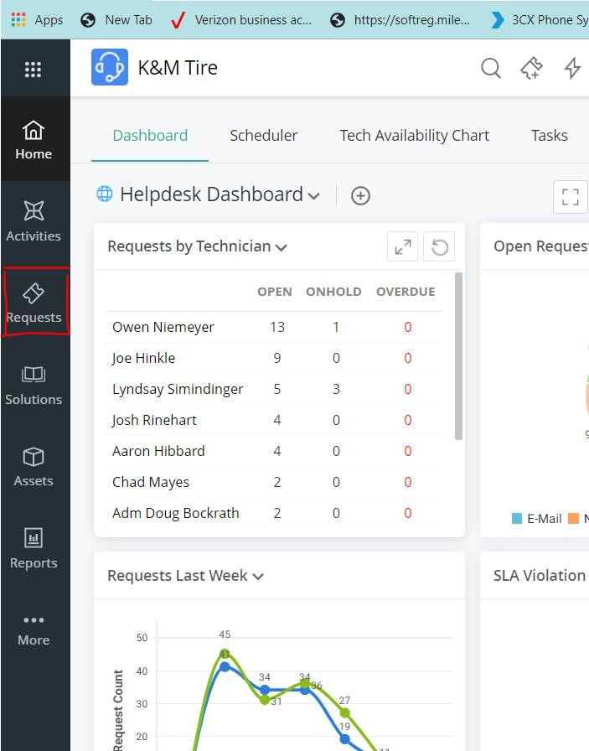

  - Click on “New Incident”
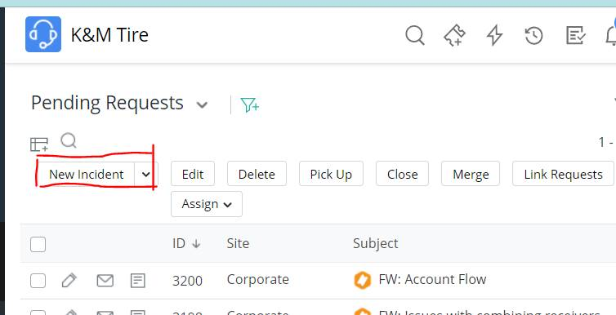
    - Fill in the following information:
      - Request Type – tells of the ticket is an incident or problem, request for information or service request.
      - Impact – how it impacts the company.
      - Request name – Person submitting ticket.
        - Auto fills in Asset.
      - Group – what department will be working on the ticket.
      - Technician – The IT User that is working on the problem.
      - Category – what area of the department it effects
        - Subcategory:
      - Subject – Describes the ticket.
      - Description – gives the details of the tickets.
    - Click Add Request
- Step Three: Updating the Ticket
  - Any actions taken to resolve the issue need to be documented in ManageEngine under the ticket created in step 2. The following steps will show how to update the ticket while simultaneously updating the user.
    - Click on the ticket you are updating.
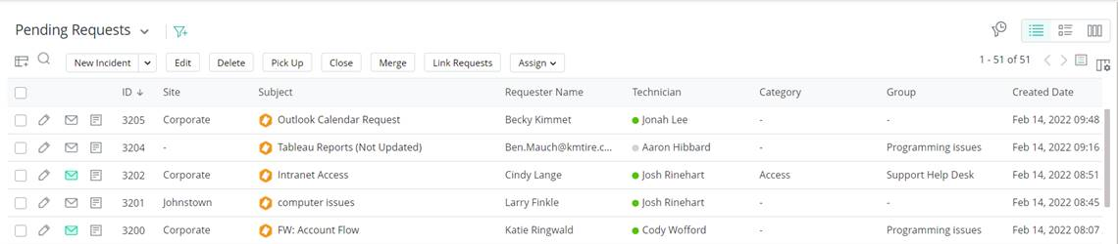
    - You can reply to the ticket and email back for additional information or to give them a solution by clicking on “email Requester.”
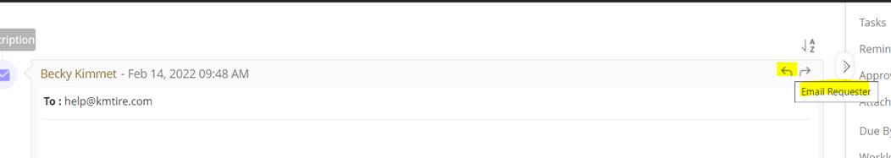
    - Enter a note.
      - Enter all updates into the Note.
      - The select for who you are sending the update out to defaults to IT only.
After entering the note select “Save”
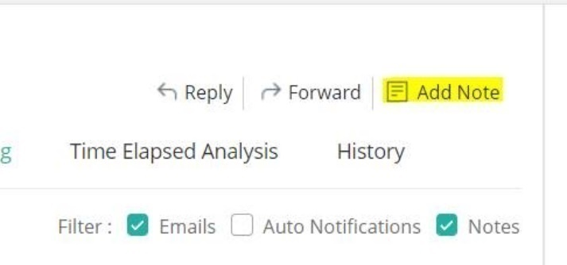
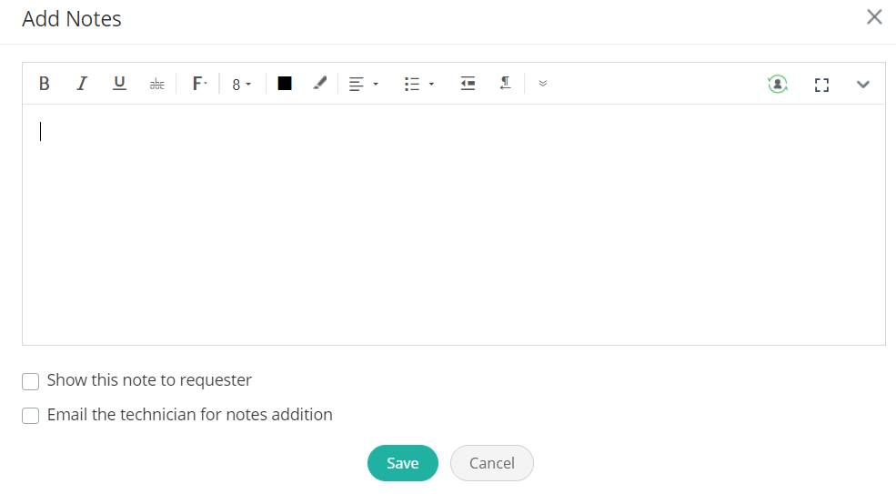
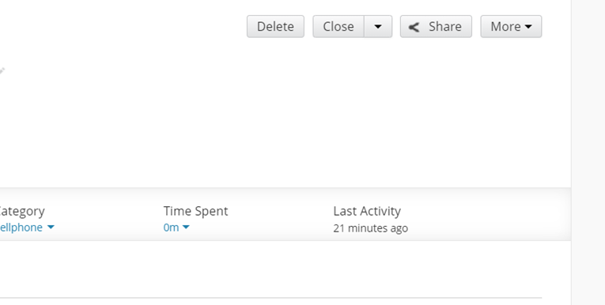
- Step Four: Closing the ticket.
  - To close the ticket, go to Status and change to ‘Resolved.’
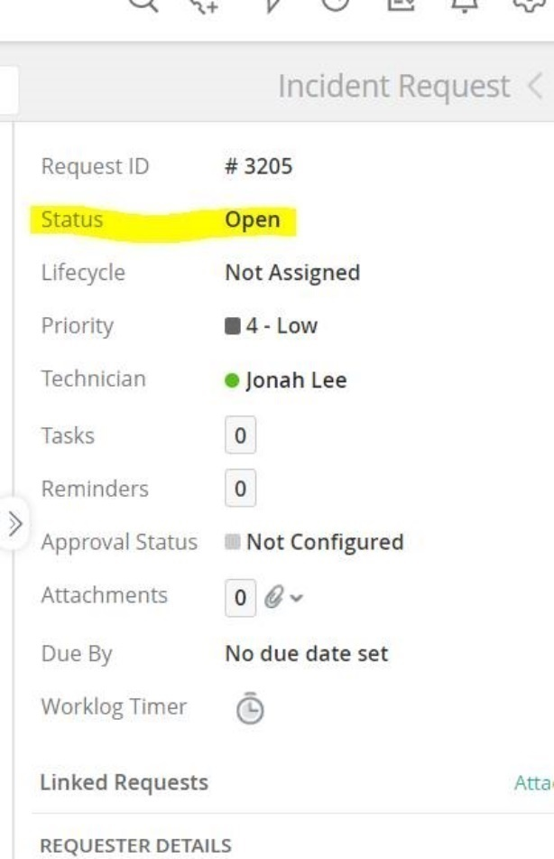

Intranet Down

18.1 Objective: Documenting Support Calls and Work in ManageEngine via the creation of tickets – These steps are followed by the Development Team.
- Step 1
  - Use command line to take action WRKACTJOB.
  - Press F8
  - Type MSGW in the String field and *STS in the column field
  - Press Enter
  - Check to see if XTOOLKIT is in MSGW status.
    - You may have to press F8 multiple times.
    - If you reach String Not Found, then have reached the end of the line.
  - If there is a MSGW on ToolKit, use C to clear it.
  - If not or clearing the error does not bring things back up, proceed to Step 2
- Step 2
  - Use command line to take action WRKACTWEB ZENDPHP7
  - Check those jobs for any with a status in CNDW that does not change after refreshing the screen a few times.
    - Clear any jobs stuck by using option 4, prompting with F4 and changing *CNTRLD to *IMMED.
    - It will take several minutes for them to end.
  - Check to see if things are back up.
    - If not, proceed to Step 3
- Step 3
  - Restart Zend Server
  - Use command line to take action GO ZENDPHP7/ZSVMENU
  - Take the menu option to end Zend Server
    - Check under WRKACTWEB ZENDPHP7 to verify all instances have ended.
      - If not, force to end them.
  - Take the menu option to start Zend Server
  - Check to see if things are back up.

IT Internal Project Requests, Project changes, and Approval

Project Proposal/Change Process
Stage Gate #1 – Idea Discovery
- Department VP, manager or employee sees an opportunity to improve or add a process.
  - The idea is to be vetted with the appropriate VP or Director.
- Define the opportunity we are trying to improve, add or replace.
- Brainstorm the idea with IT leadership to ensure IT capabilities.
Stage Gate #2 – Initiation & Scoping
- Appropriate department personnel to research and analyze what this change will do to improve K&M Tire and estimated ROI.
  - The Project Request Form should be completed with help of Development Management located here: F:\Information Technology\Public\IT Project Documents\IT Development\Project Request Form CURRENT VERSION v1.docx
    - Project Request - Approval(s) (Separate Tab) (Large/Medium)
    - Change Request (Separate Tab) (L/M)
    - ROI Calculation (Separate Tab) (L/M)
    - ROI Data (Separate Tab) (L/M)
    - Testing (Separate Tab) (L/M)
    - Issue Log (Separate Tab) (L/M)
    - Communications Log (Separate Tab) (L/M)
    - Medium/Large Process (Separate Tab) (L/M)
    - Statement of Completion (Separate Tab) (L/M)
- Present the idea with appropriate ELT member for approval to proceed.
  - Must sign off on Project Request Form to proceed.
Stage Gate #3 – Planning
- Appropriate ELT member or VP of IT to present the idea to the President.
- After approval of the President, the VP supporting the project, will provide the Development Director with the proper approval documentation.
  - Steps 4 – 6 may require multiple loops till final approval
Stage Gate #4 – Development
- Development Manager to assign and schedule work.
Stage Gate #5 – Launch & Closure
- Development leadership to update the Dev Open Projects weekly with status updates on all active projects. Task list to be shared with the President weekly.
- Project Updates with Stakeholders, Subject Matter Experts (SME’s), ELT – per communication plan.
- Project validation (testing) to be completed as scoped
- Project Training to be completed as scoped
- Implementation/Roll out to be completed as scoped
- Closure Meeting
  - Closure Statement(s)
  - Lessons Learned
  - Approver Signoff

Large Project Request (Entire Company/Multiple Departments) (120 hrs.+)

After completing the steps laid out in section 10.1 for Project Proposal/Change Process and the project has been approved, the following steps need to be followed for a project of this size.

- 1-2 weeks prior to Development Start Date
  - Formal Kickoff Meeting
- Roundtable review of the project.
- Timeframes reviewed.
- Process review.
- Dev Team, Stakeholders, SME (Subject Matter Expert)
  - Testing discussions
- What testing needs to be done by the Dev Team? Stakeholders?
- Establish testing processes and expectations.
- Dev Manager, Stakeholders
  - Training discussion
    - Is formal training needed?
    - What training needs to be done?
    - Who needs to be trained?
    - When will training need to happen?
    - Stakeholders to work on training plan.
    - Stakeholders, Training Department
- During Project Development
  - Incremental project reviews (25/50/75/100)
- Where are we in the process?
- Questions or concerns can be addressed.
- Dev Team, Stakeholders
- Dev/SME testing as available

- End of Development
  - Project review
- Review of the project.
- Questions or concerns to be addressed prior to testing.
- Dev Team, Stakeholders, SME
- Project End-User testing
  - Test team meets to perform testing, validate project
  - Dev Team, Stakeholders
  - Training Implementation
- Training plan Implemented – set completion date.
- Project Closeout
  - Project closeout meeting
- What went well? What can we improve? How close were we to timelines? Did the project scope change from what was initially approved?
- Dev Team, Stakeholders, SME

Small Project Request (Single Department) (<40)
After completing the steps laid out in section 10.1 for Project Proposal/Change Process and the project has been approved, the following steps need to be followed for a project of this size.
Small Project Approval (Tickets/Request turned into Small Projects)
  - Dev Manager to review with Dev Director and VP of IT for approval of work to be started
  - If approved, then a Testing, Roll Out, Communication plan will all need to be discussed and produced before development work is performed
  - To be place on schedule ONLY after approvals of VP of IT and Dept. ELT member
  - Small Projects scheduled, in process and completed, are to be listed in monthly communication with a description of the request for development.

- 1-2 weeks prior to Development Start Date
  - Developer will communicate with project owner / SME
    - Review of the project.
    - Review hours estimated to complete and tentative completion date.
  - Testing discussions
    - What testing is needed
    - Establish testing processes and expectations.
  - Training discussion
    - Is formal training needed?
    - What training needs to be done?
- During Project Development
  - Weekly project communication, Q&A
    - Where are we in the process?
    - Questions or concerns can be addressed.
- End of Development
  - Project review
    - Discuss Dev Testing results
    - Validate the project meet expectations.
  - Project USER testing
    - End User Testing to project meets expectations
  - Training Implementation
    - If training was required, complete training
- Project Closeout
  - Project closeout meeting (Dev Team, SME)
    - What went well? What can we improve? How close were we to timelines? Did the project scope change from what was initially approved?

Project Request from Detail
Dev Project Documentation:
- Documentation location
F:\Information Technology\Public\IT Project Documents\IT Development\Project Request Forms

- Project Request Form (Large/Medium)
Project Request - Approval(s) (Separate Tab) (L/M)
- Project Name – What’s being done
- Project Number – comes from Dev Team
- Requested By - Sponsor/SME
- Contact – SME(s)
- Date – Date of request
- Description of Request/Change- This is usually multiple lines.
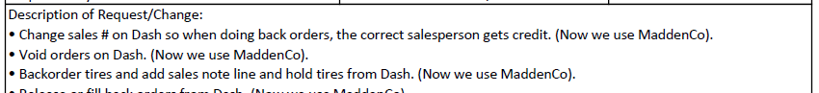
- Goal for the Project/Change: List the reason and benefits for this project.

- Priority (chose1-5) based on the descriptions on the form.
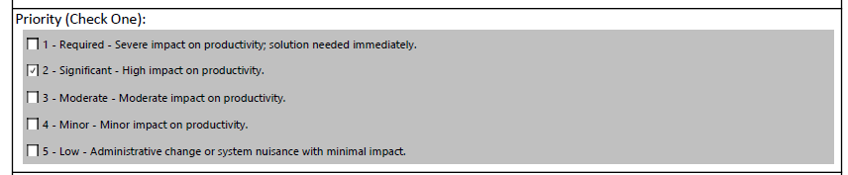
- List Streamlined Efficiencies
- SOP Change-Yes/No
- Additional Comments- If needed
- Approvals- ELT Sponsor and President
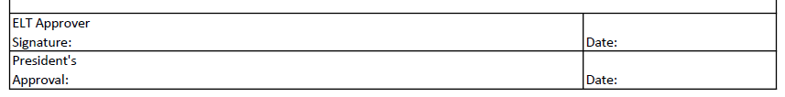
- Change Request (Separate Tab) (L/M)
  - What CHANGE is being requested?
  - How will affect the current project?
  - Any additional information needed?
  - Approvals-ELT and President
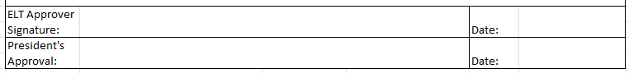

- ROI Calculation (Separate Tab) (L/M)
  - Max/Min estimations- You need to fill out both sections
- They repeat, but focus on your two estimates of savings
- All calculations are required for BOTH sections (left/right sides)
  - Developments estimated hours for doing this project
- This estimate of hours will be filled in by the Development team
  - Estimated Time saved per day (by minutes)
  - Estimated Time saved per day (by hour)
- You only need to use one (min vs hours), both are NOT required
  - All formulas exist, time for Minutes (below) will come from the ROI-Data Tab
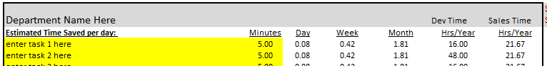
  - Total Hours Saved-For all items in the task list.
  - Estimated ROI- Showing the project savings for doing this project.
  - Assumptions- Explain rationale for task listed, if not obvious

- ROI Data (Separate Tab) (L/M)
  - Task 1 – associated to task 1 on ROI Calc tab
- This number is linked to complete the calculations
  - Dev Column is the estimated time (hours) for this task
  - Max/Min – for your estimated time saved in minutes
  - Priority – is for Dev team, items may need completed in a specific order to complete the project.
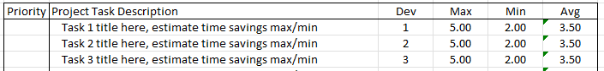

- Testing (Separate Tab) (L/M)
  - List task to validate work completed
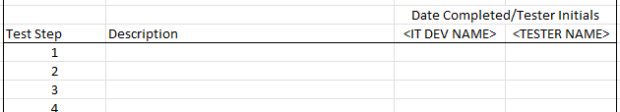

- Issue Log (Separate Tab) (L/M)
  - As issues arise, they should be tracked and updated
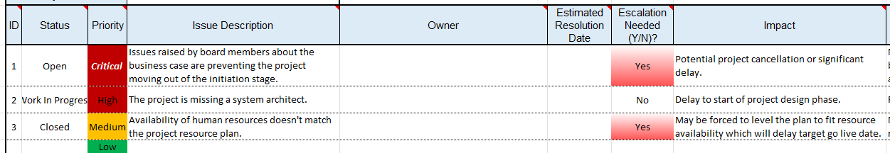

- Communications Log (Separate Tab) (L/M)
  - Log the project update meeting, follow the matrix on the sheet
  - Team Update - Weekly
- Email list for those needing this update
- Sent by / Date sent
  - ELT/Stakeholders Update – Monthly
- Email list for those needing this update
- Sent by / Date sent
  - Status of the project
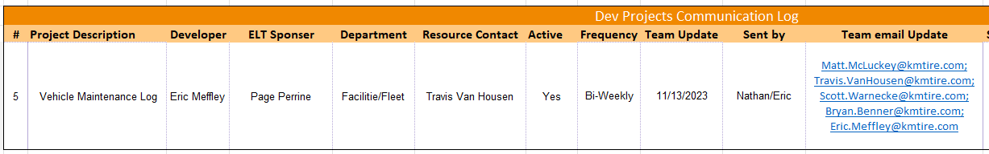

- Medium/Large Process (Separate Tab) (L/M)
  - Project progression sheet for recording milestone accomplishments
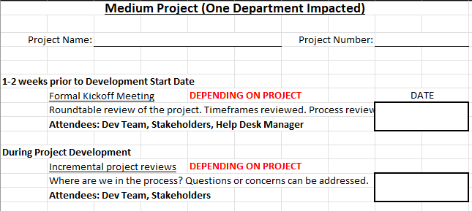

- Statement of Completion (Separate Tab) (L/M)
  - Fillable form – Project completion
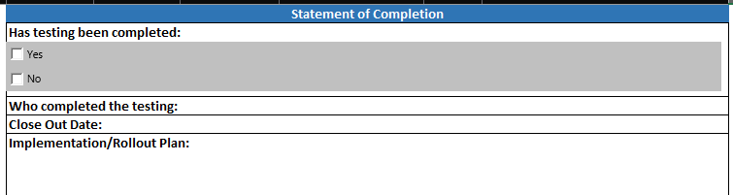
  - Lessons Learned
  - Closing comments
  - Signatures – ELT / President
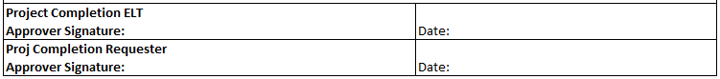

Purchasing New IT Infrastructure
How to Procure New IT Infrastructure Equipment. See Purchasing PCs and User Devices SOP for end user devices.

20.1 Identifying a need for new IT Equipment
- There are multiple reasons new IT equipment needs to be purchased. Below are examples:
  - A building is being constructed, and all new equipment needs to be installed.
  - A failure of a device occurs that is critical to the IT Infrastructure.
    - This is also true for keeping spares of critical equipment in house.
- Example: Data Center Switches
  - A project is occurring that requires additional hardware to be purchased.
    - Example: WISE requires the need for handheld scanners at the warehouse.
  - Existing infrastructure has reached capacity and additional hardware is required to sustain sufficient resources.
    - Example: F: Drive is out of resources and needs additional disk space to sustain the ability for users to save files to it.
  - New IT Infrastructure projects that bring in more efficient solutions to manage the infrastructure.
    - Example: Additional server to load balance our virtual servers so there is one-to-one redundancy in the event of a hardware failure.
  - A process changes in the business units that necessitates a need for additional hardware.
    - Example: K&M moves to video-based training due to COVID-19 restrictions on in-person meetings. Additional bandwidth is required to stream video to warehouse locations. Data Center switch bandwidth capacity may need to be modified with new switch with additional capacity.

20.2 Getting a Quote for Equipment
- After identifying the need for new equipment in step 1 you now must acquire quotes from multiple vendors.
  - Build a list of requirements for equipment that is needed.
    - Example: Hardware specs for server would be:
    - Drive space
    - Number of network interface cards (NIC’s)
    - Memory
    - Server Operating System
    - Making sure server is compatible for use with other connecting systems.
    - Review and discuss the need for new equipment with Director of Support Services for approval on starting to acquire quote process.
- Reach out to a minimum of 3 vendors to get quotes from each.
    - There are multiple vendors that we have worked with in the past and have established relationships with. A list of approved vendors for equipment is below. Do not limit the quote process to these vendors but any additional vendors will require approval from the Director of Support Services to validate quote.
    - CDW
    - PC Connection
    - Insight
    - Amazon
    - Perry Pro Tech
    - Com Resource
- Request quotes from a minimum of 3 vendors to compare pricing and ensure we are getting a fair deal.
- Requesting quotes can be done multiple ways:
      - Written request via email
      - Phone call to vendor sales team
      - Web Portal with Vendor
        - This option usually only exists with our established partners listed in step B-1.
- Formal quotes from vendors should be received within 1 week if it is a stock item not requiring customization.
      - If it’s a customized piece of equipment a meeting with the sales vendor design team may be necessary.
        - This occurs at no cost to K&M. If vendor requests payment for design, have discussion with direct supervisor before moving forward.

20.3 Submitting Quotes for Approval
- Once quotes have been obtained send a summary to IT Managing Director and Director of Support Services for approval
  - Create an excel table to show differences in quotes:
    - Vendor
    - Manufacturer
    - Model
    - Cost
    - Maintenance Cost (at least 1 year should be negotiated as included in sale price)
    - Variance from existing maintenance cost
    - Services required for installation.
    - Lead time for installation
    - Recommendation and justification on which solution to move forward with.
  - IT Managing Director and Director of Support Services will discuss and agree on a solution.
  - IT Managing Director will submit written request to President of K&M for approval to purchase
    - To include summary of organizational need
    - Justification on purchasing
      - Including what happens if we don’t purchase.
- Cost at purchase.
- Yearly maintenance cost.
- Impact to current processes.
      - If there is an impact on current processes a project will need to be created to show how the solution will be implemented. See Project Request SOP.
  - IT Managing Director will communicate back to submitter and Director of Support Services approval to move forward with quote

20.4 Purchasing
- Once approval has been given, the project lead (submitter of quotes and summary) will notify selected vendor that we are moving forward with their quote.
- The vendor will require signature to confirm the quote.
  - Project lead will give a hard copy of contract to IT Managing Director to sign.
  - Project Lead will send the signed copy of contract back to vendor confirming the terms.
- Most vendors require a Purchase Order (PO) to be submitted for ordering. Below is an example of how to submit a PO.
  - The start of the PO should be your initials.
    - Example: JAH83CRADLEPOINT
  - The PO # should have the location number and a brief description of what it’s for.
    - Example: JAH83CRADLEPOINT
  - Put a proper description in the order.
    - This will be useful for historical use and AP when paying.
  - PO’s can be sent with this format via email.

20.5 Installation of Equipment
- Project Lead will schedule any approved outside services that are required to assist in implementing the solution.
- Project lead will provide weekly updates on project status.
- If any delays or problems occur, the project lead will immediately notify direct supervisor so they can work through the issue.

20.6 Updating Documentation and Managing Maintenance Renewals
- Once an order has been placed update the following items to ensure we maintain it going forward and have quick look ups for support purposes
  - Update the site information page in One Note with:
    - Equipment model
    - Location installed.
    - Vendors contact and name.
    - Any other relevant information
  - Put a calendar entry into the sysadmin calendar for the renewal of the contract. In the body of the calendar entry add the contract information so it’s easy to find when renewal comes up.
    - Calendar Reminder to be set for 90 days prior to expiration.
  - Place a copy of the order and any other relevant information into the contracts folder for the site in F:\Information Technology\Shared\Locations

IT Invoice Approval Process
The Invoice approval SOP is a process to approve payments for Accounts Payable, assign what department or warehouse should be coded the expense, and logging of the expense in the IT Budget Spreadsheet. This is necessary for the IT leadership and accounting teams to appropriately track and understand where expenses occur and that they are vital to operations and/or approved.

Invoice Review
- Receiving Invoices
  - Two Upon receipt of an IT invoice from A/P, vendors, etc., review for:
    - Validity: Confirm it is an expected invoice to avoid spam payments.
    - Pricing: Ensure pricing matches the approved quote.
    - Receipt of Goods/Services: Confirm items or services have been received before processing payment.
      - Verify receipt with the purchaser.
      - For services billed monthly, track spending against the Statement of Work (SOW).
    - Approval of Large Invoices: Notify the VP of IT for any invoices exceeding $5,000 before approval.
- Approving Invoices with AP
  - Once an invoice is reviewed and approved by IT:
    - Reply to or email A/P Invoices with invoice details:
      - Expense is approved to pay (expected expense)
      - What is the expense for specifically?
      - What location is this expense allocated to?

Concur Expense Review
- Concur Review Process
  - When an expense report from Concur Arrives:
    - Review each line for correct coding of items.
    - Verify that each receipt matches the amount, expense type and business purpose.
      - Return any discrepancies to the submitter for correction and resubmission.

New Vendor Invoice Processing
- Preparation for A/P Submission
  - For new vendors, request a W9 form from the vendor for A/P processing.
- In the email to A/P, specify:
  - Purpose of the invoice and expense type
  - Warehouse or location the expense is being used
  - If items are stock inventory for IT replacements, they should be coded to Corporate.
  - Send a copy of Royal 4 invoices to Brian Goring and Dave Miller (Marketing) for supplier credits.
      - They can submit software invoices for Coop reimbursement to various tire vendors through marketing support programs.

Logging Invoices for IT Budget Tracking
- Budget Tracking
  - Open the “IT Budget 20xx.xlsx” spreadsheet (where 20xx is the fiscal year).
    - This is currently located in the I.T. Goals & KPIs Team under Files and in the folder named “Budgete”.
  - Key tabs needed to update the sheet are:
    - Budget – 20xx: Tracks budget, spend and remaining funds, linking back to AP and Concur tabs.
    - 20xx – Worksheet: Details annual expenditures.
    - AP: Where IT invoices are recorded.
    - Concur: Concur expenses are added monthly from A/P upon request.
- Entering invoice details into the AP tab
  - For each invoice, add the following into the worksheet:
    - Accounting Fiscal Year: Links to Budget-20xx
    - Invoice Date, Vendor, Location, Item Description, Group, Asset/Expense, Quantity, Amount and Extended Total.
    - Notes: Add additional details as needed.
      - These are all specific columns in the spreadsheet to fill in.
- Concur Expense Entries
  - Request the monthly Concur spreadsheet from A/P for IT expenses, typically delayed by one month.
  - Include fields such as Employee, Expense Type, Report Name, Transaction Date, Accounting/Fiscal Year, Payment Type, Vendor and Approved Amount.
    - Enter manually when needed, ensuring alignment with the Budget-20xx tab.
- Budget Reconciliation
  - Ensure all invoices/expenses match the “20xx Spend” column in the budget sheet.
  - Verify the “Diff from Total Spend” (cells G1 and G2) shows zero.
    - If not, check for missing entries in the AP or Concur tabs or omissions from Budget-20xx worksheet.

Hardware Return Policy
This SOP is to give direction and examples of what can be salvaged when an IT asset fails and how to dispose of parts that no longer are of value. Additionally, destruction of data storage is critical to protect company data from getting in the wrong hands.

Inspection
- Items returned to IT need inspected.
  - Inspect all items returned to IT.
    - Verify device condition.
    - Verify device age is less than 6 years old.
      - If over, dispose of the equipment. See Section 20.3.
    - Defining reason device was returned.
  - Determine if device can be reused.
    - Cleanup and Repurpose
- Usable Devices
  - Clean up device.
  - Test to make sure it is functioning properly.
  - Put device in storage or back into rotation for production.
    - Destroy and Disposal
- Determine if anything is salvageable.
  - Remove any working parts or removable parts.
    - PCs and servers
      - Hard drive
      - Spare parts
      - Miscellaneous PC cards and cords
    - Printers
      - Remove paper.
      - Remove unused toner.
      - Remove extra removable drawers.
      - Wipe and remove any stored data.
    - Networking
      - Patch cables
      - Rack organizers
      - Fiber connection
      - Shelves
      - Remove and wipe any config files.
    - Cell Phones
      - Set to factory default and wipe all data.
      - Verify all services are removed.
      - Remove sim card.
      - When a new phone is added into MaaS360
        - Remove the old phone under that route or user’s name.
  - Contact Accounting to make sure the device is no longer on the books as an asset.
    - Typically, items over 7 years are not.
  - Scraping and disposal
    - Hard drives and backup tapes storing any kind of company information need destroyed.
      - Tapes should be burned in a fire.
      - Hard drives can be decommissioned by drilling through the drive with a drill.
    - Plastic items can be tossed in the trash.
    - Metal items can be saved for recycling.
      - Recycle
    - Monitors/Printers/Laptops
      - We have individuals who will take these with scrap metal.
    - Cell Phones
      - Pace Butler will take old phones and give money for devices that are still useable and dispose of any that are not functioning.

Acquiring New Location Internet/Phone
To make clear the expectations for procuring services to new warehouses for internet.
    - New Location Acquired
- An announcement will be made to the IT Team that a warehouse has been acquired or will be built.
- Upon receiving the announcement of new warehouse System Administrator will contact Facilities Department to get address of new site.

    - Searching for available Internet Service Providers (ISP) and Phone Providers
The next step after identifying the address of the building or land is to search for available Internet Service Providers (ISP) and Phone Providers
- A ticket will be created in ManageEngine to track quotes and information on obtaining new providers.
- This will be used for both the ordering and setup of the equipment for the new site.
- Open a ticket with the below information:
    - Subject: $sitenumber $sitename New Setup
    - Priority: 5
    - Obtaining a Quote
- The System Administrator will use a search engine to identify services to that address.
- Some states that do broadband funding keep track of broadband maps. Searching for state broadband maps may help fill in missing information about availability.
- Once you’ve found providers in the area you can contact by email, phone, or online chat to get a quote started. Add any new information to the ManageEngine ticket created in the previous step. Below are requirements to guide the System Administrator through the quote process.
- The minimum speed necessary for a location is 10MB.
- This is necessary to fully utilize the Warehouse Management System (WISE)
- All locations must have a static IP setup for their public internet.
- This is how we connect the new warehouse back to the corporate office data center.
- The best services we can purchase are hardline services like Metro-E, Fiber, or Cable.
- Due to the high availability and faster speeds, you should prioritize these services when quoting.
- Services like DSL are a different type of technology called ATM.
- The conversion from cell to packet can cause problems with VPN’s and it’s suggested you stay away from DSL when possible.
- Point to Point services are similar to other hardline services but can differ greatly between providers.
- Verify what type of service and support you get with point-to-point services. Avoid if possible.
- Wireless services can have problems during storms or other hard weather.
- It’s best to avoid wireless wherever possible due to the amount of downtime we see from those networks.
- Whenever possible get quotes from 3 local service providers.
  - There are not always three options available in some rural areas or areas that have areas controlled by one ISP.
- Add all quotes and any new information to the ManageEngine ticket created in step 1.
- Once quotes have been obtained send a summary to IT Managing Director and Director of Support Services for approval.
  - Create excel table to show differences in quotes:
    - Type of service
    - Bandwidth Up/Down
    - Cost per month
    - Contract Length
    - Build out cost.
      - This is the cost to build new infrastructure to provide service when necessary.
- Variance from average monthly cost for ISP company wide.
- Variance from average monthly cost for region where new location is.
- Lead time for installation.
- Recommendation and justification on which ISP to move forward with.
  - Email with approval will come from IT Managing Director will discuss with President of K&M to determine best path forward.
    - Installation of Services
Once approval has been given the System administrator will move forward with the approved quote.
- System Administrator will respond to ISP contact who provided the quote that we are moving forward with them.
- System Administrator will give hard copy of contract to IT Managing Director to sign.
- System administrator will send signed copy of contract back to ISP confirming the terms.
- When a date for hookup or installation is given, System Administrator will work with IT Coordinators and Project Team to establish time that they can be in the building to assist.
  - In some cases, the Regional Operations Manager may need to be the primary contact for the installation.
- System Administrator will provide status changes on their weekly updates. Including any changes with timeline
  - This is especially important when a new build-out is required.

    - Managing Contract Renewals
Once an order has been placed update the following items to ensure we maintain it going forward.
- Put order information in the ticket and leave it open for the site setup.
- Update the site information page in One Note with provider contact and name.
- Put a calendar entry into the sysadmin calendar for the renewal of the contract. In the body of the calendar entry add the contract information so it’s easy to find when renewal comes up.
  - Calendar Reminder to be set for 90 days prior to expiration.
- Contract renewals should be sent to Admin to be placed in the proper folder for IT. F:\Contracts\Information Technology

WISE Set Up
To Identify and explain each step in the testing prior to going live for a new WISE location.
    - Wise Set Up Items
- Handhelds and Configuration
  - Once the scanners are in the Technical Support Representative will set them up with the Telnet information and DOT information.
    - See IT OneNote Mics. Procedures – Symbol Units-Setups for instructions on how to set up the Scanners and all passwords needed for Royal 4 Telnet setup.

- MaddenCo Control Keys
  - The following control keys need to be set up prior to WISE being turned on:
    - WIMPODEF
    - WIMPOYN
    - WICSxxx
    - WIOPCKRT
    - WICCLSYN
    - WIMYN
    - WIPSxxx
    - Vendor addresses for all locations need turned on for that store.
      - 1. Tire Dealer System
      - 6. File Maintenance Menu
      - 6. Vendor address Menu
      - 000 for all stores
      - You will put a Y to Send to WIM for the address that you need to be sent.

- Turn on Variance and Maintenance Programs (Programmers)
  - On Winphptest:55200 (mstsc -v winphptest:5520)
    - Setup ODBC
      - Go to run and type odbc
      - Click Add on System DSN
      - Go to Progress OpenEdge 11.5 Drivers and Click Finish
        - Data Source Name -> WMS0XX (XX is store number)
        - Description -> Wise Connect XX
        - Host Name: WMSXX.kmtire.local
        - Port Number -> 23243
        - Database Name -> r4_wms
        - User ID -> r4
        - Click Test Connection
        - Put in password: 90815
    - Add to C:\xampp\htdocs\wise\UPCUpload.php
      - Add variable $goodXX = false; (XX is store number)
      - Add function call $goodXX = checkUPC($connIBM, “XX”, $row['FLAG'], $row['PART'], $row['UPC']);
      - Add to $theGoods Array
      - Add to the check for goodXX before calling updateSentFlag function
      - Save Script
    - Add to C:\xampp\htdocs\wise\binMove.php
      - Add to $locArray on line 10
    - Add to C:\xampp\htdocs\wise\fixUPC.php
      - Add to $storeArray on line 51
  - On IBM I
    - www/zendphp7/htdocs/nightlyjobs
      - Find file WiseInventoryXX.php (XX is store number)
      - Open File
      - Make a copy for new store number (WiseInventoryXX.php)
      - Change Line 23 in new file to PDSTORE = '0XX'
      - Change IP address to that new WMS on line 45
        - Command Prompt -> ping WMSXX
      - Save File
    - Schedule Inventory Variance
      - Go To http://10.73.0.10:10091/ZendServer/
      - Go To Job Queue
        - Recurring jobs
        - New Recurring HTTP Job
        - Name – Wise Inventory XX – Nightly
        - URL – http://10.73.0.10:10090/nightlyjobs/WISEInventoryXX.php
        - Queue Default
        - Priority normal
        - Execute Job Daily -> Time 3:00 AM thru 6:00 AM

- Copy over database of live system.
  - This work will require configuring an MMC for Hyper-V. A user account with administrative privileges for OpenEdge and Windows. And copying data from a live server DB backup.
- Disable r4sys and r4wms DB’s On New Server
      - Before you can begin any work disable the database on the new server.
        - Log into the server you want to copy the new database too.
        - Click on Start
        - Type OpenEdge and choose “OpenEdge Explorer” from the list.
        - Internet Explorer will open. Enter the admin credentials from the IT passwords list.
        - The resources page will load by default. Scroll down to section “Database.
        - Put a check mark in wms##.R4SYS76 and wms##.R4WMS76. Click the red circle stop button at the top of the resources window. After a few moments the databases will stop.
        - The database is now stopped, and you can copy/import the new DB in.
- Copy DB Backup from Live Server to New Server
      - Copy last night’s 10pm backup from a production server to the new one.
        - Start by logging into the server you want to copy data from using RDP.
        - Open explorer and browse to C:\Royal4-7.6\db\dailybackup.
        - Copy both .dbb files to \\newwmsserver\c$\Roayl4-7.6\db
        - The files are copied over and ready for import on the new server.
- Setup MMC For Hyper-V
      - During import you want to disable the NIC so any data from the backup doesn’t update the production database. In order to make this work you will need to set up the Hyper-V MMC so you can work without a network connection.
        - From your local desktop click Start.
        - Type Hyper-V and choose “Hyper-V Manager” from the list.
        - Right click on Hyper-V Manager in the upper left-hand corner.
        - Left click on “Connect to server”
        - The radio button is in “Another Computer” by default. Type in the name of the hypervisor you are connecting to. Currently WMS servers run on hyperv-05 and hyperv-09.
        - Put the check in “Connect as another user” and use your admin account for access.
        - Click OK. You have now loaded the Hypervisor and can double click the server you want to connect to for remote access.
- Disable NIC
      - This must be run from the Hyper-V console that you setup in step “Setup MMC For Hyper-V”.
        - From the desktop of the new server click Start
        - Click “Control Panel” in the start menu.
        - Click “Network and Sharing Center”
        - Click “Change adapter settings” in the upper left-hand corner.
        - Right click on Ethernet and left click on Disable.
        - The network is now off, and you can begin import work.
- Import DB Backup
      - With the network and databases turned off you can now import a production database into the new server. This step requires you “Run as administrator” on ProEnv or it will not have access to import.
        - Click on Start
        - Type ProEnv. ProEnv will show in the list. Right lick on ProEnv and left click on “Run as administrator”.
        - Type cd c:\royal4-7.6\db then press enter.
        - Type the commands below.
          - prorest r4_wms r4_wms.dbb
          - prorest r4sys r4sys.dbb
            - It will take a few minutes for each command to run. Once complete type exit to close the window. You have now imported the databases into the new server.
- Enable NIC
      - This must be run from the Hyper-V console that you setup in step “Setup MMC For Hyper-V”.
        - From the desktop of the new server click Start
        - Click “Control Panel” in the start menu.
        - Click “Network and Sharing Center”
        - Click “Change adapter settings” in the upper left-hand corner.
        - Right click on Ethernet and left click on Enable.
        - The network is now on, and the server is live on our network.
    - Enable r4sys and r4wms DB’s
      - Log into the server you want to copy the new database too.
      - Click on Start
      - Type OpenEdge and choose “OpenEdge Explorer” from the list
      - Internet Explorer will open. Enter the admin credentials from the IT passwords list.
      - The resources page will load by default. Scroll down to section “Database”.
      - Put a check mark in wms##.R4SYS76 and wms##.R4WMS76. Click the green circle start button at the top of the resources window. After a few moments the databases will start.
- The database is now running, and you can log into the Royal4 application to finish site setup. Clear out old data
- Load R4
- Load Desk
      - Load Procedure Editor
        - Open C:\Royal4-7.6\data\Clean locations and run that
        - Open C:\Royal4-7.6\data\Clean up of transaction and run that
- Do not remove product data
- Turn on Scheduled Tasks in WISE
- To turn on the Scheduled tasks following instruction under OneNote
- WMS Setup Re-Write
- Configure WISE System
- Locations
- Areas
- Employees
- Put Away and Pick Plans
- Count Groups
- Outbound Filters
- See IT OneNote Procedures - WMS – WMS- Building the Server for each location on how to build the Wise Server for each location
- Get Wise Build List to make sure you have everything build for the server
      - F:\Information Technology\Shared\Locations\WISE\ WISE Build list
- Print Pack ID’s
    - http://10.73.0.10:10100/scheduledJobs/walmart/barcodepack.php
    - Modify the highlighted items in the file
    - I:\zendphp74\htdocs\ScheduledJobs\walmart\barcodePack.php
    - Starting number
    - $number = 10000101;
    - Ending number – 20 at a time works best
    - for ($i=$number; $i <= 10000120; $i++) {

- Print bin Labels
- Bin Labels will be printed for all PLT Bins and TWP Bins.
    - Intranet
      - http://intranet.kmtire.local/index.php?area=labelPrint
      - Do all evens increments by 2 and all odds increments by 2 separately so it is easier for installing on bins since odds on one side and evens on other side
      - Arrow down for A level
      - Arrow up for rest of the levels

- Test server
- Test the WISE server that was just built
    - Get the checklist so everything is tested in the system
      - F:\Information Technology\Shared\Locations\WISE\Checklist for testing WISE

Pre-Go Live RDP Sessions for WISE
Objective: How to Create the Remote Desktop Protocol – RDP and who all gets access for each WISE location

    - Step One: Creating the RDP session.
  - Start
    - Type Remote
      - Click on remote Desktop Sessions
      - Example is creating for WMS82 for the Lubbock WISE connection.

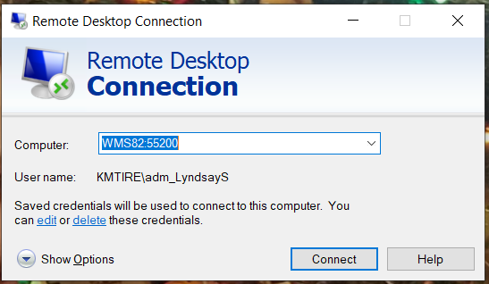
      - Click Show Options
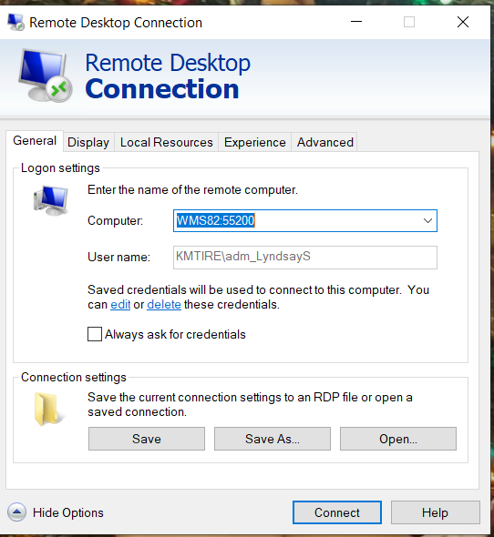
      - Do a Save as and Save to your Desktop naming it WMS82.
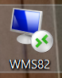

- Step Two: How to create email and who to send it to
  - Open a new email.
    - Right click on RDP you just saved to your desktop in Step 1 and copy.
    - Paste into new email.
      - This will create it as an attachment.
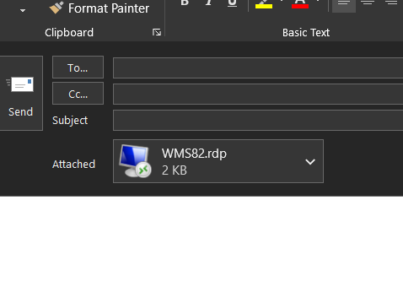
    - The following people will get the RDP’s for each WISE location
      - President
      - Project Manager
      - Warehouse Manager
        - where WISE is being installed
      - ROM
        - Where WISE is being installed
      - Purchasing and Pricing Supervisor
      - Regional Operation Support Manager
      - All Warehouse Administration Mangers
      - All Warehouse Support Managers
      - Director of Operation

WISE Go Live
The Purpose of this SOP is to understand and go through the build, setup, wireless Access points, inventory and go live of the WISE system in a location.
    - Install Software and Licenses
- WISE License
  - Send email to Luz Barragan <Luz@royal4.com>; Accounts Receivable <AR@royal4.com>; Richard Kraetz <RKraetz@royal4.com>; Danielle Sturgis <Danisturgis@royal4.com>
  - Send the following information.
      - PO – “location”
      - Server – WMSXX
      - MaddenCo Location Number – XX
      - Live date 3/06/2020 (actual date you are doing counts)
      - Loaded Licenses by 2/28/2020 (the Friday before or Monday before counts at the latest)
      - X– WISE Licenses (number of licenses decided in WISE meetings)
      - x – Progress Licenses (this is the same number as the WISE Licenses)
      - 1 -Progress Client Networking (only 1 Progress license is needed per server)
      - x – temp licenses (the number of temp licenses that is decided for counts)
        - 30-day license in which the costs will be applied to license for the next location
      - It will be for the following location.
      - K&M Tire – (location)
      - Location address
      - City, State XXXXX
- Progress
  - Ordered and set up through Royal 4

- Georgia Works
  - Ordered and set up through Royal 4

- RDP
  - Ordered through CDW
      - https://www.cdw.com/product/Microsoft-Windows-Remote-Desktop-Services-2019-license-1-user-CAL/5301548?
  - set up on server as listed in OneNote.
      - WMS Setup Re-Write
- Temp WISE License for Go Live
  - Temp licenses are ordered at the time of the reset of the licenses.
      - See section 3.1 WISE Licenses
  - The number of licenses is decided based on the size of the location and how many will be going during the Go Live and will be counting the inventory.
      - Licenses are good for 30 days once they are installed.
    - Pre-Go Live WISE Testing
- Prepping the WISE environment for testing.
  - Turn off count groups in WISE following the below path.
    - This eliminates communication and updates to MaddenCo
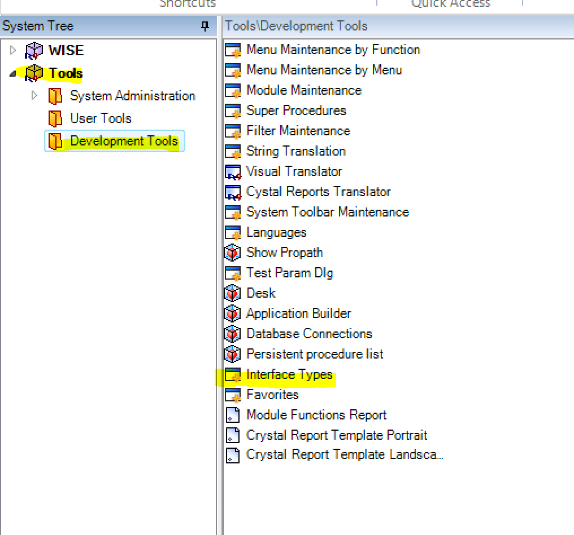
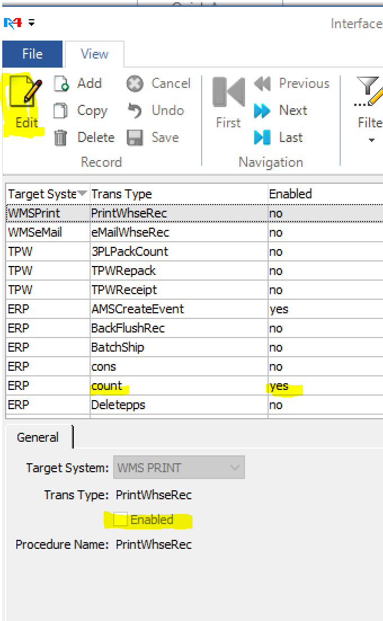
- Testing Function Built on Server
  - Create Count Groups
    - One Count group is sufficient for testing.
    - Use that count group to test all areas.
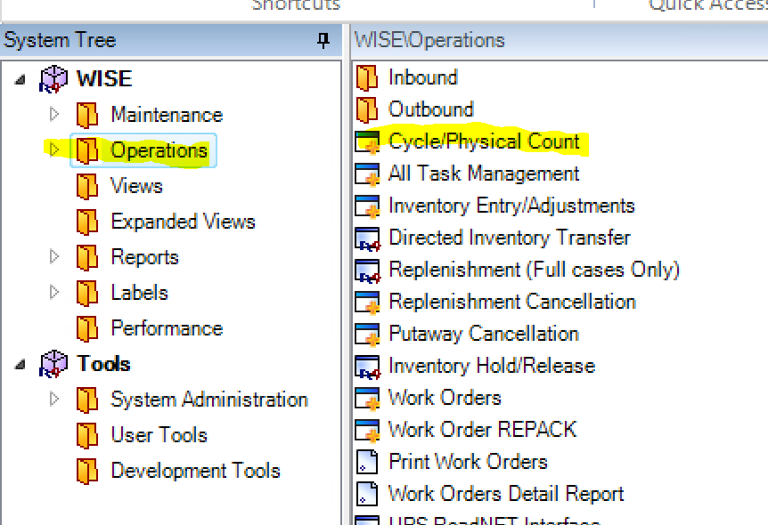
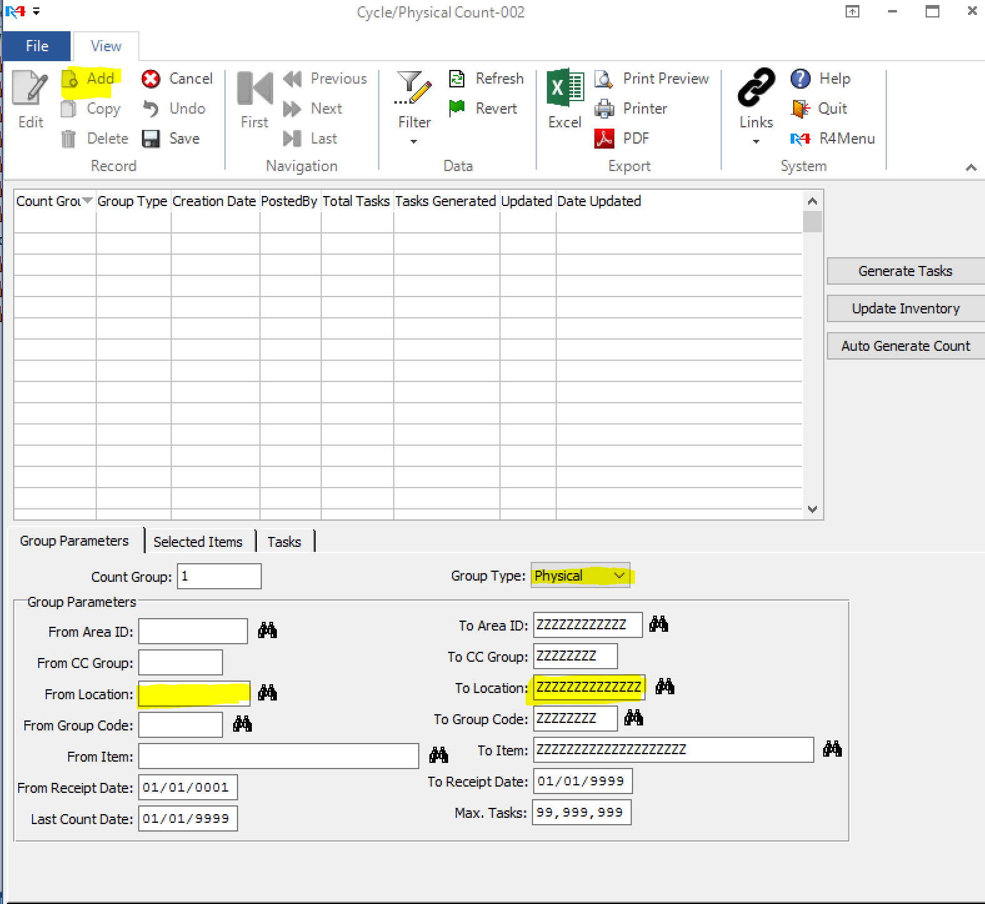

  - Test Count Group by following the below steps.
    - Login into RFLogin.bat on WISE server (found on desktop of server)
      - Enter WISE Credentials
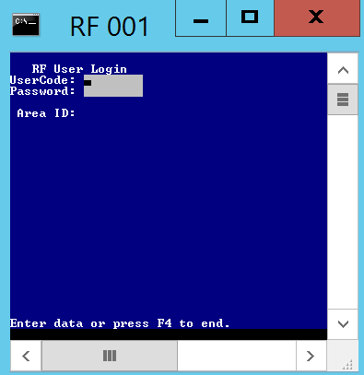
    - Select option 21.
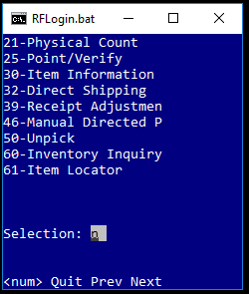
    - Enter in count group created in Step 2
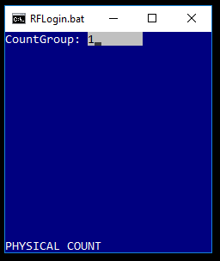
    - Use inventory from previous WISE test to check counting inventory in every area that has been defined. (It will be pre-loaded as part of server setup)
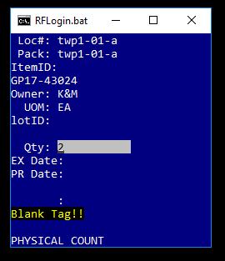
  - When you complete the RFLogin simulation of scans you will now upload to active inventory
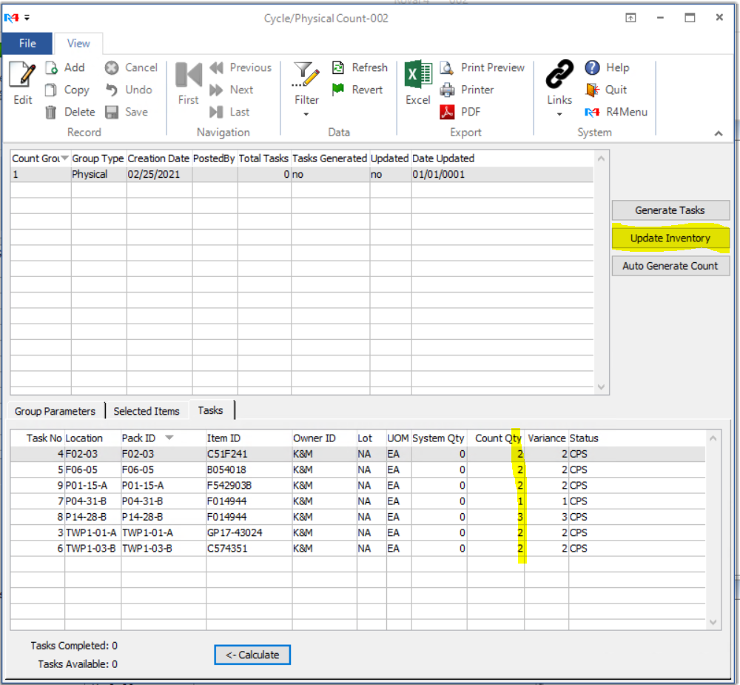
  - After uploading inventory, you will now verify that inventory is being entered into the live system.
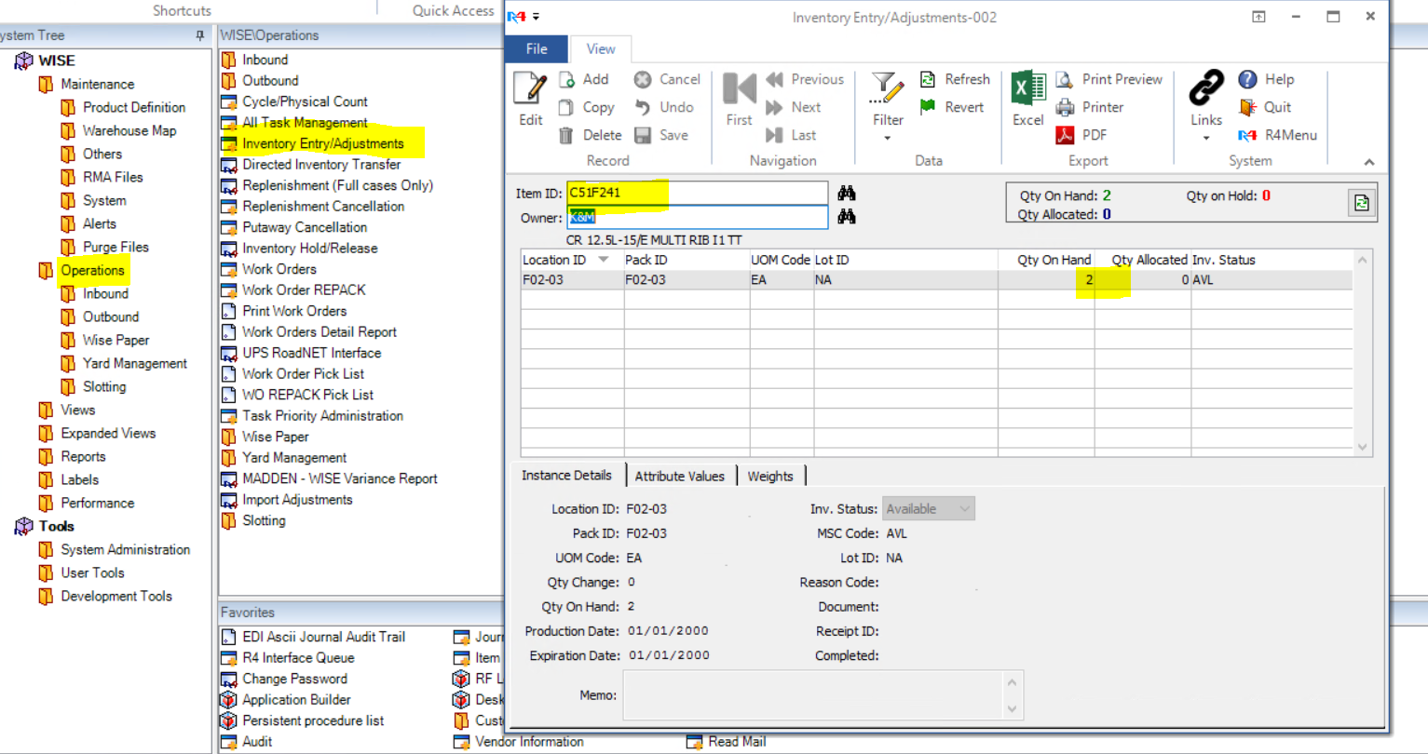
- Testing Purchase Orders Being Sent from MaddenCo to WISE
  - In MaddenCo use the following steps to create a test PO
    - Use the following steps to get to PO in MaddenCo
      - 1. Tire Dealer System
      - 3. Inventory Menu
      - 10. Purchase Order Menu
      - 1. Work with Purchase Orders
      - Enter in the Store Number to be used:
        - This is the WMS location you are testing.
      - F6 – Create New PO
      - F2 – Get Next P.O #
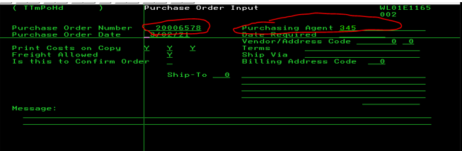
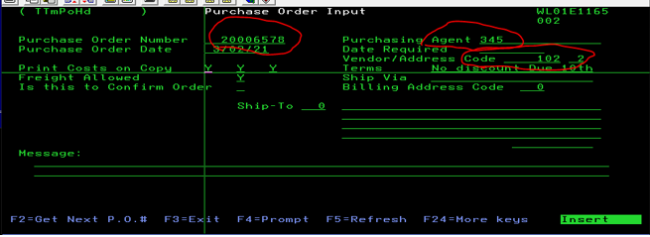
  - Add Items to PO
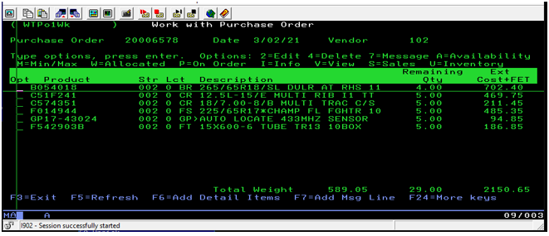
  - F3 – Exit
  - Print Purchase order? N
  - Flag Purchase Order READY to Transmit to Vendor? N
  - Flag PO Ready to send to WIM?
    - Type “Y” or “N” to above and Press Enter: Y
- Step Four: Creating Expected Receipts in WISE
  - In WISE Create an Expected Receipt from PO that was just sent over from Step 3.

    - WISE Go Live Week
- Set up Remote Desktop on Warehouse Manager, Warehouse Support Manager, Anyone going to WISE Install
  - A remote desktop session will need to be added to all computers going to the WISE install, Warehouse Manager and Warehouse Support Manager.
- UPC Validation
  - A walk through and the scanning of products will happen the week prior to Go Live
    - Labels will be turned out, labels will be created and added to products missing labels and tires will be placed in bins if currently not in a WISE bin location.

- Test Wireless Coverage
  - To test Wireless Coverage, you can walk around and look for delays in scanning. The scan guns also have a feature that test wireless strength. If there are issues, use the access point configuration OneNote walkthrough.
- Print labels for tires with no barcode
  - During the week before walk through labels should be printed and put on any products missing or without barcodes and labels.
    - To create a label in WISE
      - R4 session
        - WISE
          - Labels
            - Item Label
              - Item ID
              - Number of labels
              - 4x6 label
              - Printer setup
                - Change to the Zebra printer installed on the server.
                - OK
              - OK to print labels.
- Set up command center.
  - Table Present, adequate WIFI, printer close by, everyone on install team has printer setup, test that multiple wireless devices aren’t bogging down the network, make sure enough power strips are onsite to accommodate everyone.
- Verify wise and inventory flags are turned off.
  - This should be turned off during testing but always check before Inventory count.
    - In the R-4 session
      - Tools – Developmental Tools – Interface Types – Count - N
- Inventory Count
  - Each person counting will be assigned a count group. They will go out and count the Aisle and level they are given in that count group.
    - Once count group is done, they will return to command center for the next count group and row assignment.
- Correct issues encountered by count team.
  - Any issues that were found by the count team need to be addressed.
    - labels not scanning or UPC scanning incorrectly.
      - Give to IT to investigate the labels and send to Purchasing and Pricing if we need to find the correct UPC from Manufacturer (Can normally find UPC on tire label)
    - bins not scanning as in system.
      - Get with IT to see why the Bin is not in the system or if something is wrong with the label not scanning correctly.
    - WIFI in an Aisle is lagging.
      - Get with IT to check if he Access points need moved or change strength of Access Points
    - Any other issues should be brought up to the Management team or IT to correct while counting is still going on.

- Review count data prior to upload
  - Look through each count group to make sure each bin looks like a count that would fit in that bin. Within the WISE system, go to WISE-> OperationsCycle/Physical Count
    - Example check to see if you have a large number such as 123456789123
      - A number this size would mean a UPC was scanned and could mean that a scanner was lagging due to a bad coverage area, or the counter was not on the correct screen to be when entering the quantity.
        - If this is seen, the area around the bin should be check for connectivity issues.
- Upload counts to system.
  - If all counts look good, you will then upload them to the WISE system.
    - WISE
      - Operations
        - Cycle/physical Count
          - Highlight Group #
            - Click Update Inventory
- Run Variance Report (after counts completed)
  - Run a variance report from MaddenCo variances ran in the morning.
    - WISE
      - Operations
        - MADDEN-WISE Variance Report
          - Chose Inventory File …
            - C:\Temp\ascii\Reports\IN\(date of count.CSV)
          - Owner
            - KM
          - Check Ver Only
          - Check CSV file.
          - Complete
- File will be saved under C:\Royal4-7.6\WISEinventory.csv
- Give variances to whomever is running command center to go over and see if any recounts need to be done based off the variances that we are seeing.
- Recounts if necessary
  - Recounts are triggered by variances between MaddenCo and WISE (what was counted for go live) numbers. Command Center will assign counter to recount certain part numbers manually to confirm count is accurate. If variance is found in manual recount, the command center will then go into a new count group and manually make the change on the guns (option 21, key in bin, sku and new qty) or key changes on PC as Wise Only Adjustment.
- Adjust inventory in MaddenCo if product not found during count (Ops Mgr.)
  - If the inventory is not found in the warehouse, an inventory adjustment can be made. Command Center Lead Wise Project Manager can put in 101086 until they have time to look and see where these products might be located. This is done so we do not list inventory that cannot be located on Weblink and/or other customer facing order sites.
- Creating Desktop Shortcuts for users
  - A remote desktop session will need to be added to all computers going to the WISE install, Warehouse Manager and Warehouse Support Manager.
- Turn on the shipment monitor.
  - Shipment monitors will be turned on and logged into once counts are done so they are not taking up a license during the counting.
    - Log into computer with R4monitor user and Welcome1$ password
    - Log into r4 session with monitor user and kmon password
- Train warehouse employee to use the system.
  - The ROMS or Support Warehouse Management will go over the system and train the users on how to use the scanners, how to receive, how to pick and how to push the orders to the board.

Password Management
    - Password Criteria
This applies to the user’s main workstation/network login. Employees are encouraged to use a “passphrase” style of password instead of a traditional one word “password.” The following rules apply:
- Use uppercase and lowercase letters.
- Use numbers, special characters, and spaces.
- The minimum number of characters is 12.
  - No uppercase or lowercase requirements.
  - No number or special character requirements.
  - An example would be:
    - Old Password Style: Welcome01$
    - New Password Style: Welcome Branch 01
    - IT Password Storage
IT stores all IT specific usernames and passwords in a password protected One Note file.

Customer Number Change
    - The Customer Number Change is a process designed to accompany route changes that impact the customer’s primary supply warehouse.
- Specifically, it enhances our ability to serve customers by:
  - Making the first digits of the customer number match up with location number.
    - Ensuring Will Call customers will be routed to the correct location for pick up.
    - Ensuring that inventory visibility on Weblink is displaying properly.
    - It allows for warehouse personnel to quickly sort tires for transfer by looking at the first digit of the customer number on printed invoices.
  - We limit the frequency of Customer Number Changes to twice per year because it requires a 4-8-hour downtime to all systems. Including all ordering systems.
- They take place when large reroutes occur due to:
  - Acquisitions
  - New warehouse construction
  - Closure of existing warehouses
  - Or any other large quantity changes to customer’s primary ordering warehouse
- Customer Number Change Procedure:
  - Sales should be made aware of the changes before actually doing.
    - In addition, we need to coordinate the change date with Logistics and Accounts Departments.
    - If more than 20 customers are going to be changed Marketing, Inside Sales, Logistics, and Credit and Collections must be notified.
      - This is so they can contact the customers about the change.
  - If only 20 or below, Credit and Collection Supervisor and Purchasing and Pricing needs to be notified only.
  - A list would be provided from either Logistics Supervisor or C&C Supervisor, which needs to be approved by Marketing Director.
- Step 1 can be done at any time.
  - Logistics sends Credit Collections spreadsheet of proposed changes.
    - Logistics maintains spreadsheet of proposed customer numbers of changes. Credits enter the old and new customer numbers into:
    - http://intranet.kmtire.local/index.php?area=custnumchange
    - Credit and collections click approve to confirm/lockdown changes.
    - Have Logistics and C&C review the list and modify changes.
      - Verify that there is not any data in the TMCXRF file.
      - When all is approved Click the Complete Button to move the data to MaddenCo
    - Take options 1, 15, 7, 15, 1, 10, (1)
      - Option 1 is Work w/ Customer Number Change.
      - Data can manually be added or changed on this screen.
    - Verify old and new customer numbers are correct.
    - Before exiting the “Work with Customer Number Change” screen, press F9 to print a report of the customer number you entered for later reference. Just put the print job on hold and you can look at it later via WRKSPLF {YourMaddenCoLogin}. ⁽¹⁾
- The following steps need to be done when no one is on the system and not during a close to the nightly update.
  - End all websites running on the system.
    - Enable maintenance sites on Barracuda F180 Firewall
      - How to enable maintenance sites on the Barracuda F180 Firewall
        - Part 1: Updating HTTP Sites in Reverse Proxy
          - 1. Log into the Barracuda F180 using the maintenance utility. The current version is 8.0.1 and can be found at F:\Information Technology\Shared\Applications\Barracuda\Barracuda F150 CG FW. *NOTE that this is not an installer, it is a standalone executable. You need to copy this to your computer before running.
          - 2. Log into the Barracuda F180 at 10.73.0.9. The user is root, and the password is KMCorp01$
  - Click on the Configuration Tab
  - Browse to Box -> Virtual Servers -> S1 -> Assigned Services -> HTTPProxy -> HTTP Proxy Settings. Double click on HTTP Proxy Settings to open up a new tab with the settings.
  - Click on Reverse Proxy Settings on the left-hand side of the screen.
  - Start by clicking the Lock button in the upper right-hand corner of the screen. This will allow you to control the firewall and lock everyone else out of it.
  - Under the heading Domain to Backend Mapping, you need to change the internal IP and port of the server that requests forward to. You can edit and entry by double clicking on it. The table below shows what websites belong to what ports.
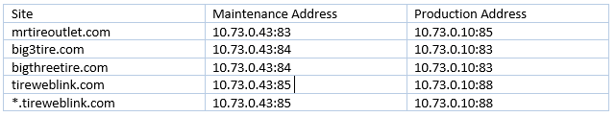
  - Repeat Step 7 for all of the items in the above table.
  - Once finished click on the Send Changes Button in the upper right-hand corner. After this process completes and active link will appear at the top of the screen. Click Activate to make the changes take effect.

    - Updating HTTP/HTTPS Sites in Firewall Rules
- If you need information on logging into the Barracuda, please refer to step 1 on page 1 of this documentation:
  - Under the Configuration Tab. Click on Box -> Virtual Servers -> S1 -> Assigned Services -> NGFW (Firewall) -> Forwarding Rules. Double click on Forwarding Rules to open up a new tab with the settings.
  - Start by clicking the Lock button in the upper right-hand corner of the screen. This will allow you to control the firewall and lock everyone else out of it.
  - There is a section in the rules called Maintenance Rules. You will need to active all of the rules in this section to enable maintenance pages. To activate a rule, right click on it and choose Activate Rule. When it comes time to deactivate the rule, you’ll do the exact same thing but Deactivate Rule will be the option you choose.
  - Repeat step 3 for all maintenance pages. Then click Send Changes and Activate.
  - At this point you should now have all traffic going to maintenance pages and can begin your work on the AS400.
    - ENDTCPSVR SERVER(*HTTP) HTTPSVR(*ALL)
  - Verify all websites are ended.
- WRKACTJOB SBS(QHTTPSVR)
      - Sooner or later, there should be nothing in the list after QHTTPSVR.
  - Run program to convert non-MaddenCo. files.
- Username: U273UPDATE
- Password: KMCorp01$
      - CALL PGM(KMTPGM/CVTCSTNUM)
      - This takes around 5 minutes.
  - Run program to change customer numbers in MaddenCo. (approx. - 1hour)
- Take options 1, 15, 7, 15, 1, 10, (4)
      - Job – QBATCH PTCC1
  - Start all websites that need to be running on the system.
- STRTCPSVR SERVER(*HTTP) HTTPSVR(BIG3TIRE)
- STRTCPSVR SERVER(*HTTP) HTTPSVR(GYORDERWS)
- STRTCPSVR SERVER(*HTTP) HTTPSVR(INTRANET)
- STRTCPSVR SERVER(*HTTP) HTTPSVR(KMTIRE)
- STRTCPSVR SERVER(*HTTP) HTTPSVR(MRTIRE)
- STRTCPSVR SERVER(*HTTP) HTTPSVR(MRTIRERTL)
- STRTCPSVR SERVER(*HTTP) HTTPSVR(PUBLIC)
- STRTCPSVR SERVER(*HTTP) HTTPSVR(TIREWEBLNK)
- STRTCPSVR SERVER(*HTTP) HTTPSVR(WEBLINK2)
- STRTCPSVR SERVER(*HTTP) HTTPSVR(WEBTEST2)
- STRTCPSVR SERVER(*HTTP) HTTPSVR(ZENDPHP74)
  - Verify all websites are started.
- WRKACTJOB SBS(QHTTPSVR)
  - Check http://10.73.0.10:10101/ZendServer/ to ensure Zend is running.
  - Start TO and FROM MCI batch jobs.
- Take options 1, 15, 7, 15, 12, 1. (Start background Processing
  - Verify TO and FROM MCI batch jobs are running.
- WRKACTJOB SBS(QBATCH)
  - Reverse the Barracuda rules changed in step 1.
- Server Change Log: (Keep entries for 1 year; PCI Compliance)
  - Test a few customers that are on the websites affected to make sure it is working.
- Test in Weblink 2
- Test in Sales Dashboard
- Test on Intranet
  - Send email to all send in item 3 and CC Accounting, Sales, and Logistics Department heads.
  - Notify Marketing to update the following:
- Home Store
      - Intranet – Marketing/Customer Maintenance
      - http://10.73.0.10:93/Intranet/index.php?area=macumast
- Default Store
      - Intranet – Marketing/Weblink 2 User Maintenance
      - http://10.73.0.10:93/Intranet/index.php?area=weblink2usermaint
  - Run Wise File
- Go to MaddenCo and Press ESC
      - This will bring up the operations menu.
      - Page down to the WIM interface
      - Opt 1
      - Opt 3 -> Initial Load of Customers To WIM
      - Chose 000 for all stores.
      - There are a few sorting screens to go past.
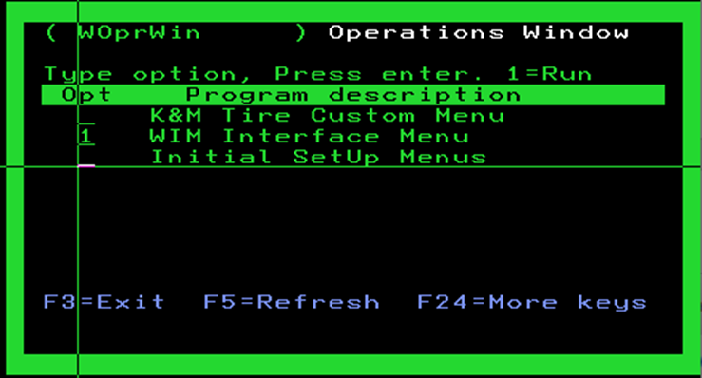

      - If complete you should get a screen like this.
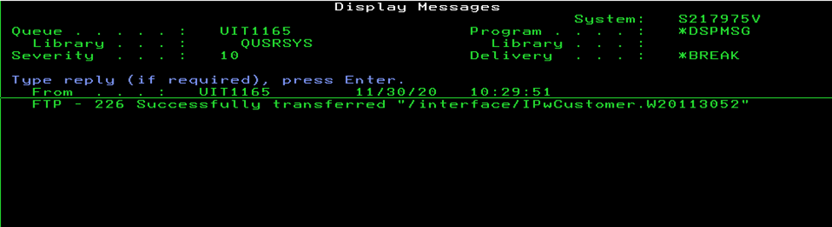
  - Remove customers from KMTDTA.DASHSEARCH
  - Document any changes that may need to be done and add to this document.

Quoting Branch Services
    - Managing Task
- When you start a quote open a ticket to track information in ManageEngine. This will be used for both the ordering and setup of the equipment for the new site.
  - Open a ticket with the below information:
    - Subject: $sitenumber $sitename New Setup
Priority: 5
- Track any updates and attach all quotes to the ticket.
- When the order is complete attach the final pricing and leave the ticket open so that new equipment setup can be appended to the ticket
    - Searching and Quoting
- Search Engine
  - Use a search engine to search for internet service at the building’s address.
  - Some states that do broadband funding keep track of broadband maps. Searching for state broadband maps may help fill in missing information about availability.
- Contacting Service Providers
  - Once an ISP has been located, contact to get a quote.
    - Add new information to the ManageEngine ticket.
- Service Requirements
  - The minimum speed necessary for a branch location is 100 MB.
  - All branch locations must have a static IP setup for their public internet.
- Number of Quotes
  - Whenever possible, receive three quotes from local service providers.
- Preferred Services
  - The best services are hardline services like Metro-E, Fiber, or Cable.
    - Due to the high availability and faster speeds, we should prioritize these services when quoting.
  - Services like DSL area different type of technology called ATM.
    - The conversion from cell to packet can cause problems with VPNs and it is suggested to stay away from DSL when possible.
  - Point to Point services are similar to other hardline services but can differ greatly between providers.
    - Verify what type of service and support you get with point-to-point services.
  - Wireless services can have problems during storms or other severe weather.
    - It is best to avoid wireless whenever possible due to the amount of downtime we see from those networks.
    - Ordering
- Orders must be approved by the Director of Support Services prior to ordering.
    - Managing Contract Renewals
- Once an order has been placed, update the following items to ensure we maintain it going forward.
  - Put order information in the ticket and leave it open for the site set up.
  - Update the site information in One Note.
  - Put a calendar entry into the sysadmin calendar for the renewal of the contract.
    - In the body of the calendar entry, add the contract information so it is easy to locate.
  - Contract renewals should be sent to Admin to be placed in the proper folder for IT.
    - F:\Contracts\Information Technology

Quoting Equipment
    - Equipment Providers
- Below is a list of providers we purchase equipment from.
- CDW
- PC Connection
- Insight
- Amazon
- Perry Pro Tech
- Com Resource
    - Quoting and Ordering
- Whether by web portal or talking to the sales rep, get pricing from at least two vendors.
- Get quotes from at least two vendors.
- Once a price is chosen, send the quote to the Director of Support Services for approval.
- After approval, place the order with the following information:
  - The start of the PO should be your initials.
    - Example: JAH83CRADLEPOINT
  - The PO should have the site number and brief description of what it is for.
    - Example: JAH83CRADLEPOINT
  - Put a proper description in the order. This will be useful for historical reference and AP.
    - Example: JAH83CRADLEPOINT
    - Managing Agreement Renewals
- Once an order has been placed, update the following items:
  - Update the site equipment page in One Note to show the new hardware information.
  - Put a calendar entry into the sysadmin calendar for the renewal of the maintenance agreement.
    - Add the contract information so it is easy to locate.
  - Contract renewals should be sent to Admin to be placed in the proper folder for IT.
    - F:\Contracts\Information Technology

OE Connection Setup
OE Connections are FTP Connections set up to send Inventory to OEC, who is a third-party distributor of OE Tires. These connections are set up in MaddenCo on the MaddenCo FTP Server
    - Identifying a need to set up a connection.
  - The Car Dealer Sales Manager sends the request for connection to OEC who then sends a request to Supervisor Support Services
    - Pub ID – This is the unique identifier for OEC.
      - Ex: 394529667
    - FTP File Name – The file format OEC requires us to send the file to them in
      - Ex: D3945296677.TXT (you must add the .TXT in MaddenCo or it will fail on their end)
    - FTP Username – How we authenticate with OEC.
      - Ex: OEC394529667
    - FTP Password – Authenticating the connection with OEC.
      - This is sent in a separate email and will be a combination of numbers and letters Case Sensitive
    - Setting up the connection to OEC in MaddenCo
  - Once the information is received the Supervisor IT Support will set the connection up in MaddenCo using the following steps and information provided in the email from OEC:
    - Entering the Pub ID:
      - In MaddenCo follow these steps:
1. Tire Dealer System
6. File Maintenance
1. Control File Maintenance
Start at OEC
Hit enter.

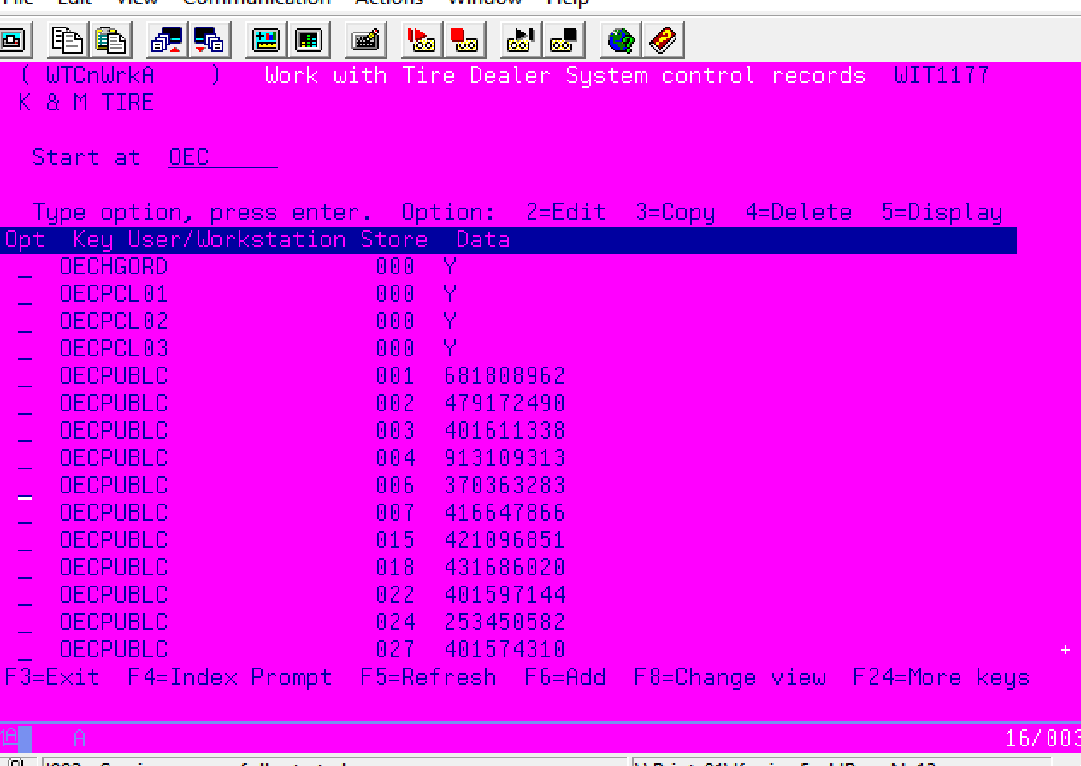
  - Copy one of the existing OECPUBLC control keys.
    - Put a 3 on the line and hit enter.
      - Change the store (location number) to the new store you are setting up and press enter.
    - Under the Data line, you will enter in the new Pub ID that was given to you by OE Connections in the email (Step 1) and hit enter to complete.
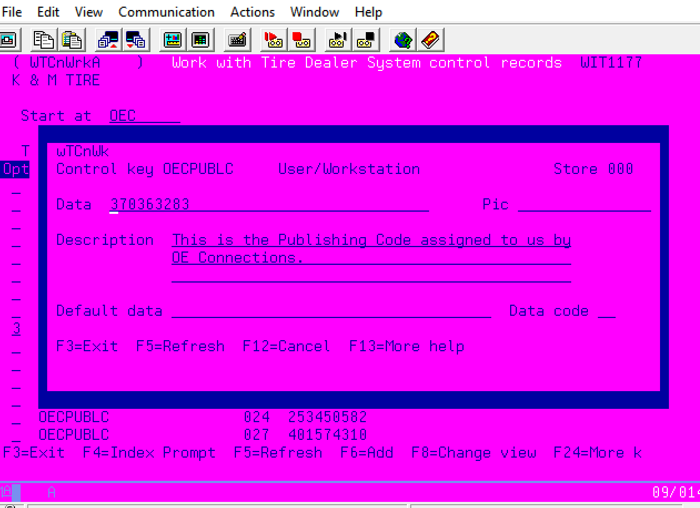
    - Entering Username, Password, File Name provided by OEC in step 1.
      - In MaddenCo follow these steps:
        - 1. Tire Dealer System
15. More Option Menu
4. Data Exchange Menu
20. Additional Interfaces
5. O/E Connections
15. Create O/E Cnct FTP Tran

- To set up the FTP Transaction for the transfer, select the option to Create O/E Cnct FTP Tran.
    - The Name of the transaction can be input here, it will Default to EWFTP
      - Change that to EWFTPxx
        - The xx represents the location number of the FTP.
          - Ex: EWFTP57 would be for location 57 FTP file to be sent over
    - The IP address: ftp.oeconnection.com
    - Username is the information given to you by OE Connection in Step 1 email.
    - Password is the information given to you by OE Connection in Step 1 email.
    - Remote Directory will be left blank.
    - Remote File Name is the information given to you by OE Connection in step 1 email.
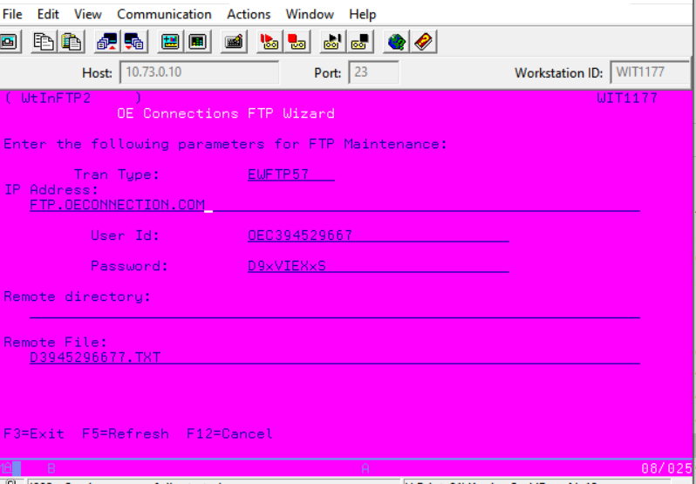

    - Auto Report and Send Setup
  - Setting up Auto Report in MaddenCo to send inventory file to OEC every night.
    - MaddenCo instructions:
      - 20. System Menu
        - Auto Report Maintenance
          - Work with Auto Reports
            - Put a 2 on the line for AUP RUNS EVERY NIGHT
      - You will find the next Sequential number for the OE Connections FTP process.
        - F6 to add a new job.
        - Sequence number (next number in line for OE Connections)
        - Description: OE Connection FTP Location #xx (xx is the location number you are creating this for)
        - ‘Front end’ Program: PTOECPD0
        - Library: GPTIRLIB
        - ‘Back End’ Program: PTOECPD1
    - Step Four: Generate and Transfer File Testing
  - In this step the initial file is generated and transferred via FTP to OEC to determine if connection has been established and data link is functional.
    - MaddenCo instructions:
      - 1. Tire Dealer System
      - 15. More Option Menu
      - 4. Data Exchange Menu
      - 20. Additional Interfaces
      - 5. O/E Connections
      - 1. Send on Hand to OE Cnct
- Select the Store you wish to generate the on-hand file for

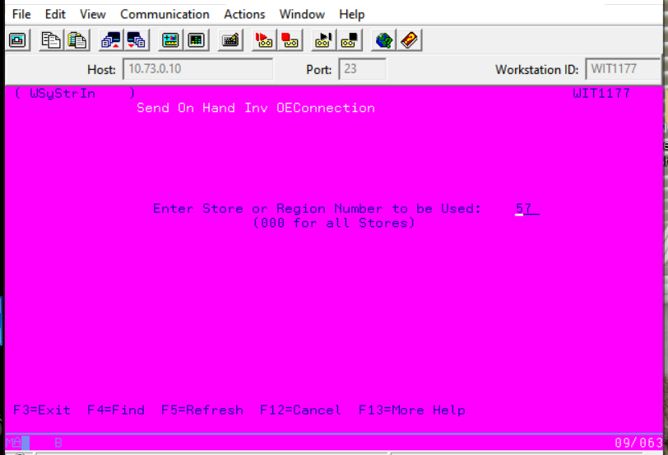
    - Enter through the next screen with the date and report spacing.
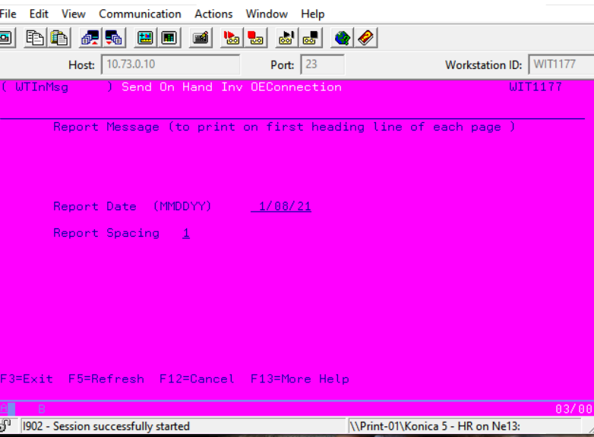
      - Select the Sort order of the products.
        - Enter the order in which you want the report to be printed: 01.
        - 01 Vendor; Prod#
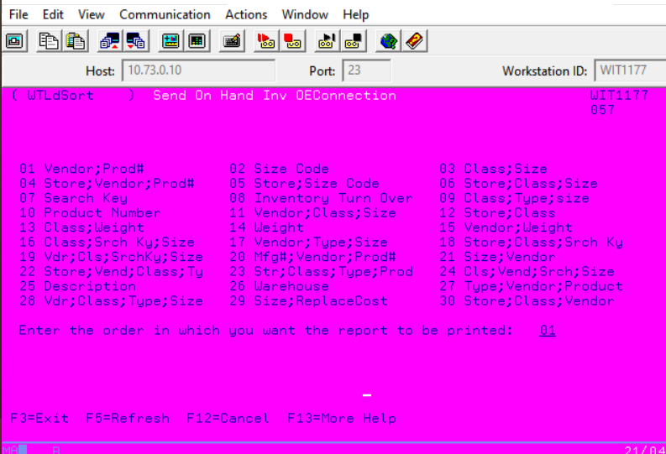
      - Next, select which inventory quantity to be sent as the on-hand Value
        - A = Available quantity (Memo – Allocated)
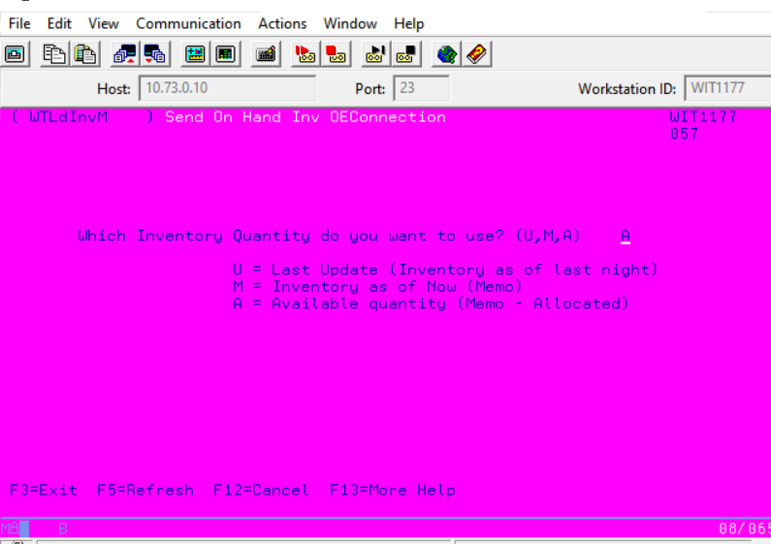
      - Print Items with Zero Amounts Y/N = N
        - By selecting a Value of N, the Zero on hand will not be included in the on-hand file.
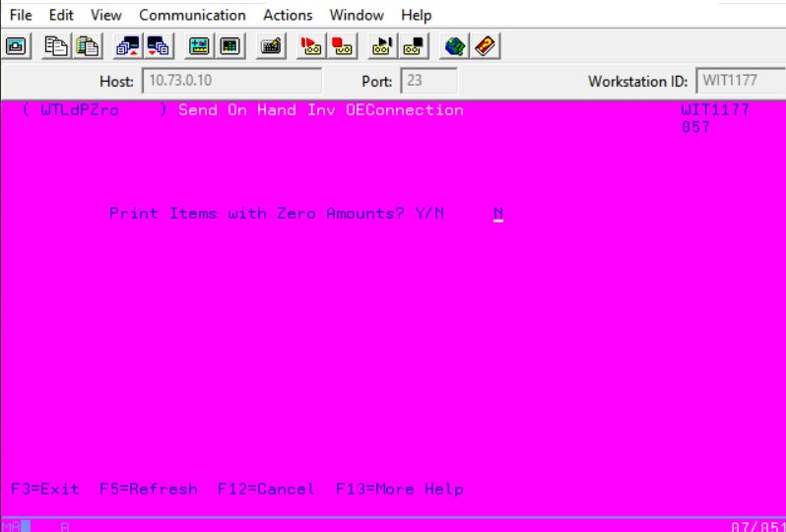
      - The last screen allows you to select which FTP Transaction to use to transfer the file. It will default to EWFTP but the value you need to use will be the one you just created in step 2.
        - Ex: EWFTP57
      - Once you select and run it will bring up a screen if it was successful or if the Transaction failed.
        - If the transaction failed, you would need to start over at step 1 of this document.
        - If successful send an email to OE Connections and the K&M Car Dealer Sales Manager that the connection has been tested successfully
          - Then log change in IT Change Log

Cell Phone
    - Purchased through Verizon Business Account
- Verizon Info
- https://sso.verizonenterprise.com/amserver/sso/login.go
- Login information
      - Cell Phones:
- Verizon Rep:
  - Contact IT Support Manager for current representative contact information.
- Ordering Cell Phones
  - Select Purchase Device & Service
- Select the Device we are currently buying.
        - We buy our devices full retail NOT contract.
- Find a billing account that has an open line.
- Look at another line and look at the plan information.
        - Reference the plan information and select those options when you are creating the new line.
- When picking a phone number, it allows you to put in the area code the phone will reside.
        - Input the appropriate area code for what location it will be in so it will get a familiar phone number.

Cell Phone Maintenance
Note: Age of the cell phone should be considered prior to making any decisions to discard the phone as ‘bad.’
    - Screen is cracked.
- Phones are considered bad.
  - Save the phone until there is a sufficient number to send to PaceButler.
  - They send a prepaid label for shipping to them.
    - Screen is Not Cracked
- Plug in to verify that it holds a charge.
  - If it does not charge, the phone is considered bad.
- Save phone until there is a sufficient number to send to PaceButler.
- They send a prepaid label for shipping to them.
  - If phone does charge, continue charging to at least 50% and proceed to next step.
- Remove from charger and verify if the phone is on IEM/EMM or Knox.
  - If the phone is on IEM/EMM
- The phone is considered bad because we no longer have access to IEM/EMM because they are out of business.
- Save the phone until there is a sufficient number to send to PaceButler.
- They send a prepaid label for shipping to them.
  - If the phone is on Knox
- Let the phone sit idle for approximately 10 minutes to verify if there is significant battery drainage.
      - If the battery drains more than 5% in 10 minutes, the phone is considered bad.
      - Save the phone until there is a sufficient number to send to PaceButler.
      - They send a prepaid label for shipping to them.

Year End Tasks
    - Annually Completed in January
- Clear files out of the IFS/TMP folder on the System i.
  - Open System i Navigator.
    - My connections/10.73.0.10/File Systems/Integrated File System/Root/tmp
  - See chart for file reference:
File | Definition
ARSE**** | K&M Statements
EACTMPSP01.EAC
httpapi_debug | http debug
mlt********** | mmail debug
RPT******* | K&M Accounts Receivable Report - rTAgROL2
sess_***** | PHP session edit
INVC******* | K&M Invoice
SHPN******* | K&M Invoice
- Do a full backup of the System i. (Usually done with PTF process)
  - Run command Go Save and choose option 21, Entire System.
    - This can only be run in a restricted state.
- Send an email to remind users that they can do a “Clean Up” of their files because we have a Year End tape.
  - This could include both files on the file server as well as the email server.
  - Send email to all Managers to clean up their department folders and emails.
    - Example, Inventory & Pricing has large “price folders”.
    - Make sure this is done after we do a year-end backup.
- Run an SQL statement over store *ZERO to check for active items.
  - SELECT *
  - FROM DTA273/TMPROD
  - WHERE PDSTORE = 0 AND PDDELETE ='A'
  - If there are active items that show up, verify they are not active size code.
    - The only way they can be input is with VPROD upload.
    - Manually make these records with a delete code of ‘D’
- Clear last year’s errors out of the “Error Log” within Madden Co.
  - Take option 20, 20, 1 and enter last year’s date range.
- Purge data from within Madden Co. (1, 12, 11) (Before running see notes; Out of Balance)
  - Should be using the date of 12/31/2010 any time after 1/1/2018.
    - Must be at least 7 years on the system.
  - Do not do (1), it is already being done by End of Month and Kelly.
  - If you do not want to keep watching QBATCH, hold QBATCH, run report, change job priority to 4 and then release QBATCH.
    - This will allow all other jobs to run just fine without having to watch and move them.
  - (2) A/R Detail History Purge, last time ran took 3 minutes.
    - Control Key &A/RH000 will be modified/changed automatically.
  - (4) Product History Purge, last time ran took 6 minutes.
    - Control Key &PRDH000 will be modified/changed automatically.
  - (6) Invoice History Purge, last time ran took 8 minutes to run.
    - Control Key &INVHIST will be modified/changed automatically.
  - (8) Sales Purge, last time ran took 1 minute.
    - Control Key &SALES will be modified/changed automatically.
    - Will generate a report.
      - Report needs to be sent to A/R and Credit Manager, Admin, VP of Finance and Controller.
        - TSLSPG
      - Use Current sales to calculate the next day’s Current Sales total report.
        - Sales removed only shows 7 digits.
  - (10) Purchase Order Purge last time ran took 1 minute.
    - Control Key &POPURGE will be modified/changed automatically.
  - (12) Employee Hours Purge, immediate to run.
    - Control Key &EMPH999 will be modified/changed automatically.
  - (14) Vehicle History Files Purge, immediate to run.
    - Control Key &VEHCPRG will be modified/changed automatically.
  - (16) ASN/Vendor Invoice Purge, immediate to run.
    - Control Key &ASNPURG will be modified/changed automatically.
  - (17) Vendor Invoice Purge, immediate to run.
    - Control Key &EVNPURG will be modified/changed automatically.
- Purge data from Doc Record?
  - Per the President from an IT meeting in November 2010, we can purge everything except previous two years.
    - Therefore, this could be 2 years and 11 months of data on Docstar; now Doc Record.
  - Need to find way to do this, after first time, update notes.
  - Because of signature capture, this may not even need to be done, but removed.
- PCI Compliance Items: See document F:\Information Technology\Shared\Documents\PCI Compliance\PCI Self-Assessment Questionnaire for details.
  - Anti-virus section:
    - 5.1.2 Evaluate any computers that have had issues in the previous year to determine if any activity is re-occurring.
    - Computers/Users affected since last year.
  - Policy:
    - 12.8.4: You should verify that all of your service providers are PCI compliant themselves at least once per year.
    - Will need to get updated document from Merchant Partners located in F:\Information Technology\Shared\Documents\PCI Compliance.
  - SSL Security Check:
    - Using 3rd party site (https://www.ssllabs.com/ssltest/index.html) input domain name with SSL applied.
    - Submit the domain, this process takes 1-2 minutes.
    - Based on the results, perform corrective tasks.
- Clean up records in Madden Co. (User & Workstation Items)
  - May be some manual removals within Control Key maintenance, Store Access and System i Users.
    - RazorSQL – F:\Information Technology\Shared\Programmers\RazorSQL Queries\System i – Clean Up
    - You need to run the command that is within the RazorSQL template first, then the queries will work.
  - Remove all, ask if unsure; for example, I left U273MADDENCO because there may be some reason for it.
- Clean filters in Data Center.
  - F:\Information Technology\Shared\Locations\Corporate\Data Center Filters.pdf
- Delete inactive Web Link 1.0/2.0 users.
  - Web Link 1.0 will be all inactive users less than July 1st of previous year.
  - Web Link 2.0 will be all inactive users less than January 1st of previous year.

    - Annually Complete in April/May
- Renew ZEND license in April/May
  - Renewing license requires restart of ZEND server.
  - Should be done after hours or during downtime.

    - Notes
- If you are deleting a store, do not do it in Store Maintenance.
- Use options 1, 15, 7, 15 and 80.
- Out of Balance issues.
- Because purging data takes out the beginning inventory for Part Number History, you will need to run before and after.
- Before meaning before you purge and after meaning after you purge.
- If you find items in the after report, normally about 17 pages, you will need to run the report again with correcting entries to fix.
- Out of Balance “Fix”.
- Options to take to run/fix problem.
      - Report – 1, 15, 7, 15, 3, 10.
      - Select all Stores.
      - Select 10 for what you want printed.
      - After print option select “Y” to create a Correcting entry for any OOB Products.
      - Fix – 1, 15, 7, 15, 3, 3. (Do not run, see below message)
      - Fix doesn’t work as of February 1st, 2013, have to use report and choose Yes at the end to fix.
      - See task; “Out of Balance problem” for issues with previous years or task “Out of Balance with Product History” for most recent issues.

IT Acquisition
    - Physical Asset
All Specific model information for equipment is located in OneNote Equipment Template
- Router and Switch
- Ordered and set up by system admin.
- PC for employees
- Ordered and set up by IT Support
- Desk phones
- Ordered and set up by IT Support
- Phone equipment
- Ordered and set up by system admin.
- Printer and scanner
- Ordered and set up by IT Support
- Paging system
- Ordered and set up by system admin.
- Time clock
- Ordered and set up by IT Support
- Cell phones
- Ordered and set up by IT Support

    - MaddenCo Set Up
- Set up store information – Location Setup – In OneNote – MaddenCo New Location - New Control Keys
- Enter location name and address.
- Make active.
- Store access
  - Give accounting department, IT, credits, AP, and President access immediately.
  - Purchasing, AR, logistics, HR can have access once control keys are set up.
  - Sales and all remaining users get access week of go live.

- Add users.
  - Set up new users and give them the necessary permissions.
    - Review Adding Access for New Users
    - HR will provide a list of names and titles.
- Control keys
- Notes listed in ONE Note – Location Setup - Madden Co New Location - New Control Keys
    - Location setup - madden co new location – control keys.
    - PNQTB will need to be set up to match location data.
      - IT support is email when a change is made on the intranet.
- Customer upload
- Credit will send customer list.
- Notes listed in ONE Note
    - Location setup – New location documentation and setup

- Vendor and customer Cross reference table
- Under store Set up F2 to access info – see example below.
    - Purchasing will give you vendor information.
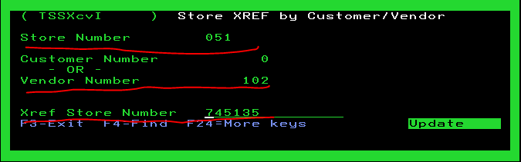
- OE Connection
- Car Dealer Sales Manager will request the information to start sending file.
    - Typically wait a month or more from go live.
    - Paper documents in folder in IT room – OECA INFO
      - Detailed instruction of how to insert into MaddenCo
    - Example of data received.
FTP Site: ftp.oeconnection.com
Name: K&M Tire – Winters / Winters, TX
Publication ID: 416668164
Inventory File Name: D4166681647.TXT
FTP User ID: OEC416668164
FTP Password: Will be provided on a separate email.

    - Intranet Set Up
- Setup location Data and make active.
  - Needs inserted into the file manually – Run the below query and update storenum
UPDATE
KMTDTA."STORES"
SET ACTIVE = 'Y'
WHERE STORENUM = 50;

Needs updated to reflect new location data, adding Sold to Customer Number, and email addresses.

- Make internal sites active.
- Hard code new location into dropdown list
    - Notify the developers.
- Developers would then update.
    - Instructions below
Update Function selectStore(), selectStore2(), selectTempStore() in Intranet2\htdocs\includes\functions.php
Case by case basis to update individual reports that might not be using these functions but have a store dropdown.
Generally, we search for any script that has KMTDTA.STORES and update it manually to include a location that isn’t ready to be made active.
- Future plans include a middle status that we can set up to make it Inactive on the live sides but, active Internally.

- Go Live makes all sites live.
- Internal
- Intranet – just need to verify new location is in drop down lists.
- External
- KMTire.com
        - Needs map updated.
        - Marketing puts dot on location map.
- Weblink2
        - Will show up under locations.
        - Verify location shows up as an option to order from.

    - Go Live Preparation
- Contact Manager or Owner to find out current set up.
- Phone provider and current setup
- See Section 27.4.2 for additional information.
- Internet provider and speed
- See Section 27.4.2 for additional information.
- PC’s / terminals
- Current inventory system / MaddenCo
- Paging system
- Internet/Phone Services
- The Director of Support Services will be responsible to ensure the collection of the current provider contact information.
- The Director of Support Services will contact the provider or will assign a System or Network Administrator to contact the provider to transfer services.
- The contacting IT Team Member will be responsible for verifying the account was transferred properly and will monitor the account until the transition has been completed.
- In the event that services cannot be transferred, the Director of Support Services will order the required services, verify service implementation and cancel existing services.

- Pack and Ship Equipment
- Items are given to Security. They will pack IT items.

- Verify everything – Check all items below.
- Make sure supplies arrive.
- Make sure the inventory team schedule didn’t change.

    - Clean Up – AR Upload of Invoice Details (All New Re-write)
This SOP section is in place to make sure our AR Upload process is clean and accurate for an acquisition. This will include verifying and scrubbing the data prior to upload and then confirming with Accounting and/or Administration that the numbers tie out and balance.
- Prior to Preparing AR Upload file IT must complete the below steps.

- Check TMAROP for items with invoice # of 0
- SELECT *
- FROM DTA273.TMAROP
- WHERE TARONUMINV = 0;
- Run a VLOOKUP on customer upload list to find existing customers with previous uploads
- If there are no customers with “0” as invoice number on the Customer Upload List, proceed to Step 4 and skip the next step.
- If you see records with invoice numbers as “0” for any customers needing to be uploaded, please proceed to the next step and complete.

- For customers that have had previous invoices uploaded at one time and have invoices with “0” as the invoice number please follow the below instructions:
- Set the Starting Sequence number for the first AVAILABLE invoice to be uploaded as the next available Sequence number on the upload sheet.
    - Example if customer has 5 previous entries that were uploaded previously on the new upload file you would start at Sequence 6 for the first invoice to be uploaded and so on.
    - This will need completed and double checked for each of these customers prior to uploading to MaddenCo.

- AR upload
- If creating the A/R file from scratch:
    - VAR00SEQ – incremented from 1 -? (total invoice line count)
    - VAR01NBCUS – Customer number
    - VAR02NBINV – Can be Blank or valid invoice number
    - VAR03NBCNT – Needs Incremented if multiple invoices per customer
    - VAR04BREF – Reference number prefixed with 2 letter initials for new company
    - VAR05DATTR – Date field
    - VAR06DATTR – Date uploaded field
    - VAR07AMNT - Needs positive numbers only
      - Items marked with C will automatically show up as a credit
    - VAR08TRNCD –Type of transaction – mandatory
      - AJ – Adjustment, BF – Balance Forward, C - Credit, FC – Finance Charge, I – Invoice, LF – Late Fee, PM – Payment, SC – Service charge
    - VAR09NBSTO – store input – typically always location 1
  - After that you can initiate the Madden Co. program to make the actual adjustments. CALL MVCONVER – Option 8.
  - Credit will send AR list.
    - F:\Information Technology\Shared\Programmers\New Store\Inventory & AR
  - IT will use the file listed below to upload the details into MaddenCo.
    - F:\Information Technology\Shared\Programmers\New Store\Inventory & AR\Midwest Tire\VAR\DTA273\VAR
    - Location setup – New location documentation and setup
      - AR adjustment procedure
  - Notes listed in ONE Note
    - Location setup – New location documentation and setup
      - AR adjustment procedure
  - To review what was just uploaded in madden Co.
  - 1) Tire Dealer system, 1) accounts receivable, 8) Customer Inquiries, 1) Customer Balance Inquiry, 000) all stores, F9 enter customer #, 6) to view Open A/R
  - Send DanL excel sheet with Query to open A/R
  - Example AWTARQRY.xlsx
  - Send confirmation of upload to VP of Finance, Controller and Credit Manager.

New Location Install
    - Physical Asset
All Specific model information for equipment is located in OneNote-Equipment Template
- Router and Switch
- Ordered and set up by system admin.
- PC for employees
- Ordered and set up by IT Support
- Desk phones
- Ordered and set up by IT Support
- Phone equipment
- Ordered and set up by system admin.
- Printer and scanner
- Ordered and set up by IT Support
- Paging system
- Ordered and set up by system admin.
- Time clock
- Ordered and set up by IT Support
- Cell phones
- Ordered and set up by IT Support

    - MaddenCo Set Up

- Set up store information – Location Setup – In OneNote – MaddenCo New Location - New Control Keys
- Enter location name and address.
- Make active.
- Store access
- Give accounting department, IT, credits, AP, and President access immediately.
- Purchasing, AR, logistics, HR can have access once control keys are set up.
- Sales and all remaining users get access week of go live.

- Add users.
- Set up new users and give them the necessary permissions.
    - Review Adding Access for New Users
    - HR will provide a list of names and titles.
- Control keys
- Notes listed in ONE Note – Location Setup - Madden Co New Location - New Control Keys
    - Location setup - madden co new location – control keys.
    - PNQTB will need to be set up to match location data.
    - IT support is emailed when a change is made on the intranet.
- Customer upload
- Credit will send customer list.
- Notes listed in ONE Note
    - Location setup – New location documentation and setup

- Vendor and customer Cross reference table
- Under store Set up F2 to access info – see example below.
    - Purchasing will give you vendor information.

- OE Connection
- The Car Dealer Sales Manager will request the information to start sending file.
    - Typically wait a month or more from go live.
    - Paper documents in folder in IT room – OECA INFO
      - Detailed instruction of how to insert into MaddenCo
    - Example of data received.
FTP Site: ftp.oeconnection.com
Name: K&M Tire – Winters / Winters, TX
Publication ID: 416668164
Inventory File Name: D4166681647.TXT
FTP User ID: OEC416668164
FTP Password: Will be provided on a separate email.
    - Wise Set Up
- Contact Project manager for installation details.
- Warehouse layout
- Store access
- Give accounting department, IT, credits, AP, and President access immediately.
- Purchasing, AR, logistics, HR can have access once control keys are set up.
- Sales and all remaining users get access week of go live.
- Add users.
- Set up new users and give them the necessary permissions.
    - HR should have a list of names and titles.
- Control keys
- Notes listed in ONE Note
    - Location setup - madden co new location – control keys.
    - PNQTB will need to be set up to match location data.
    - IT support is email when a change is made on the intranet.
- Customer upload
- Credit will send customer list.
- Notes listed in ONE Note
- Location setup – New location documentation and setup
- Vendor and customer Cross reference table
- Under store Set up F2 to access info
- Purchasing will give you vendor information.
- OE Connection
- Marketing will get the information to start sending files.
- Typically wait a month or more from go live.

    - Intranet Set Up
- Setup location Data and make active.
  - Needs inserted into the file manually – Run the below qry and update storenum
UPDATE
KMTDTA."STORES"
SET ACTIVE = 'Y'
WHERE STORENUM = 50;

Needs updated to reflect new location data, adding Sold to Customer Number, and email addresses.

- Make internal sites active.
  - Hard code new location into dropdown list
    - Notify the developers.
  - Developers would then update.
    - Instructions below
    - Update Function selectStore(), selectStore2(), selectTempStore() in Intranet2\htdocs\includes\functions.php
    - Case by case basis to update individual reports that might not be using these functions but have a store dropdown.
    - Generally, we search for any script that has KMTDTA.STORES and update it manually to include a location that isn’t ready to be made active.
  - Future plans include a middle status that we can set up to make it Inactive on the live sides but, active Internally.

- Go Live makes all sites live.
  - Internal
    - Intranet – just need to verify new location is in drop down lists.
  - External
    - KMTire.com
      - Needs map updated.
      - Marketing puts dot on location map.
    - Weblink2
      - Will show up under locations.
      - Verify location shows up as an option to order from.

Sophos Notification
    - Critical Incident Found
- If there is a critical incident found by the Sophos Managed Thread Response (MTR) service, three designated MTR Authorized Contacts in IT should be contacted via office phone, email, or cell immediately.
  - The designated employees will then collaborate with us to resolve the incident.
  - If none of the MTR Authorized Contacts can be reached, the IT employee who noted the critical incident should take the actions needed to resolve the incident.
- This will also prompt an investigation by following the “Threats Detected on Network” SOP.
- The three MTR Authorized Contacts are:
  - Jerry Henery
  - Doug Bockrath
  - Carter Teman
- If Doug is not the person contacted initially, he should be notified immediately and will take the next steps to communicate as needed.
    - Lower-Level Incident Found
- All other lower-level events found by the Sophos Intercept AV/security software generate email notifications to these accounts:
  - IT Support
  - Sys Admin
  - Jerry Henery
  - Carter Teman
    - All other items
- If another suspicious item is located that warrants further investigation, Sophos MTR should be contacted at:
  - For immediate attention
    - 888-201-7672, option
  - For less urgent requests
    - Email mtr-ops@sophos.com

Cyber Security
    - Spam
- Spam Filtering
- A software routine that deletes incoming spam or diverts it to a "junk" mailbox.
- Scam Email Testing
- A spam test checks your email to see whether certain spam filters will flag it and move it out of your inbox.
- The test looks at the content of your email and where you are sending it from.
    - SFTP
Secure File Transfer Protocol – it is used by the developers for secure transfer to 3rd parties for program data and inventory feeds.

- Below is a list of companies that K&M developers currently transmit data to through SFTP.
  - Belle
  - Bridgestone
  - Chase
  - Continental
  - Cooper
  - Falken
  - Hankook
  - Mastercraft
  - Mikey Thompson
  - Pirelli
  - Yokohama

    - HTTPS
HTTPS is used for the transfer of secured information over the web.
- A wildcard certificate is managed by GoDaddy for all *.kmtire.com sites. This includes:
  - kmtire.com
Primary K&M Tire website
  - mail.kmtire.com
Management domain for email system
  - webmail.kmtire.com
User domain for accessing features of the email system.
  - weblink2.kmtire.com
Customer system
  - webservices.kmtire.com
Vendor and customer system for programming
  - 3cx.kmtire.com
Phone system
- Tire Images Hosting
  - The domain tireimages.com is the hosting site for images that K&M shares across web sites.
  - This domain, its FTP site, and certificate are managed through Network Solutions.
  - The modules that programming uses for several of our systems require that these images be on a secure site.

    - Firewall Security for Outside Access –
Access to the servers in Corporate is limited by a firewall that is dedicated to managing this access. All traffic that routes to the branch locations is done over a Virtual Private Network that is separate from the firewall system.
- DNS Mapping
  - The table below shows the DNS configuration and how it is mapped into our IP ranges.
Record | Name | External IP
A | autodiscover | 70.63.17.68
A | webservices.kmtire.com | 70.63.17.72
A | kmtire.com. | 70.63.17.67
A | mail.kmtire.com | 70.63.17.68
A | webmail.kmtire.com | 70.63.17.68
A | weblink2.kmtire.com | 70.63.17.70
A | 3cx.kmtire.com | 70.63.17.73
A | *.big3tire.com  *.mrtireoutlet.com | 70.63.17.75
A | big3tire.com  mrtireoutlet.com | 70.63.17.69
PTR | 70.63.17.68 | mail.kmtire.com.
TXT(SPF) | kmtire.com. | “v=spf1 a mx ip4:70.63.17.68 -all”
- Port Mapping
  - The table below shows a port mapping of how the firewall allows outside access to the internal servers.
Reverse Proxy Outline
Site | Port | Server
Intranet | 80 | 10.73.0.10
brfs.kmtire.com | 81 | 10.73.0.10
big3tire.com | 83 | 10.73.0.10
bigthreetire.com | 83 | 10.73.0.10
kmtire.com | 84 | 10.73.0.10
mrtireoutlet.com | 85 | 10.73.0.10
Big3tire / mrtireoutlet customer sites | 87 | 10.73.0.10
tireweblink.com | 88 | 10.73.0.10
*.tireweblink.com | 88 | 10.73.0.10
djtire.tireweblink.com | 88 | 10.73.0.10
Paid Site Forward | 90 | 10.73.0.10
HTTP/HTTPS Firewall Port Outline
Incoming traffic is port 80/443. The port column is the internal port on the server.
HTTPS Site | Ext IP | Port | Server
kmitre.com | 70.63.17.69 | 444 | 10.73.0.10
kmtire.com | 70.63.17.69 | 84 | 10.73.0.10
exchange (webmail/owa/utodiscover) | 70.63.17.68 | 443 | 10.73.0.46
exchange (webmail/owa/utodiscover) | 70.63.17.68 | 80 | 10.73.0.46
weblink2.kmtire.com | 70.63.17.70 | 449 | 10.73.0.10
weblink2.kmtire.com | 70.63.17.70 | 86 | 10.73.0.10
webservices.kmtire.com | 70.63.17.72 | 451 | 10.73.0.10
webservices.kmtire.com | 70.63.17.72 | 92 | 10.73.0.10
3cx.kmtire.com | 70.63.17.73 | 80/443 | 10.73.0.22
Big3tire / mytireoutlet Customer Portal | 70.63.17.75 | 87 | 10.73.0.10
Customer Portal Outline
Domain Name | Forwards To
cpi.mrtireoutlet.com | http://cpi.mrtireoutlet.com/mrt/cpi/index.html
deanstire.big3tire.com | http://deanstire.big3tire.com/b3t/deanstire/index.html
degenhardt.mrtireoutlet.com | http://degenhardt.mrtireoutlet.com/mrt/degenhardt/index.html
dickstirebarn.big3tire.com | http://dickstirebarn.big3tire.com/b3t/dickstirebarn/index.html
jonestires.mrtireoutlet.com | http://jonestires.mrtireoutlet.com/mrt/jonestires/index.html
trucktiresales.mrtireoutlet.com | http://trucktiresales.mrtireoutlet.com/mrt/trucktiresales/index.html

    - Creating NordLocker Cloud Account
NordLocker is an encryption tool anyone can use to protect their files from snoopers, hackers, and advertisers. NordLocker can secure files and sync them via a zero-knowledge cloud for easy access at any time. This is the encryption tool K&M Tire requires all sensitive & secure data to be encrypted through when sending through email networks:

- Go to NordLocker website to sign up.
  - Cloud.nordlocker.com
- Select “Create Nord Account”
- Input your company email account.
- A verification email will be sent to your email with a code you must input
- Then you must create a password using the requirements needed (length, complexity, etc.)
- Once logged in, you must create a NordLocker Key that will allow you to encrypt your files. This should be different from your login password.
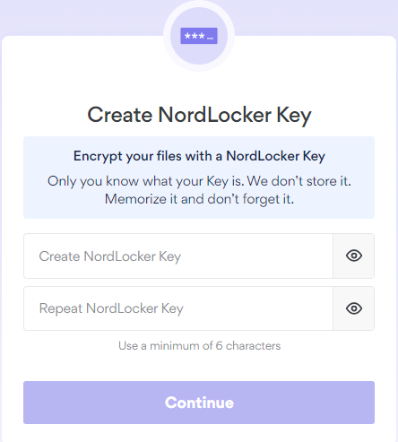

- After you create your NordLocker Key, they will provide you with a Recovery Key for your account. This is important because if you forget your key this is the ONLY way to recover your account and reset your password.
- PLEASE SAVE THIS KEY IN A SAFE PLACE
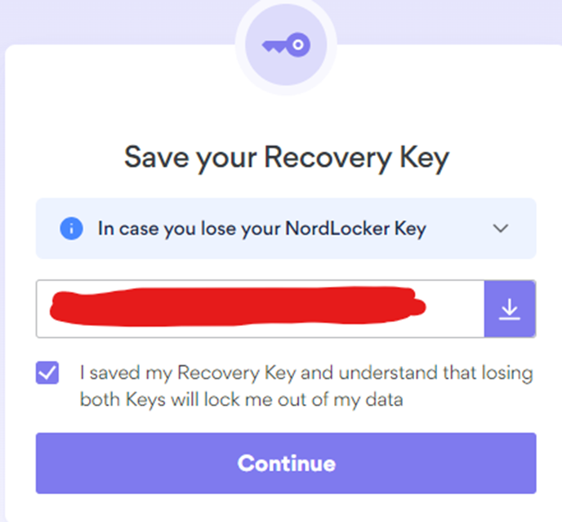.

9. After this your account is set up.

    - Using NordLocker File Encryption
This section will spell out how and when to use your NordLocker Cloud Account for transmitting sensitive and confidential information over the company email network. This includes creating a locker, sending files through your secured link and proper communication of your encryption passwords:
- When in your NordLocker Account at cloud.nordlocker.com and after signing in, you can start with “Create a locker” option.
- This will allow you to create a location (locker) to upload files for encryption.
- Enter the name of your locker you would like to create. This is like creating a folder you would put files in on your PC.
- Once you have a locker setup, you can add a file or folder that would need to be encrypted for sharing by clicking the “Upload” button.

- After files are uploaded you can select the file and make sure it is check marked as shown below and then click the “Share a copy” button circled in red below.
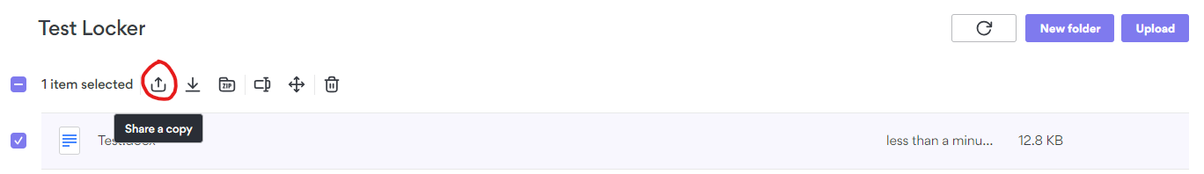
- When you click this it will pop up asking to Generate a Link. Click the “Generate Link” button. This will create both a link to share and a security code to open the link.

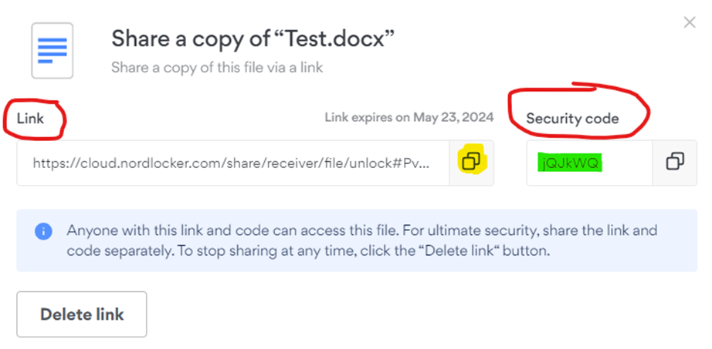

- At this point it is important to understand that you will copy the link by clicking on the yellow highlighted button.
- Create a new email and make sure you have verified the email address of the person you are sharing the sensitive information with.
- Then you will paste the link into the body of your email to whomever you need to share your encrypted file.
- Send the email letting the receiver know that you will need to contact them by phone to verify the link and to provide the “Security Code” to open the file.
- The Security Code is highlighted in Green below and will need to be sent through another channel to the receiver of your encrypted file.
  - Phone is best to verify the user’s voice and if you could text the code as well to the person it would be a good dual verification.



- It works to be speaking to the user opening the file to verify that they were able to open the file and view the confidential or sensitive information that is required.
- After you are done and the receiver does not need the link or file anymore you should go back into your NordLocker account and delete the file from your locker.
  - This is done by selecting your file and clicking the “Delete” button.
  - This will deactivate your file and link that was sent so no other person can access.
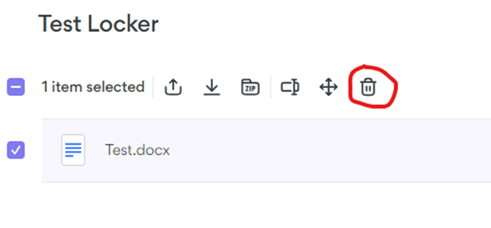
14. Click “Delete” and confirm and then the file will be removed from your locker.
15. The last step is to logout of your account so no one can access your information.
- Click on the circle icon at the top right and then select “Log out” as shown below.

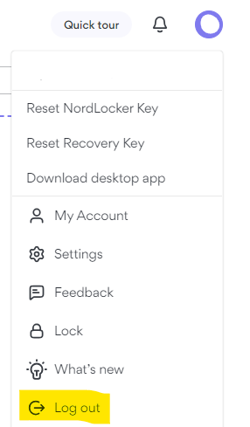

Sophos User Quarantine
    - Daily Emails
- At 7 am Monday – Friday, the Sophos system will email users with a list of Quarantined messages.
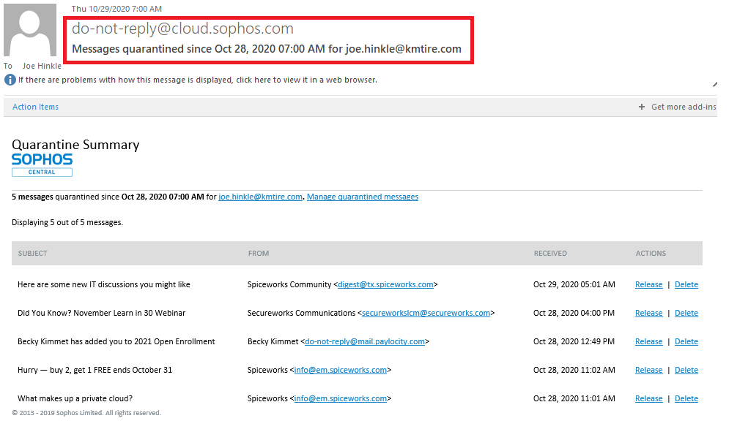

    - Email Contents
- The email contains a table showing the Subject, From, Received Time, and Available Actions.
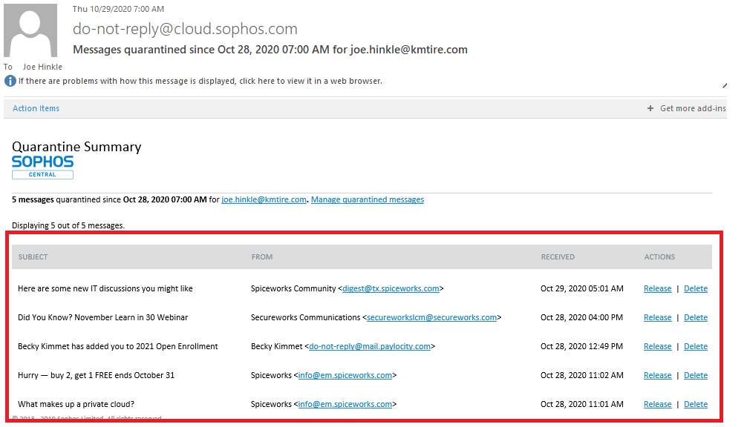

    - Release/Delete Action Links
- If a message is legitimate and you want to receive it you can click the Release link.
- If a message is spam and you want to remove it from the quarantine, you can click the Delete link. Messages in Quarantine are removed automatically after 30 days.
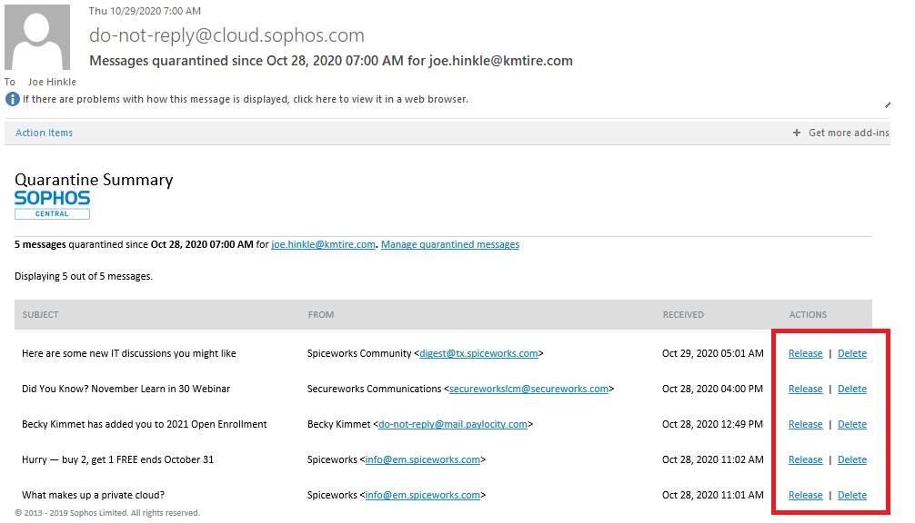
    - Releasing a Legitimate Message
- When you find an email that was mistakenly quarantined click on the release button to send it to your mailbox
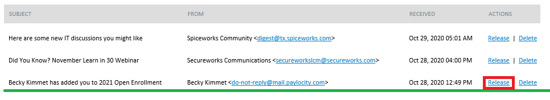
- A web page will pop up letting you know the message was released.
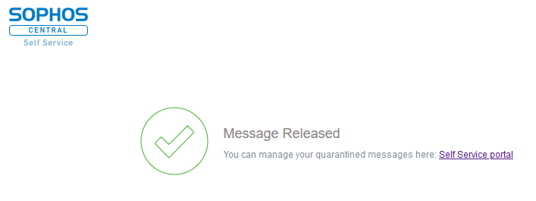

Using the Sophos Self Service Portal
    - Log into the Sophos Portal
1. Open https://cloud.sophos.com/manage/self-service in a web browser.
2. Login with your company email address and password you set up for Sophos.
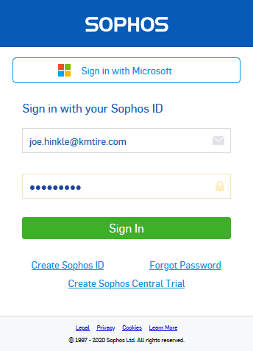

    - Navigating the Sophos Self Service Portal
1. In the left pane, Email should be highlighted. If it isn’t, click on email.
2. Click on Quarantine (#) in the right pane. This will take you to view your message in Quarantine.
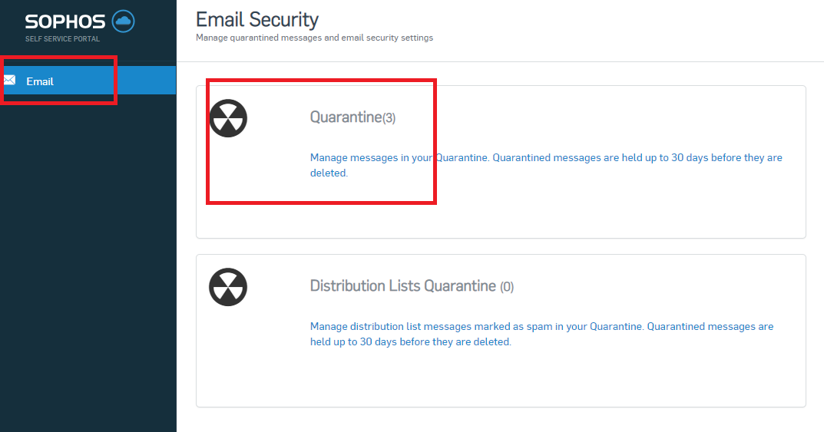
3. You can view, Release, and Release and Allow. You can also Delete and Delete and Block.
  - Clicking the Release button will allow the message through to your inbox.
  - Clicking the Release and Allow button will release the message and add the sender to a whitelist to allow future messages through.
  - Clicking the Delete button will delete the message and will not send it to your inbox.
  - Clicking the Delete and Block button will delete the message and add the sender to a blacklist to block all future messages.

Threats Detected on the Network
    - Preparation
The goal is to gather information and form a hypothesis on what is happening inside the network. IT needs to gather any observables or IOCs (Indicators of Compromise). Observables vary from case to case, and there could be many of them. Using TheHive & Cortex, IT is able to analyze the following types of observables: autonomous-system, domain, file, filename, fqdn, hash, hostname, ip, mail, mail-subject, other, regexp, registry, uri_path, url, and user-agents. (Not all of these are available to analyze, due to our use of free analyzers.) These are going to be crucial in the following stages of the investigation. This is when a case will be created inside TheHive. This will keep track of the observables and any updates on the case.

- Creating Cases – To create a new case, login to TheHive and click “New Case” in the top left. Once the window appears, fill in the following fields:
  - Title – Input a title for the case.
  - Date – The Hive automatically inputs the current date, only changes if necessary.
  - Severity – Select one of the severity levels (varies from case to case). Defines how the case affects the organization overall. The severity levels are as follows:
- Low – The case has little to no impact on the company.
- Medium – The case is a priority, if left unresolved it has the potential to affect the company.
- High – The case is of high priority and affects some users of the company.
- Critical – The case needs resolved immediately, and directly affects all of the company.
  - TLP (Traffic Light Protocol) – Select one of the following (varies from case to case). This defines what information/observables can be shared inside and outside of the Organization. Here are your options:
  - White – No restrictions
  - Green – Caution sharing information externally.
  - Amber – Share with ORG only
  - Red – Do not interact.
  - PAP (Permissive Actions Protocol) – Select one of the following (varies from case to case). This defines what actions will be taken on an observable. The options are:
  - White – No restrictions
  - Green – Caution sharing information externally.
  - Amber – Indirect action permitted against the observable.
  - Red – Do not interact.
  - Tags – input tags relevant to the case.
  - Description – Enter a description for the incident.
  - Case Tasks – Enter applicable case tasks. Templates can also be created.

- Adding observables – After a case has been created, click it to see more details. There will be a tab called “observables”. This is where they are input. Creating an observable is similar to creating a case. Select the “Add Observable(s)” button, and input the following:
  - Type – Choose the type of observable being input.
  - Value – Input the observable itself in this field.
  - TLP – Choose the TLP level for the observable.
  - Is IOC? – If it is an IOC, click the star to collect
  - Has been sighted? – If it has been sighted on the network, click the slider
  - Ignore similarity? – if set to true, it will be ignored when fetching cases similar to the alert.
  - Tags – input tags that are relevant to the observable.
  - Description – Input a description for the observable.

    - Identification

- Once data has been collected, IT staff is ready to begin the identification process.
  - After creating a case on TheHive, input the observables into the case.
  - Then run analyzers against the observables. These analyzers will search different databases on the internet and report back any findings.
  - After the reports are returned, IT will analyze the findings, and possibly run more analyzers on the observables.
- Running Analyzers – Select the observable(s) to analyze and click the drop-down box right next to “Add Observables” and click “Run Analyzers”.
  - Select analyzers from the list provided by Cortex.
    - Find the appropriate analyzer and click “Run
Analyzers”.
    - The job progress should be running on the right-hand pane.
    - Once complete, reports are returned on the observable.
    - To open and view, click the analyzer name under the observable.
  - At this point in the Identification stage, IT staff will continue the investigation or be alerted if it is a false positive. If the observables come back as malicious or questionable, continue to the Containment stage of the investigation.

    - Containment
- After the first two stages, if a malicious actor is found on the network or if there is still a level of suspicion, begin the containment stage.
  - If a greater threat is on one machine, it is likely that it will/has spread to others.
  - GRR will help identify how many machines are affected.
  - GRR will run hunts on the entire network by searching every device on the network for the observables/IOCs (As long as GRR client is installed on the device).
- Hunt Manager – All hunts will be running through the “Hunt Manager” inside of GRR.
  - Once logged into GRR, Hunt Manager is found on the left sidebar.
  - From here, IT staff can create a new hunt, stop a hunt, modify a hunt, copy a hunt, or show automated hunts.
    - Creating a new hunt – To create a new hunt, click “New Hunt” button. A dialogue box should appear.
    - Begin to configure the hunt. There are many options presented and each has a description with different options that will need set.
    - Click next to proceed.
    - The next step will be to configure the hunt parameters.

    - Some of these options include Description, Client Limit, Crash Limit, Expiry Time, and Client Rate. There are more advanced options which can be set as well, these mainly have to do with hardware and network resources.
    - After configuring these parameters, click next to continue.
    - On the next page, the user can select output plugins. Two are currently setup, BigQueryOutputPlugin and EmailOutputPlugin.
    - Select either one of these or configure the required settings.
    - Click next to continue.
    - For the next page, the user will configure where the hunt will run.
    - There are several options for this.
    - It can match systems with different rules such as: OS, Label, Regex, and Integer. Configure this to fit the needs of the task.
    - Once done configuring, click next.
  - The last page is a review page.
- Verify all the settings for the hunt are configured correctly.
- Click “Create Hunt.”
- From here, the hunt should show up in the list in the Hunt Manager, user can run it from here.
- This will give information needed for containment.
  - From here, depending on the situation, there are many options.
  - The main goal in any situation is to isolate any of the affected devices from the network to prevent further escalation after gathering the information from GRR.
  - This needs completely quickly, before the attacker notices and reacts.
  - It is recommended to run another GRR hunt after we have isolated/removed the devices from the network to ensure it does not continue to spread.
    - Eradication
- After the malicious actor has been contained, begin the Eradication stage
- Eradication can be a tedious process, and it will vary depending on the situation.
- This will most likely require external research and possibly help from Sophos.
- The process will vary, but once an eradication plan is made, the user will begin to perform the eradication process on each of the effected machines.
    - Recovery
- After the eradication stage, it is possible that data has been lost or the attacker may have broken some of the servers.
- The goal of the Recovery stage is to remediate all of these “post-attacker” issues.
- This could involve restoring from backups, reformatting, re-setting up users, etc.
- This stage is considered complete once all of the affected devices have been cleaned of the attacker and IT has restored the machine(s) to a functional state.
- User will need to verify that all systems are clean and functioning properly after the attack before being considered ‘recovered.’
- It is recommended to perform another GRR hunt or running triage scripts, to completely verify that the attacker is no longer on the network.
    - Lessons Learned
- This stage is essentially a reflection on what happened.
  - Why did it happen?
  - How can we prevent it in the future?
- It is recommended to complete an incident report that includes all of these reasons.
  - Once comfortable with the MISP platform and sharing valuable information, users can begin sharing the data collected with the greater Information Security community.
    - Report Out
- Send reflection from Stage 6 (what happened, how to prevent in the future) within 10 business days to:
  - IT Managing Director
  - President

Milestone Server Set Up
    - Server Set Up
- Install windows 10.
- Move server to camera server AD Group
- Remote on to server
  - Right Click Start menu – Open Disk Management.
  - Initialize Disk –
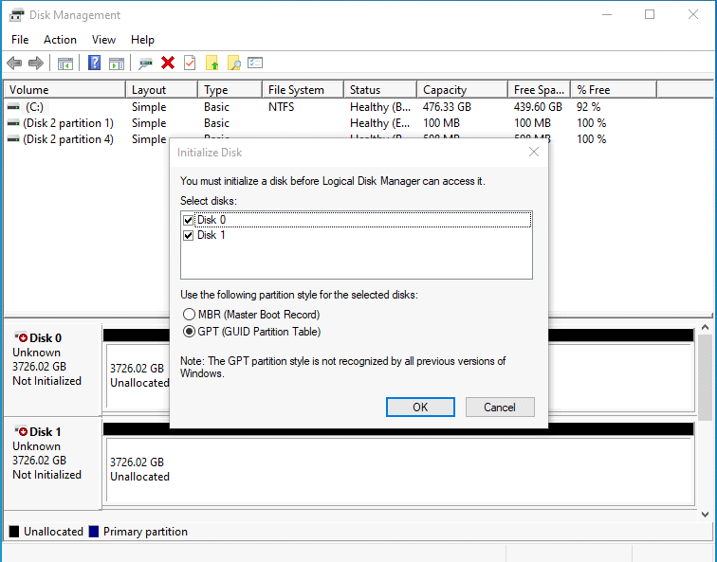
- Create a new Volume.
  - Lager locations Get 3 drives.
    - 2 spanned to create larger Live Recording Drive - D:
    - 1 Simple Volume to Archive Drive - E:
  - Smaller locations Get 2 drives.
    - 1 Simple Volume for Live Recording Drive - D:
    - 1 Simple Volume for Archive Drive - E:
  - Use default volume size.
  - Verify correct drive letter.
  - Format volume wizard
    - Change allocation unit size to 64K.
    - Change Volume label.
    - Check the box “Perform a quick format.”
    - See below screen shot.
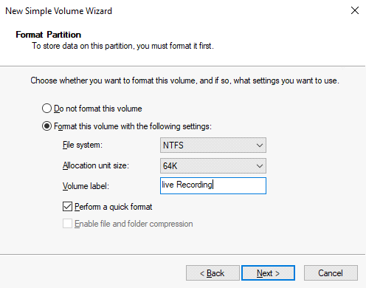
    - Repeat for Archive drive.
- Set Time and date to proper region.
- Check Power setting to make sure system is not set to turn off or go to sleep.
- Copy install file to new folder on Desktop.
  - F:\Information Technology\Public\Approved Applications\Milestone
    - MilestoneXProtectRecordingServerInstaller_x64
    - MilestoneXProtectVMSLegacyDriverInstaller21b23067854
- Run the installers.
  - MilestoneXProtectRecordingServerInstaller_x64
    - Typical – Install
    - Settings
      - Change Management name to CAM-MGMT
      - Verify Media database location.
      - Set retention time to 30 days.
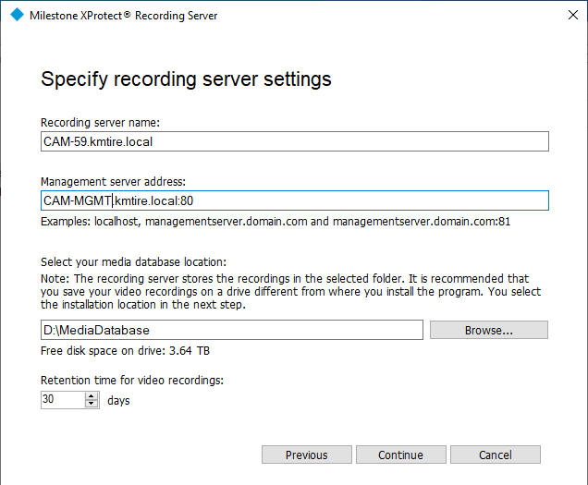
- Encryption
  - Uncheck both boxes.
  - File location
    - Leave default location.
      - C:\Program Files\Milestone/
  - Click install.
- Install Device Driver pack.
  - Use default File location.
  - Basic Recording Server is complete – Change IP after setting it up on Management server!
- Set up Server on CAM_MGMT
  - Open Management Client
    - Servers
      - Recording servers
        - F5 to refresh if server is not in the list.
  - Click on the server you are setting up.
    - Open the storage tab.
      - Double Click the Recording tab to open settings
        - Change max Size to match recording database Size.
          - 7000 GB for larger locations
          - 3500 GB for smaller location
        - Add archive.
          - Set path to E:
          - Retention Time 31 days
          - Max Size 3500 GB
- Add View Group
  - Add a View Group to match location.
- Add Device Group Folder
  - Device
    - Cameras
      - Right Click Cameras
        - ADD Device Group to match the location.

Zebra Label Ordering
Summary: To identify what the labels are used for and when to order.
    - Identify what is ordered and its use
- Roll of 4” Ribbon
  - Used in ZT400 label printer for 3” and 4” Label printing.
- Roll of 3x5 White
  - Used for Bin labels for wise system.
  - Standard B, C, and D levels
- Roll of 3x5 Yellow
  - Used for Bin labels for wise system.
  - Standard A Level
- Roll of 3x5 Light Blue
  - Used for Bin labels for wise system.
  - Standard Temp Label on bins that are scheduled to be moved.
- Box of 4x6 White (Extra Sticky)
  - Used for Identification Tags and Shipping labels on Tires.
  - Locations with wise or Locations that ship Ecommerce.
- Roll of 4x6 Red
  - Used for RAR Labels
  - Adjustments use them to mark tires to be returned to Customer.

    - When to order and what quantities.
- 4” Ribbon - Comes in a case of 24
  - Try to keep enough on hand to match the number of labels we have on hand.
  - 1 roll = case or Box of Labels
- 3x5 bin labels come in a case of 8 rolls.
  - Order when a case is getting low.
  - Labels are printed approximately one month prior to wise go live.
    - Plan for 5-6 wise locations per year
  - 4X6 White (Extra Sticky)
    - Order 40 cases
    - Labels are ordered when we are down to about 5 or 6 left since we send 4 cases to a location at a time.

    - Where and how to order.
- unitedlabel.com - email Pete and Kelly for orders
  - jmurphy@unitedlabel.com
    - John Murphy - shipping
  - pmurphy@unitedlabel.com
    - Pete Murphy – sales
  - kcarr@unitedlabel.com
    - Kelly Carr – customer service

Existing User Requests
Summary: The user access request is a critical process within the IT department so security standards can be maintained. As a general rule, IT should always error on the side of caution when giving access to new data and be vigilant in questioning anything that may raise red flags.
    - Requests should be brought to the attention of their supervisor or manager.
- Based on the request
  - Manager can approve the request.
  - Or the manager can take the request to the next level.
    - If approved.
- Requests should be sent to IT Support, and they can either make the change.
- Or escalate approval process to President.
    - If supervisor is unsure.
- They can request explanation of request or further authorization.
- Can look at people that do similar work and compare access.
    - If denied.
- Supervisor should question why user needs the access they requested.
  - Are there any security concerns?
    - IT should review all requests.
- If there are any concerns, they should bring the concern to their immediate supervisor for verification and approval.

Daily System Check
    - Log into as400 admin account
- Check System Account message logs.
    - DSPMSG MSGQ(QSYSOPR)
    - DSPMSG MSGQ(U273UPDATE)

- Make sure there are no Errors that are waiting or stuck in the message queues.
    - If so, notify developers of Said error.
- Check Active Jobs running in QBatch
    - Wrkactiob
      - Should have the following maddenco Jobs running.
        - FROMMCI
        - TOMCI
      - Anything else is an active job and should eventually clear out.
        - WRKJOBQ
          - Put a 5 on Queue QBATCH
          - To edit the jobs run at priority use option 2.
            - Normal jobs run at priority 5.
            - To push a job to the front of the user choose priority 4.
- Check UPC Mailbox for emails of missing UPC’s.
  - Use the following web program to correct UPC’s.
    - http://winphptest.kmtire.local/wise/FixUPC.php
      - Enter part number that needs corrected.
      - Add or correct UPC or Alias

Monthly System Clean UP
    - Clean Up
- The easiest way to check for excessive spooled files is to browse through your output queues by using the Work with Output Queues (WRKOUTQ) command, like this:

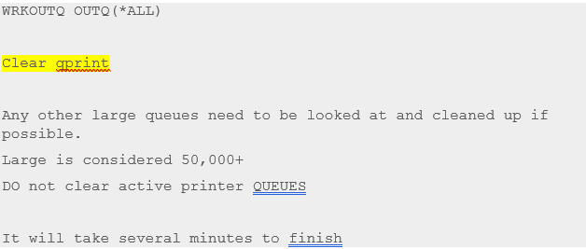

    - Check the below two for any large queues and clean up.
- DSPOBJD OBJ(*LIBL/*ALL) OBJTYPE(*MSGQ)
- DSPOBJD OBJ(QUSRSYS/*ALL) OBJTYPE(*MSGQ)

    - Clear by doing the following.
- dspmsg printers
- Then Shift+F1 (F13=Remove all)
Appendix A: Revision History Tracking
The following table records information regarding changes made to the Operations Binder.

Table 6 - Revision History Tracking
Version Number | Date | Author/Owner | Description of Change
1 | 7-14-2021 | Joni Zerkel | ENTIRE SOP – Updated ‘VP of IT’ to ‘IT Managing Director’
1 | 7-14-2021 | Joni Zerkel | PAGE 10 – 7.1 – Removed ‘Security’ & ‘A full camera outage a location’ (LYNDSAY)
1 | 7-14-2021 | Joni Zerkel | PAGE 8 – 6.1 – Removed Outlook as an SOP source (LYNDSAY & DOUG)
1 | 7-14-2021 | Joni Zerkel | PAGE 12 – Added Step Five: Summary of Incident sent to VP IT and President within 3 business days.
1 | 7-14-2021 | Joni Zerkel | PAGE 11 – 7.2 – Listed the IT Managing Director and Director of IT to be notified on all communications about High Priority Issues. (TIM)
1 | 7-14-2021 | Joni Zerkel | PAGE 14 – Added Section “8.3 - Only Admins, President, Managing Director of IT, Director of IT, Director of Support Services, Help Desk Manager, and other designated users are allowed to use Corporate wide distribution lists.” (TIM)
1 | 7-14-2021 | Joni Zerkel | PAGE 19 – Changed minimum number of vendors to receive quotes from 2 to 3. (TIM)
1 | 7-14-2021 | Joni Zerkel | PAGE 20 – 11.2.2 – Changed to ‘Select add new users’ (LYNDSAY)
1 | 7-14-2021 | Joni Zerkel | PAGE 36 – 12.1 – Changed to state the Help Desk receives the email from HR. (LYNDSAY)
1 | 7-14-2021 | Joni Zerkel | PAGE 36 – 12.2 – Modified to state what events would trigger a ticket to be created for a New Hire. (LYNDSAY)
1 | 7-14-2021 | Joni Zerkel | PAGE 46 – 13 – Added new SOP for Terminations
1 | 7-14-2021 | Joni Zerkel | PAGE 39 – A link was added to a Role Access Chart. Provides assistance to hiring managers when granting IT access.
1 | 7-14-2021 | Joni Zerkel | PAGE 40 – Bullet point added to section C. – A copy of the user profile should be sent to the hiring manager for review and approval.
1 | 7-14-2021 | Joni Zerkel | PAGE 44 – ‘Adding Door Access and Alarm Arm/Disarm’ Section Removed. (LYNDSAY)
1 | 7-14-2021 | Joni Zerkel | PAGE 44 – ‘Security Access’ bullet points removed. (LYNDSAY)
1 | 7-14-2021 | Joni Zerkel | PAGE 45 – 9. ManageEngine – updated to state a Project is created and ticket is closed upon completion of Project. (LYNDSAY)
1 | 7-14-2021 | Joni Zerkel | PAGE 49 – Step Four modified to state the status should be changed to ‘Resolved.’ It was listed to change it to ‘Closed.’ (LYNDSAY)
1 | 7-14-2021 | Joni Zerkel | PAGE 50 - Step b. removed. (LYNDSAY)
1 | 7-14-2021 | Joni Zerkel | PAGE 57 – Security section removed (LYNDSAY)
1 | 7-14-2021 | Joni Zerkel | PAGE 57 – Added to dispose returned equipment over 6 years old. (LYNDSAY/TIM)
1 | 7-14-2021 | Joni Zerkel | PAGE 62 – Added WICCLSYN (LYNDSAY)
1 | 7-14-2021 | Joni Zerkel | PAGE 64 – Updated section 18.5 to state contracts should be sent to Admin for uploading to the proper folder. (TIM)
1 | 7-14-2021 | Joni Zerkel | PAGE 69 – Added SOP for Pre-Go Live RDP Sessions for WISE
1 | 7-14-2021 | Joni Zerkel | PAGE 67 – Added TWP Bins. (LYNDSAY)
1 | 7-14-2021 | Joni Zerkel | PAGE 67 – Updated link for Print Pack IDs (http://10.73.0.10:10100/scheduledJobs/walmart/barcodepack.php)
1 | 7-14-2021 | Joni Zerkel | PAGE 68 – Changed contact name and email for ordering licenses for Royal 4. We no longer will go through Peter Carlino. We now need to go through Luz Barragan.
1 | 7-14-2021 | Joni Zerkel | PAGE 77 – (REVIEWED BY FORRY)  12) Recounts if necessary – a line was added to reference changes can be made as a WISE Only Adjustment.
1 | 7-14-2021 | Joni Zerkel | PAGE 77 – (REVIEWED BY BOCKRATH)  13) Paragraph was restructured and rewritten.
1 | 7-14-2021 | Joni Zerkel | PAGE 87 – (REVIEWED BY BOCKRATH)  q. Added direction to contact Marketing to update information.
1 | 7-14-2021 | Joni Zerkel | PAGE 90 – Updated 23.4 to state contracts should be sent to Admin for uploading to the proper folder. (TIM)
1 | 7-14-2021 | Joni Zerkel | PAGE 91 - Updated 24.3 to state contracts should be sent to Admin for uploading to the proper folder. (TIM)
1 | 7-14-2021 | Joni Zerkel | PAGE 92 – Removed that OE Connection is set up by Programming (LYNDSAY)
1 | 7-14-2021 | Joni Zerkel | PAGE 99 – Added a note that Age of cell phone should be considered prior to making any decisions to discard the phone.
1 | 7-14-2021 | Joni Zerkel | PAGE 103 – Added a link to the Adding Access for New Users section of the SOP.
1 | 7-14-2021 | Joni Zerkel | PAGE 106 – Send a confirmation to VP of Finance, Controller and Credit Manager.
1 | 7-14-2021 | Joni Zerkel | PAGE 108 – Added a link to the Adding Access for New Users section of the SOP.
1 | 7-14-2021 | Joni Zerkel | PAGE 124 – Added Stage 7: to send Reflection to VP of IT and President within 10 business days.
 | 6/14/23 | Kayla Perrine | Added Revised Creating an invoice for shipping an Item
 | 7/14/23 | Kayla Perrine | Added New Hire SOP- Section 12
 | 10/19/2023 | Kayla Perrine | Added Daily System Check & Monthly System Clean up
 | 11/16/23 | Donna Burgei | Fixed all the numbering issues
 | 5/16/24 | Shaina Johnson | Added section 36.5 & 36.6
 | 8/21/24 | Kayla Perrine | Updated SOP Management and added Computer Setup
 | 9/17/2024 | Shaina Johnson | Update Section 33.5
 | 9/27/24 | Kayla Perrine | Updated Section 18.
 | 12-5-24 | Barb Suever | Updated Section 7
 | 12-12-24 | Barb Suever | Added Section 20
 | 4/3/2025 | Angie Prichard | Added Sections: 10.6, 12, 13, & 14
 | 10/29/25 | Angie Prichard | Updated 10.1 How to Procure New PC’s and User Devices

